Food Technology
Year 8 Recipe Booklet
Module 1
2025 - 2026

Walton High School

Introduction
In Food Technology you will be making a variety of products and will be looking into the nutritional aspect of the ingredients. As you work through key stage 3 (years 7-9) you will build up your skills and knowledge of food. We have tried to include as many practical activities as possible.
All of the recipes in this booklet can be completed within the time of the lesson, including the clearing up of the work area. The clearing up at the end of the lesson is an important part of your learning and you are constantly assessed by your teacher on your time management, hygiene and safety practices.
Your teacher will go through the recipes in time for your next practical lesson, so that you can organise your ingredients to bring into the lesson. To help there is also a list of dates below showing when each product will be made. Pease note that these dates may have to change but we aim to give students at least a week’s notice for ingredients needed. Participating within the practical lessons is compulsory. You may not make all of the recipe’s during your Food module, however we have included some that you may wish to try at home. We have been mindful to keep the cost of the recipes within this booklet as low as possible. For some recipes contributions for ingredients have been paid for at the start of the school year. Therefore, school will provide these ingredients. These are clearly stated below, and in the recipes, and will only cover the ingredients stated.
In the department we encourage students to adapt recipes/ingredients to suit individual preferences. E.g. to be suitable for different diets and / or lower the cost further. Adaptations that can take place will be discussed within lessons.
Nut Free—we have made all of our recipes nut free, therefore please don’t bring any nuts into the department. We ask that all parents check through the recipe booklet and inform the school if there are any ingredients that your child may be allergic to.
For hygiene and safety reasons all students are expected to tie up long hair. Students are not allowed to wear nail varnish, nail décor, false eyelashes or jewellery in practical lessons.
We hope that you enjoy the course. Miss E. Dixon

Lemon Drizzle Cake

Ingredients for cake | Equipment from home
75g soft baking margarine | *18cm (7inch) lined cake tin
75g castor sugar | *Tin to carry home in or
125g white self-raising flour  1 egg | foil to cover cake
1 tsp baking powder | Oven Temp 180C
3 TBSP of milk  Finely grated rind of lemon | Gas 5
Time 25 – 30 minutes
For the Topping
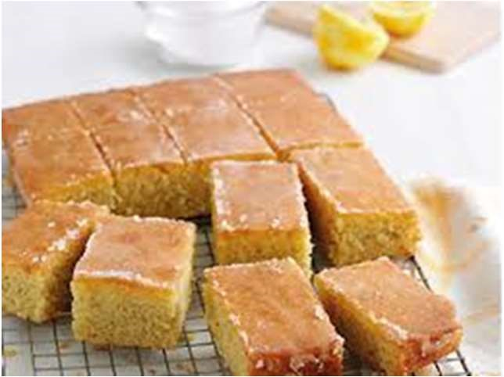
75g/3oz granulated sugar
Juice of 1 lemon
Method
- Collect equipment, organise work area.
- Pre heat oven 180C/gas 5.
- Place softened margarine, sugar, flour, baking powder into a mixing bowl.
- Crack egg into a jug and place shell in the bin. Check the eggs freshness before adding it to the mixture.
- Grate the rind of the lemon and add to the mixture. Keep the lemon for later. Beat with a wooden spoon for 2 – 3 minutes until smooth. Add milk if needed.
- Spoon mixture evenly into a lined tin and level with the back of a spoon.
- Bake for 25—30 minutes or until the cake is golden brown and shows signs of shrinking from the sides of the tin. Press the cake gently, it should be slightly resistant to the pressure.
- Remove cake from oven.
- Mix together the granulated sugar and the lemon juice.
- Drizzle the topping over the surface of the hot cake.
- Leave the cake in the tin to cool.
- Wash up, clean and check equipment.

Cheese and Potato Bake

Ingredients Equipment from home
200g cheese grated
1KG Potatoes *Ovenproof dish
50g margarine *Tin to carry home in
2 TBSP milk
Pinch black pepper
Method
- Collect equipment, organise work area
- Peel and chop potatoes into small pieces on a white chopping board.
- Place in a saucepan and cover with cold water. Bring to the boil.
Simmer for 20 minutes approx.
- Grate cheese.
- Drain potatoes when cooked and place back into saucepan.
- Add margarine, milk and pepper—you may not need all of your milk and mash the potatoes.
- Add ¾ of the grated cheese and stir in.
- Place into your ovenproof dish.
- Sprinkle remaining cheese over the top.
- Wash up, clean and check equipment.
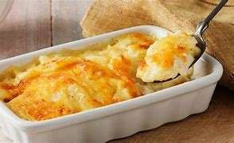

Macaroni cheese
Ingredients Equipment from home
200g macaroni pasta (or other small pasta) *Ovenproof dish
100g grated cheese *Tin to carry home in.
25g margarine or butter
25g plain flour
250ml milk
Black pepper to season
You may add fresh herbs such as chopped parsley or basil.
Method
- Collect equipment and organise work area.
- Bring a large pan of water to boil, add the macaroni. Cook for 10/12 minutes until al dente.
- Grate the cheese.
- Once the macaroni is cooked use a colander to drain the boiling water away. Put to one side.
- Rinse out the saucepan and make the sauce—place the butter/margarine, flour and milk into the saucepan.
- Bring the sauce to simmer, whisking all of the time, until the sauce has thickened.
- Reduce from the heat and stir in the black pepper. Stir in three quarters (75g) of the grated cheese.
- Stir the drained macaroni into the cheese sauce.
- Pour into the ovenproof dish from home.
- Sprinkle over the remaining cheese.
- Wash up, clean and check equipment.
 | 
  Reheating
  Reheat in oven at 180C / Gas 5 for 20 minutes or until piping hot in the centre. Can be microwaved.

Chicken Stir Fry
Ingredients Equipment from home
2 chicken breasts *Container to carry home in
2 cloves garlic
2cm root of fresh ginger or 1 tsp dried
- TBSP oil
- vegetables of choice (spring onions, red pepper, mushrooms, baby corn)
2- 4 TBSP soy sauce
Method
- Collect equipment, organise work area.
- Prepare the vegetables on a white chopping board. Grate the ginger and crush the garlic.
- Slice the chicken into thin strips on a red chopping board.
- Place the oil, garlic, and ginger into a saucepan with the chicken. Cook for 5 minutes to brown the chicken.
- Add the vegetables and continue to cook until the chicken is fully cooked.
- Add the soy sauce and cook for further 2 minutes. Take off the heat.
- Wash up, clean and check equipment.
- This dish is good served with noodles or rice when reheated at home.
 | 
  Reheating
  Reheat in oven at 180C / Gas 5 for 20 minutes or until piping hot in the centre. Can be microwaved.

Scones

Ingredients | Equipment from home
200g self-raising flour  50g margarine or butter  25g sugar | *Tin to carry home in
100ml milk | Oven Temp 220C
1 tsp baking powder  1 egg | Gas 7
Time 12-15 minutes
Optional
25g/1oz of the following – currants, raisins, sultanas, glace cherries (chopped), cheese* (*Remember to miss out the sugar if making a savoury scone)
Method
- Collect equipment, organise work area.
- Pre - heat oven 220C/Gas 7.
- Sieve flour and baking powder into a large mixing bowl.
- Break the fat into pieces – rub into the flour until it looks like breadcrumbs.
- Stir in the sugar and any other ingredients.
- Mix the milk and egg together in a jug.
- Add the milk/egg mixture slowly (TAKE CARE – all the mixture may not be required), mix with a palette knife to make a soft dough.
- Put the dough onto a floured surface, press out to approx. 2cm thick. Cut the dough into rounds using a cutter.
- Place the scones onto the baking tray and brush the tops with milk.

- Bake in the oven 200C/Gas 7 for 12-15 minutes, until scones are well risen and are golden brown.
- Wash up, clean and check equipment.

Artisan Bread Rolls

Ingredients | Equipment from home
Flavouring of own choice  (no nuts or chocolate)  E.g. (50g cheese, 1 tsp mixed herbs/ | *Tin to carry home in
oregano, Sundried tomatoes, Olives, | Oven Temp 220C
Cooked ham / pancetta, Poppy seeds, Sunflower seeds) | Gas 8 20 mins
300g strong white flour
½ tsp salt
25g margarine / butter
1 sachet easy blend yeast
200ml tepid water
The flour, yeast, salt and butter only are provided by school from payment made at the beginning of the year.
Method
- Collect equipment, organise work area.
- Light oven 220C/Gas 8.
- Sieve the flour and salt and add flavourings into a large bowl.
- Rub in the fat.
- Stir in the yeast and enough water to make a firm dough (Take care adding the water DO NOT add too much).
- Knead until smooth and elastic.
- Shape bread rolls.
- Allow rolls to rise a little, bake in the oven 220C/Gas 8 for 12-15 minutes until golden brown.
- Place onto a wire cooling tray to cool.
- Wash up, clean and check equipment.
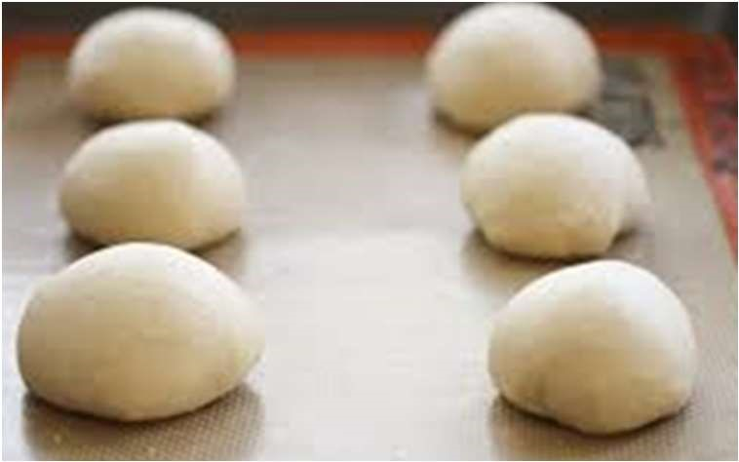
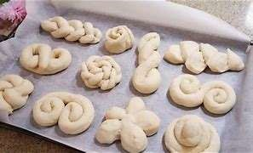

Flat Pizza (using bread recipe from artisan bread)
Ingredients Equipment from home
Small jar pizza sauce or 3-4 TBSP tomato puree *large oven tray
150g grated cheese *foil
2 or 3 of the following toppings: Oven Temp 220C
- onion (peeled and chopped) Gas 8
- slices ham (chopped)
½ red pepper (chopped)
Small tin sweet corn

50g mushrooms (sliced)
½ tsp mixed herbs/oregano or you may choose your own
200g strong white flour
½ tsp salt
25g margarine / butter
1 sachet easy blend yeast
200ml tepid water. The flour, yeast, salt and butter only are provided by school from payment made at the beginning of the year.
Method
- Collect equipment, organise work area.
- Pre heat oven 220C/Gas 8.
- Prepare all toppings if not done so at home.
- Grease baking tray.
- Make up dough mixture (see Quick Bread recipe), roll out dough to form a circle to fit your baking tray, finish edges.
- Spread the pizza sauce / tomato puree onto the top of the dough.
- Arrange the toppings on top and sprinkle over with cheese and herbs
- Bake in the oven 220C/Gas 8 for 20 minutes until golden brown.
Reheating
Reheat in oven at 180C / Gas 5 for 10 minutes or until piping hot in the centre.
- Wash up, clean and check equipment.


Muffins

Ingredients | Equipment from home
100g Soft Margarine | *Container to carry home in.
100g Sugar  2 Eggs | *12 muffin cases
150g Self-Raising Flour | Oven Temp 180C
50g of flavouring of own choice – no nuts Gas 5
e.g. (blueberries, raspberries, choc chips)
Time 20 minutes
Method
- Collect equipment, organise work area.
- Pre - heat oven to 180c/ Gas Mark 5.
- Place margarine and sugar into a large mixing bowl, and cream together until soft and fluffy, using a wooden spoon.
- Beat eggs in a small bowl, and add to creamed mixture, a little at a time.
- Sieve flour into the mixture, and mix together to achieve a soft dropping consistency.
- Add flavourings and stir well.
- Spoon the mixture evenly into muffin cases, in muffin tins, and place in oven for 15-20 minutes or until golden and springy in texture.
- Place muffins on cooling rack.
- Wash up, clean and check equipment.

