Food Preparation
& Nutrition
Year 9 Recipe Booklet 1
2025-2026

Walton High School

Introduction
In Food Technology you will be making a variety of products and will be looking into the nutritional aspect of the ingredients. As you work through key stage 3 (years 7-9) you will build up your skills and knowledge of food. We have tried to include as many practical activities as possible.
All of the recipes in this booklet can be completed within the time of the lesson, including the clearing up of the work area. The clearing up at the end of the lesson is an important part of your learning and you are constantly assessed by your teacher on your time management, hygiene and safety practices.
Your teacher will go through the recipes in time for your next practical lesson, so that you can organise your ingredients to bring into the lesson. To help there is also a list of dates below showing when each product will be made. Pease note that these dates may have to change but we aim to give students at least a week’s notice for ingredients needed. Participating within the practical lessons is compulsory. You may not make all of the recipe’s during your Food module, however we have included some that you may wish to try at home. We have been mindful to keep the cost of the recipes within this booklet as low as possible. For some recipes contributions for ingredients have been paid for at the start of the school year. Therefore, school will provide these ingredients. These are clearly stated below, and in the recipes, and will only cover the ingredients stated.
In the department we encourage students to adapt recipes/ingredients to suit individual preferences. E.g. to be suitable for different diets and / or lower the cost further. Adaptations that can take place will be discussed within lessons.
Nut Free—we have made all of our recipes nut free, therefore please don’t bring any nuts into the department. We ask that all parents check through the recipe booklet and inform the school if there are any ingredients that your child may be allergic to.
For hygiene and safety reasons all students are expected to tie up long hair.
Students are not allowed to wear nail varnish, nail décor, false eyelashes or jewellery in practical lessons.
We hope that you enjoy the course. Miss E. Dixon
Date | Recipe
 | Flavoured bread (see recipe for ingredients provided by school)
 | Gingerbread
 | Quiche
 | Traybake

Flavoured Bread – makes 6 rolls

Ingredients | Equipment from home
½ tsp sugar  25g butter | *Tin to carry home in
250ml tepid milk | Oven Temp 220C  Gas 8
Time 12 - 15 minutes
(flavouring – dried herbs, tomato puree, cheese, poppy seeds, sunflower seeds, sun dried tomatoes, olives)
300g strong white flour
½ tsp salt
1 sachet easy blend yeast
Extra flour for dusting
The flour, salt and yeast are provided by school from payment made at the beginning of the year.

Method
- Collect equipment, organise work area
- Preheat oven 220C/Gas 8.
- Gently heat the milk and margarine in a small pan until butter just melts and cool until lukewarm.
- Sieve the flour and salt into a large bowl.
- Stir in the sugar, yeast and flavourings.
- Add enough milk to make a firm dough (Take care adding the milk DO NOT add too much)
- Knead until smooth and elastic.
- Shape bread rolls.
- Allow rolls to rise a little, bake in the oven 220C/Gas 8 for 12 - 15 minutes until golden brown.
- Place onto a wire cooling tray to cool.
- Wash up, clean and check equipment.
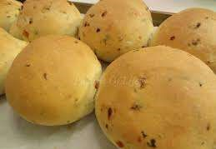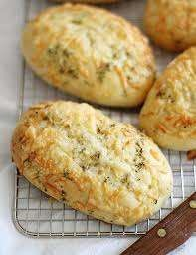

Gingerbread

Ingredients Equipment from home
150g self-raising flour *Tin to carry home in
1 ½ tsp ground ginger *Shaped biscuit cutter
50g soft brown sugar
25g butter Oven Temp 180C
1 ½ TBSP golden syrup Gas 5
2-3 TBSP water
Currants for decorations (optional) Time 10-15 minutes

Method
- Collect equipment, organise work area
- Pre – heat oven to 180C / Gas 5
- Place the sugar, syrup and butter into a saucepan and heat gently until all has combined (stir continuously).
- Take off the heat and add in the flour and ginger.
- Mix together and add 2 – 3 tablespoons of water (if needed) to make it into a firm but not sticky dough.
- If time allows wrap in clingfilm and chill for 10 minutes.
- Roll out the dough on a floured worksurface until the thickness of a £1.
- Cut out shapes and place on a lined baking tray. Leave space between the biscuits.
- Push in currants to decorate if using.
- Place in a pre-heated oven at 180°C / Gas 5 for 10 minutes until slightly risen and golden brown.
- Leave to cool.
- Wash up, clean and check equipment


Quiche
Ingredients | Equipment from Home
200g Plain Flour | *8 in/ 20cm tin (see below)
100g Butter / block Margarine  2 Eggs | *Container to carry home in
100ml Milk | Oven Temp 180C
2 rashers Bacon or sliced Ham | Gas 5
50g Cheese | Time 20 - 30 minutes
1 extra Vegetable of own choice
(e.g. Pepper, Sweet Corn, Broccoli, Peas, Spring Onion)
.

Method
- Collect equipment, organise work area
- Preheat oven on at 180˚C / Gas 5.
- In a mixing bowl, place the flour and butter divided into small pieces.
- Using fingertips, rub the butter into the flour until it resembles breadcrumbs. Use a blunt knife to mix in the butter if fingertips are too warm.
- Add enough cold water to make a stiff dough. Do this a tablespoon at a time.
- Use hands to form a ball of dough and place on a floured surface.
- Roll out pastry until ½cm thick and line baking dish.
- Blind bake for 5 minutes if time allows.
- Place milk in measuring jug and add eggs and cheese. Beat with a fork.
- Chop up bacon using scissors and add to the mixture.
- Chop extra ingredient on a white chopping board into small pieces. Add to the egg and milk mixture and stir well.
- Pour into the pastry case and bake in a pre-heated oven at 180˚C / Gas 5 for 20 - 30 minutes.
- Once cooked, place on a cooling rack to cool down.
- Wash up, clean and check equipment
Reheating
Reheat in the oven at 180C / Gas 5 for 10 minutes or until the centre is piping hot.
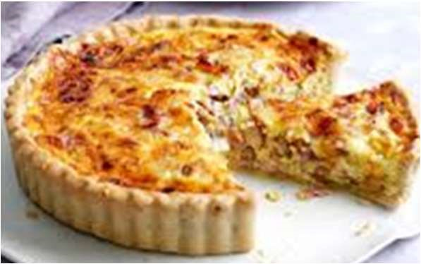

Tray Bake

Ingredients for cake | Equipment from home
75g soft baking margarine | *18cm (7inch) lined cake tin
75g castor sugar | *Tin to carry home in or
125g white self-raising flour  1 egg | Foil to cover cake
1 tsp baking powder | Oven Temp 180C
3 TBSP of milk  Flavouring of own choice | Gas 5
(vanilla essence, lemon zest, | Time 25 – 30 minutes
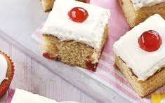
orange zest, cocoa powder, fresh / dried fruit)
Topping
150g melted chocolate OR
200g icing sugar mixed with a little water
Decorations (fresh fruit, glace cherries, chocolate buttons)

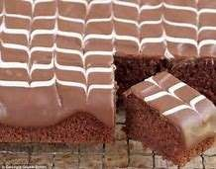
Method
- Collect equipment, organise work area.
- Pre heat oven 180C/gas 5.
- Place softened margarine and sugar in a bowl and cream together.
- Crack egg into a jug and place shell in the bin. Check the eggs freshness. Beat the egg with a fork and gradually add to the margarine and sugar mixture.
- Sift in the flour and baking powder and beat well.
- Add flavourings and milk if needed and beat until the mixture is of dropping consistency.
- Spoon mixture evenly into a lined tin and level with the back of a spoon.
- Bake for 20—30 minutes or until the cake is golden brown and shows signs of shrinking from the sides of the tin. Press the cake gently, it should be slightly resistant to the pressure.
- Remove cake from oven and leave to cool slightly.
- Melt chocolate or prepare icing.
- Decorate your tray bake with toppings and decorations,
- Leave to set. Once set cut into bars (this may need to be done at home).
- Wash up, clean and check equipment.

