Food Technology
Year 7 Recipe Booklet
Module 2
2025 - 2026


Walton High School

Walton High School
Introduction
In Food Technology you will be making a variety of products and will be looking into the nutritional aspect of the ingredients. As you work through key stage 3 (years 7-9) you will build up your skills and knowledge of food. We have tried to include as many practical activities as possible.
All of the recipes in this booklet can be completed within the time of the lesson, including the clearing up of the work area. The clearing up at the end of the lesson is an important part of your learning and you are constantly assessed by your teacher on your time management, hygiene and safety practices.
Your teacher will go through the recipes in time for your next practical lesson, so that you can organise your ingredients to bring into the lesson. To help there is also a list of dates below showing when each product will be made. Pease note that these dates may have to change but we aim to give students at least a week’s notice for ingredients needed. Participating within the practical lessons is compulsory. You may not make all of the recipe’s during your Food module, however we have included some that you may wish to try at home. We have been mindful to keep the cost of the recipes within this booklet as low as possible.
In the department we encourage students to adapt recipes/ingredients to suit individual preferences. E.g. to be suitable for different diets and / or lower the cost further. Adaptations that can take place will be discussed within lessons.
Nut Free—we have made all of our recipes nut free, therefore please don’t bring any nuts into the department. We ask that all parents check through the recipe booklet and inform the school if there are any ingredients that your child may be allergic to.
For hygiene and safety reasons all students are expected to tie up long hair.
Students are not allowed to wear nail varnish or jewellery in practical lessons.
We hope that you enjoy the course. Miss E. Dixon

Date | Recipe to be made
 | Italian Pasta Bake
 | Cupcakes with Glace Icing
 | Scone based pizza
 | Chocolate Cookies
 | Indian Chicken Curry
 | Palmiers
 | Own product based on brief

Italian Pasta Bake

Ingredients | Equipment from home
175g Pasta shapes, e.g. penne, fusilli | *Large oven proof dish
400g Tin chopped tomatoes | *Container to carry
1 Onion (chopped)  100g Mushrooms or peppers or sweetcorn | home in
2 TBSP Olive oil | Oven Temp 200C
150g Mozzarella Cheese  50g Cheddar cheese, grated | Gas 6
2 tsp mixed herbs  1 Clove garlic/salt and pepper  Method | Time 10-20 minutes
- Collect equipment, organise work area.
- Heat oven to 200C/Gas 6.
- Fill pan 2/3 full with water and place on heat to boil. When water is boiling add the pasta, and simmer for 10 minutes until pasta is tender.
- Drain pasta in colander, and place in ovenproof dish.
- Whilst pasta is cooking prepare vegetables, cheese and garlic on a white board.
- Gently heat oil in a saucepan, and then add onion, vegetables and garlic.
- Add tomatoes, herbs and seasoning. Bring to the boil, and remove from the heat.
- Pour over the pasta, add the chopped mozzarella and mix well.
- Sprinkle over the grated cheddar and place in oven for 10-20 minutes.
- Wash up, tidy area and check equipment.
 | 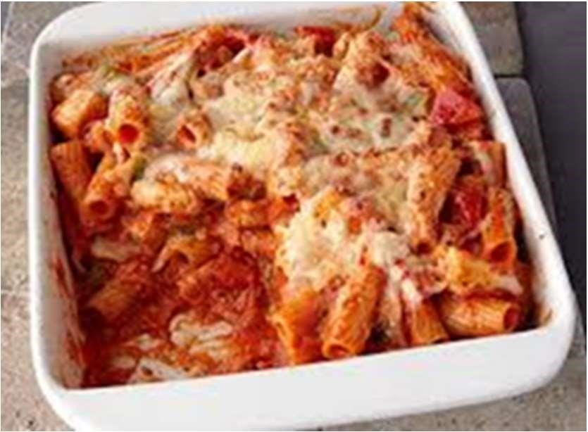
  Reheating
  Reheat in oven at 180C / Gas 5 for 20 minutes or until piping hot in the centre. Can be microwaved.

Cup Cakes with Glace Icing

Ingredients Equipment from home
60g Self-raising flour *Sealable container to
60g Soft baking margarine e.g. stork carry home in
60g Caster sugar
1 Large free-range egg Oven Temp 180C
1/2 tsp vanilla extract Gas 5
6 large cup-cake cases (not fairy cake cases)
100g Icing sugar
1 small decoration of choice Time 15 - 20 minutes (e.g. chocolate buttons, glace cherries halved)

Method
- Preheat oven to 180C / Gas 5
- Collect equipment, organise work area.
- Place margarine, sugar, self-raising flour, and vanilla essence into a mixing bowl.
- Crack egg into a jug and place shell in the bin. Check the eggs freshness before adding it to the mixture. Beat with a fork.
- Place egg into the mixture and beat all the ingredients together with a wooden spoon until mixture is a dropping consistency. Use an electric mixer if you need to.
- When thoroughly combined spoon the mixture into the paper cases evenly with a metal spoon—Take Care—only fill the cases two thirds full.
- Bake for 15 - 20 minutes or until risen, golden brown and firm to the touch. Cool on cooling rack.
- Place icing sugar in a small bowl. Make icing by adding a teaspoon of cold water at a time until icing is correct consistency (similar to toothpaste).
- Spread onto the top of cakes using the back of a teaspoon.
- Add the decoration.
- Wash up, clean and check equipment

Scone based pizza

Ingredient | Equipment from home
150g Self-raising flour | *large oven tray

25g Butter  1 Egg  50ml Milk | *foil
3 TBSP tomato puree / pizza sauce | Oven Temp 200C
½ tsp mixed herbs  50g Grated cheese, e.g. Mozzarella  2 toppings of own choice | Gas 6
(e.g. ham, mushrooms, sweetcorn, pineapple, spring onion, tuna) | Time 15 - 20 minutes

Method
- Collect equipment, organise work area.
- Preheat oven to 200C / gas 6.
- Sieve flour into a large mixing bowl.
- Break the fat into pieces – rub into the flour until it looks like breadcrumbs.
- Mix the milk and egg together in a jug.
- Add the milk/egg mixture slowly (TAKE CARE – all the mixture may not be required), mix with a palette knife to make a soft dough.
- Flatten out dough to form a circle.
- Spread over the pizza sauce / tomato puree.
- Sprinkle with some herbs.
- Arrange your fillings onto the top and sprinkle with cheese.
- Bake in a preheated oven for 15 – 20 minutes until golden brown.
- Wash up, tidy area and check equipment.

  Reheating
  Reheat in oven at 180C / Gas 5 for 20 minutes or until piping hot in the centre.

Chocolate Cookies

Ingredients Equipment from home
80g Soft baking margarine e.g. stork *Container to carry home in. 70g Caster sugar
110g Self-raising flour
50g Chocolate chips Oven Temp 180C
Optional for choc biscuit mixture exchange Gas 5 1 TBSP of the flour for cocoa powder
Time 10 minutes

Method
- Collect equipment, organise work area.
- Pre-heat oven to 180c/gas mark 5.
- Mix together the sugar and butter in a mixing bowl.
- Add the flour and flavourings and stir well until all the ingredients are combined.
You may need to use your hands to bring the mixture together.
- Divide the dough into 8 even sized pieces.
- Place your pieces of dough onto the tray lined with baking paper so they are far apart from each other. Flatten slightly with the palm of your hand.
- Carefully place your tray into the oven using oven gloves for 10 minutes. Your cookies are ready when they are golden brown on the edges. (These cookies will be soft when they come out of the oven and will harden as they cool down) • Wash up, clean and check equipment.
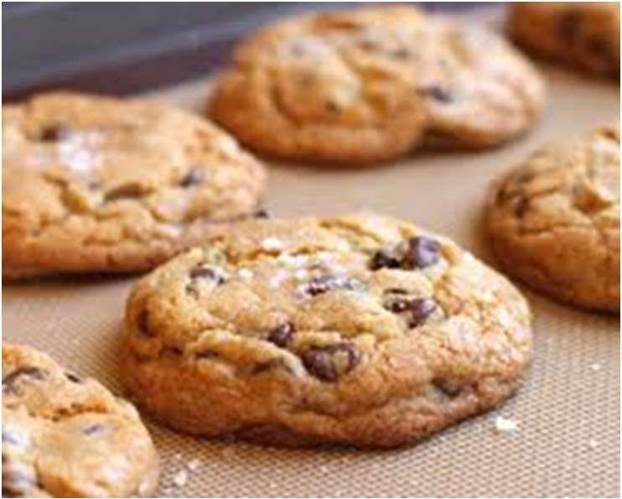

Indian Chicken Curry

Ingredients Equipment from home
2 Chicken breasts *Sealable container to
1 Onion carry home in
- TBSP oil
- TBSP curry paste
400g tin chopped tomatoes
Optional – 3 handfuls of fresh Spinach.

Method
- Collect equipment, organise work area.
- Using a white chopping board peel and finely chop the onion.
- Using a red chopping board cut the chicken into bite size pieces.
- Fry the onion for 2 minutes in the oil, and then add the chicken. Cook until it turns white on the outside.
- Stir in the curry paste.
- Add the tomatoes, bring to the boil and then simmer for 10 minutes until the chicken is cooked.
- Stir in the spinach if using, and cook for a further 2 minutes.
- Wash up, clean and check equipment.
- Serve with boiled rice, naan bread and a side salad.
 | 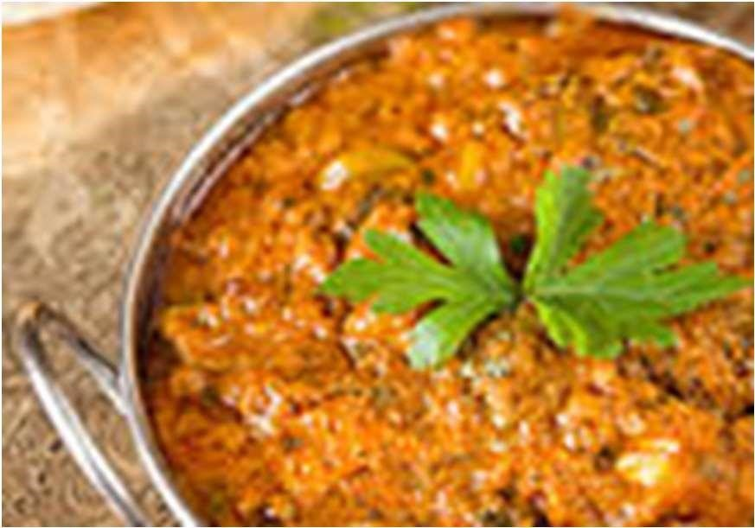
  Reheating
  Reheat in oven at 180C / Gas 5 for 20-30 minutes or until piping hot in the centre. Can be microwaved.

Cinnamon Palmiers
Ingredients Equipment from home
375g ready-made puff pastry sheet *Tin to carry home in
50g soft margarine
1 ½ tsp ground cinnamon Oven Temp 180C
3 TBSP sugar Gas 5
Time 20 minutes

Method
- Collect equipment, organise work area. Pre-heat oven 180C or gas mark 5
- Line baking tray with baking parchment.
- Unroll the pastry sheet.
- Brush lightly with margarine to fully cover the pastry sheet.
- Mix together the cinnamon and sugar and sprinkle evenly over the butter.
- Roll the pastry up from each of the longer sides until the rolled up edges meet in the centre.
- Slice the pastry into 2cm pieces, then place, cut-side up, on the baking trays, flattening a little with the palm of your hand.
- Bake for 20 mins until golden and puffed up, then cool on a wire rack.
- Wash up, clean and check equipment.
