Food Technology
Year 7 Recipe Booklet
Module 1
2025 - 2026


Walton High School
Introduction
In Food Technology you will be making a variety of products and will be looking into the nutritional aspect of the ingredients. As you work through key stage 3 (years 7-9) you will build up your skills and knowledge of food. We have tried to include as many practical activities as possible.
All of the recipes in this booklet can be completed within the time of the lesson, including the clearing up of the work area. The clearing up at the end of the lesson is an important part of your learning and you are constantly assessed by your teacher on your time management, hygiene and safety practices.
Your teacher will go through the recipes in time for your next practical lesson, so that you can organise your ingredients to bring into the lesson. To help there is also a list of dates below showing when each product will be made. Pease note that these dates may have to change but we aim to give students at least a week’s notice for ingredients needed. Participating within the practical lessons is compulsory. You may not make all of the recipe’s during your Food module, however we have included some that you may wish to try at home. We have been mindful to keep the cost of the recipes within this booklet as low as possible. For some recipes contributions for ingredients have been paid for at the start of the school year. Therefore, school will provide these ingredients. These are clearly stated below, and in the recipes, and will only cover the ingredients stated.
In the department we encourage students to adapt recipes/ingredients to suit individual preferences. E.g. to be suitable for different diets and / or lower the cost further. Adaptations that can take place will be discussed within lessons.
Nut Free—we have made all of our recipes nut free, therefore please don’t bring any nuts into the department. We ask that all parents check through the recipe booklet and inform the school if there are any ingredients that your child may be allergic to.
For hygiene and safety reasons all students are expected to tie up long hair.
Students are not allowed to wear nail varnish, nail décor, false eyelashes or jewellery in practical lessons.
We hope that you enjoy the course. Miss E. Dixon

Moroccan Couscous

Ingredients | Equipment from home
125g Couscous | *Container to carry home in
- vegetable stock cube
- spring onions
1 red pepper
1 tomato
OPTIONAL - Small bunch flat leaf parsley.
OPTIONAL – handful of black olives chopped or 100g chopped dried apricots.

Method
- Collect equipment, organise work area.
- Place the couscous in a large bowl.
- Boil the kettle. Once water is boiled carefully measure 150ml of boiling water into a jug. Add a stock cube to the water and stir until it has dissolved.
- Pour the stock over the couscous. Add more boiling water if needed to make sure the water just covers the couscous. Leave for 10 minutes.
- Meanwhile chop the onions, pepper, tomato and parsley, and chop any optional ingredients.
- When the couscous has absorbed all water fluff it with a fork.
- Gently stir through the onions, pepper, tomato and parsley and any remaining ingredients.
- Wash up, tidy area and check equipment.
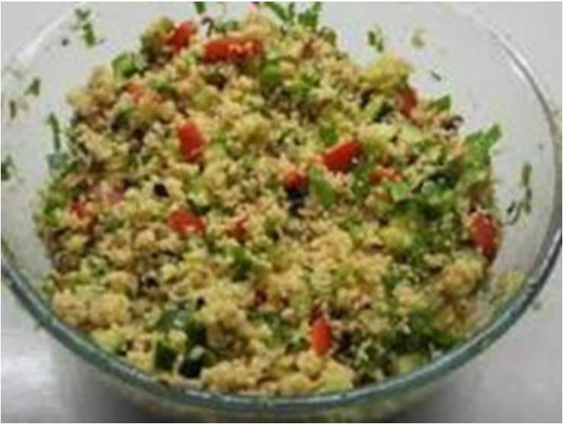

Fruit crumble (serves 4)

Ingredients Equipment from home
150g/6oz plain flour *Oven proof dish
50g/2oz porridge oats *Tin to carry home in
75g/3oz sugar
75g/3oz hard margarine Oven Temp. 200C
2 tins of pie filling or 500g stewed fruit Gas 6
Time 20 minutes

Method
- Collect equipment, organise work area.
- Pre - heat oven 200C/Gas 6.
- Place flour into a large mixing bowl.
- Rub in margarine to resemble breadcrumbs.
- Stir in sugar and oats. Put to one side.
- Place fruit into oven proof dish.
- Cover fruit with crumble topping.
- Bake in the pre-heated oven for 20 minutes (approx.) until golden brown.
- Wash up, clean and check equipment.
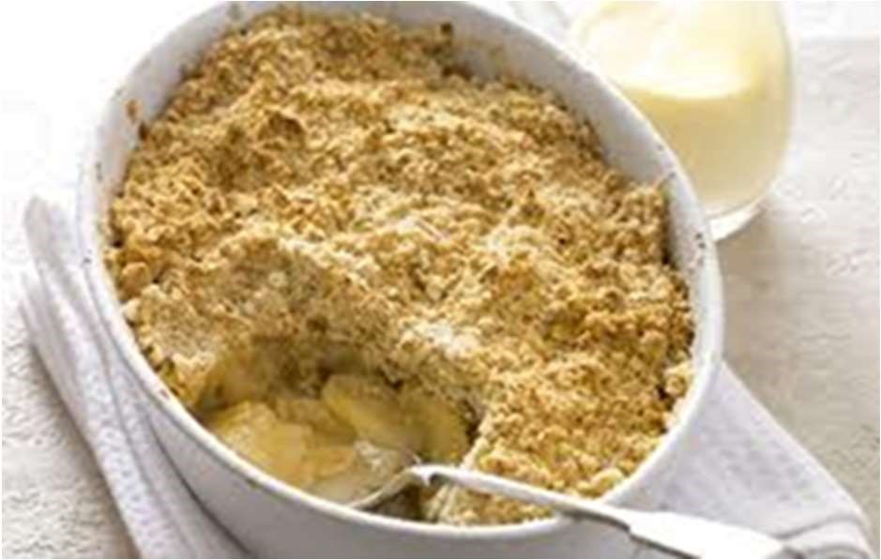
Reheating
Reheat in oven at
180
C / Gas 5 for 20
minutes or until
piping hot in the
centre. Can be
microwaved.

French bread pizza

Ingredients | Equipment from home
2 bread muffins or small French stick | *Plastic container to
4 TBSP tomato puree / pizza sauce  ½ tsp mixed herbs  100g grated cheese | carry home in
2 toppings of own choice | Oven Temp 180C
(e.g. ham, mushrooms, sweetcorn, pineapple, spring onion, tuna) | Gas 5  Time 10 minutes

Method
- On a white chopping board slice the bread in half lengthways.
- Spread over the pizza sauce / tomato puree.
- Sprinkle with some herbs.
- Arrange your fillings onto the top and sprinkle with cheese.
- Place under in the oven, until the cheese bubbles (take care not to allow your pizza to burn). Approximately 5-10 mins.
- Wash up, clean and check equipment.
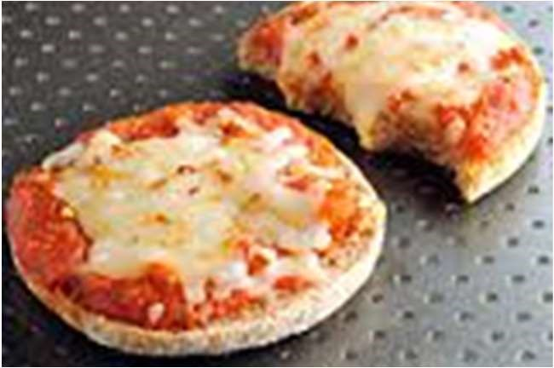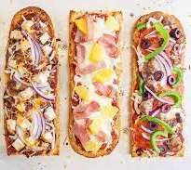
Reheating
Reheat in oven at 180C / Gas 5
for 10 - 15 minutes or until piping
hot in the centre.

Potato Salad

Ingredients Equipment from home
400g / 1lb new potatoes *Plastic container to carry home in
3 TBSP mayonnaise / salad cream
2 TBSP chopped chives (optional)
1/2 tsp salt (optional)

Method
- Scrub potatoes and cut into even sized pieces.
- Place in saucepan and just cover with water.
- Add 1/2 level tsp salt (if using).
- Bring to boil, turn pan down and simmer for 10 minutes.
- Drain potatoes and place in mixing bowl.
- Add mayonnaise whilst still hot and stir in chives and gherkins if used.
- Wash up, clean and check equipment.
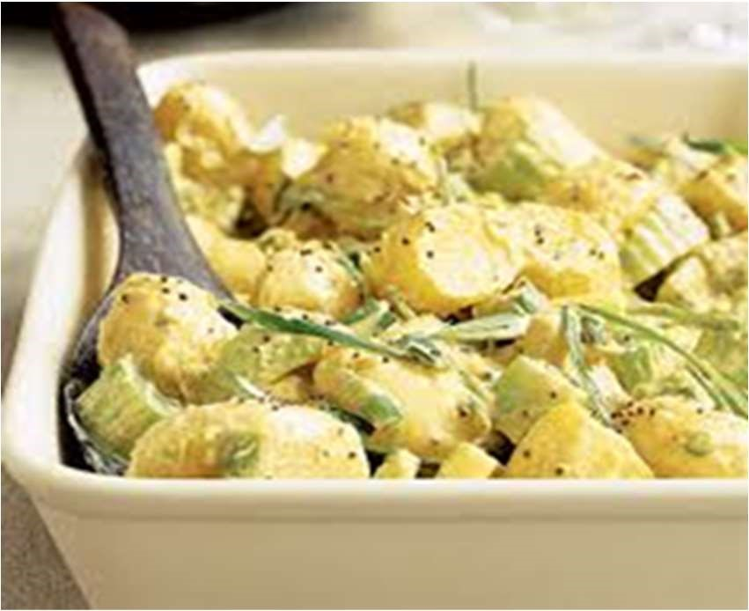
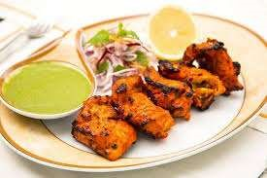

Chicken Tikka
Ingredients

Chicken Tikka Equipment from Home
175g Chicken breast * Container to carry home in
15g/ 1 TBSP thick natural yogurt
1 TBSP lemon juice
1 tsp tomato puree Oven Temp 200C
1 clove garlic
1 tsp ground cumin
½ tsp turmeric
½ tsp ground ginger
Gas 6
Time 20 minutes
Provided by school:
The turmeric, ginger, and cumin are provided by school from payment made at the beginning of the year.

Method
- Collect equipment, organise work area.
- Preheat oven to 200c/gas mark 6.
- Place the yoghurt, lemon juice and tomato puree into a large bowl. Crush the clove of garlic and also add to the bowl.
- Add the cumin, turmeric, and ground ginger. Mix well.
- Place the chicken on a RED chopping board. Cut into large chunks using a sharp knife.
- Add the chicken to the yogurt mixture, mix, and marinate for 5 minutes.
- Wash hands after handling raw meat. Wash all equipment that has touched raw meat in hot soapy water.
- Transfer the chicken pieces to a baking tray (with sides) and bake in the oven for 20 minutes or until cooked through.
- Clean down the work area. Wash up, clean and check equipment.

Reheating
Reheat the chicken in oven at 180C / Gas 5 for 20 minutes or until piping hot in the centre. Can be microwaved.

Bolognaise Sauce

Ingredients Equipment from Home
1 large clove of garlic * Container with a lid to
- Onion carry home in
500g Minced Beef or Quorn mince
400g can chopped tomatoes
- tsp dried oregano
- beef stock cube
- TBSP Tomato Puree
1 extra vegetable e.g. mushrooms, peppers

Method
- Collect equipment, organise work area.
- Using a white chopping board chop the onion, and extra vegetable. Crush the garlic.
- Using a saucepan, brown the mince and onion, and then drain off any extra fat using a colander.
- Add the extra vegetable and garlic and cook for 2 minutes more.
- Add the tomatoes, tomato puree, stock cube and dried oregano.
- Bring to the boil, turn down the heat and leave to simmer for 10-15 minutes.
- Place in container to take home. Serve with cooked Spaghetti, or pasta.
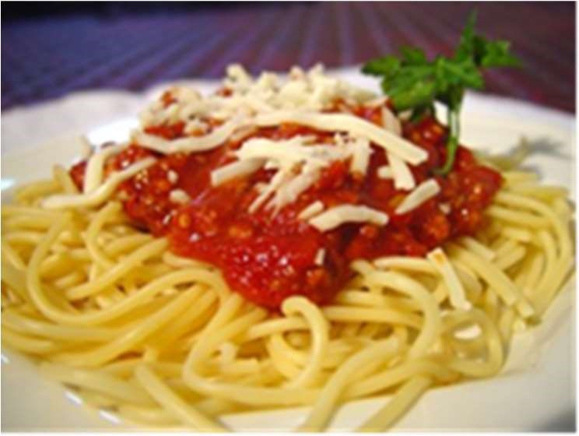
- Wash up, clean and check equipment.

Reheating
Reheat the mince in the oven at 180C / Gas 5 for 20 minutes or until piping hot in the centre. Can be
microwaved.

Shortbread

Ingredients | Equipment from home
100g softened butter | *8 in/ 20cm tin
50g caster sugar  150g self raising flour | Tin foil to cover product. Bag to carry product.
Extra Caster Sugar for dusting | Oven Temp 160c  Gas 4
Time 20 minutes
Flavouring of your choice e.g.
Glace cherries – 50g glace cherries, finely chopped.
Chocolate and orange – 50g chocolate chips and zest of ½ orange. Cranberry and white chocolate – 25g cranberries and 25g white chocolate chips.
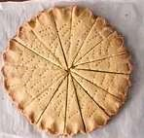
Apricot and Vanilla – 1 tsp vanilla extract and 8 dried apricots, finely chopped.

Method
- Collect equipment, Organise work area.
- Pre-heat oven to 160c/gas mark 4.
- Put the flour in a mixing bowl and place the butter on top in small pieces.
- Rub the butter into the flour using fingertips until it resembles breadcrumbs.
- Stir in the sugar and the flavouring of your choice.
- Transfer the mixture to the tin, and using a palette knife or the back of a spoon, press down and make the top as smooth as possible.
- Mark the top of the shortbread into 8 triangles with a sharp knife. Do not cut all the way through.
- Using a thumb or the back of a spoon mark a pattern round the edge of the shortbread, and prick each triangle with a fork.
- Place in the hot oven for 15/20 minutes or until lightly golden.
- Dust with extra sugar and slice into triangles whilst still warm.
- Wash up, clean and check equipment.

Cereal Bars

Equipment from home
*8 in/ 20cm tin
Tin foil to cover product. Bag to carry product home.

Ingredients

2 level tablespoons golden syrup
50g sugar
150g porridge oats
70g margarine

Oven Temp 180c
Gas 5
Time 15-20 minutes

Other ideas to try
Add 75g chopped glace cherries, dried apricots or your choice of flavouring (NOT CHOCOLATE)
Foil Trays are provided by school from payment made at the beginning of the year.

Method
- Collect equipment, organise work area.
- Pre-heat oven 180c/Gas 5.
- Put margarine, syrup and sugar into a large saucepan.
- Stir over a low heat with a wooden spoon until the margarine has melted (CARE MUST BE TAKEN)
- Remove from the heat and add oats – mix thoroughly.
- Mix in any additional flavourings (cherries/apricots)
- Turn mixture into tin and cook 180C/Gas 5 for 15-
20 minutes until golden brown.
- Leave to cool in the tin for 5 minutes, then cut into portions. Place onto a wire cooling tray.
- Wash up, clean and check equipment.
