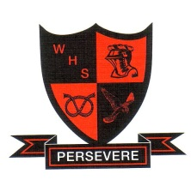
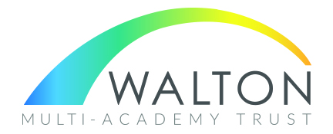
WALTON HIGH SCHOOL
The Rise, Walton on the Hill
STAFFORD, ST17 0LJ
Mixed 11 – 18 secondary school with 1260 students on roll
Including an Outstanding Post 16 of 220 students

Teaching Assistant – Additional Needs - term time only
start date – SEPTEMBER 2025
This post may be suitable for a graduate looking for experience of working with students with SEND

FIXED TERM COnTRACT
25 hours per week, monday – friday

Grade 5, Scale 6 - 9 (depending upon Continuous Service)

We are seeking to appoint an enthusiastic and committed Teaching Assistant, to join our team of highly professional support staff. You will be required to work, under guidance of the Class Teacher and SENDCo, to provide support in addressing the needs of a pupil who requires particular help to overcome barriers to learning.

Walton High School is an oversubscribed, high-achieving school. It is situated in a pleasant residential area on the edge of Cannock Chase and enjoys an excellent reputation.

If you would like to take this opportunity to join our school, please visit our website at www.waltonstaffs.com to download an application pack and return to recruitment@walton.staffs.sch.uk

Previous applicants need not apply.

Closing date: 9.00 am on Friday 4th July 2025
Interview date: To be confirmed

We reserve the right to close this vacancy when we are in received of sufficient applications. Should you wish to apply for this post you are advised to complete and submit your application as soon as possible.

This position is subject to an Enhanced Disclosure check under the Rehabilitation of Offenders Act 1974. Further details regarding this check are available from school or by visiting https://disclosure.capitarvs.co.uk/staffordshire
This school is committed to safeguarding and promoting the welfare of children and young people/vulnerable adults and expect all staff and volunteers to share this commitment.

In line with KCSIE 2023 and safer recruitment practices, the school will conduct an online search on all shortlisted candidates. This will be carried out before the interview which may identify any incidents or issues that have happened, and are publicly available on line, which we might want to explore with you at interview.

