

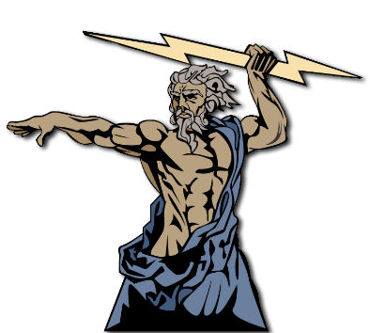



The ‘nature of God’ talks about what God is like. In Christianity, there is   
only **one God**, and He is described as being:

* **Omnipotent** (all powerful)
* **Omnipresent** (everywhere)
* **Omniscient** (all knowing)
* **Omnibenevolent** (all loving)
* **Transcendent** (outside of this world)
* **Timeless** (exists outside of time)
* **Eternal** (lasting forever)

These beliefs are in the Bible and are part of **God’s revelation to   
humans** (he revealed the truth of Himself to humanity). God is:

* The **creator** of all life: “In the beginning God created the  
   heavens and the earth” (Genesis 1:1)
* **Involved** with the world in a mysterious way. Humans are   
  made in a special way: “Then God said, Let us make   
  mankind in our image, in our likeness…”   
  (Genesis 1:26)

Omnipotent means the all-powerful, almighty and unlimited nature of God.

For example, in Exodus God instructs Moses to lead the Jews out of Egypt.   
God sent plagues and parted the Red Sea, showing God’s omnipotence. The immensity of God’s power is also shown in the Creation story (Genesis 1).

Omnibenevolent means the state of being all-loving and infinitely good – a characteristic often attributed to God.For example: “*You Lord are a compassionate God*” (Psalm 86:15)**.** “*For God so loved the world that he gave his one and only Son, that whoever believes in him shall not perish but have eternal life*” (John 3:16)

This spiritual likeness enables all humans to have some  
understanding of God’s nature through ‘revelation’. **Revelation  
 is God showing or   
revealing Himself to   
people**.

If God is all-loving, all-powerful and all-knowing,   
then why doesn’t God remove evil and suffering from the world?   
The existence of evil and suffering is one of the strongest arguments against the   
existence of God. These people might call themselves **atheist** (believing in no God)   
or **agnostic** (unsure whether or not a God exists). The problem of evil and suffering is   
a difficult question for people of faith. For Christians, suffering is seen as an essential   
part of human life. These arguments are known as ‘**theodicies**’ and they attempt to   
reconcile the existence of a good, loving God with the existence of evil and suffering.

**Theodicies:**

* **Free Will** – people must make their own choices, which cause evil and suffering
* There is a force for evil in the world, sometimes referred to as the ‘devil’ or ‘Satan’.
* Traditionally, the devil was believed to be a fallen angel, thrown out of heaven when he disobeyed God
* God shares in our suffering. Some believe that suffering is a way to participate in the suffering of Jesus. This suffering (and all suffering) can be a test.
  + Suffering is the result of sin (actions that go   
    against God’s laws)
  + How we deal with suffering gives us the opportunity to become better people – it is strengthening and soul-shaping.

**Trinity:**The three persons of God:   
God the Father, God the Son, God the Holy Spirit.

Christians are often blessed in church services by a minister with reference   
to this belief, e.g. “*In the name of the father, the Son and the Holy Spirit*.”

Roman Catholics might bless themselves by making the sign of the cross and   
reciting, “*In the name of the father, the Son and the Holy Spirit*.”

**God the Father**

Jesus taught to refer to God as ‘God the Father’. This refers to God as the   
all-powerful (**omnipotent**) and all-knowing (**omniscient**) part of God.

**Jesus Christ:**Christians believe that Jesus is the Son of God. For Christians, Jesus ***is*** God. This belief is   
known as the ***incarnation***. Christians believe that by coming to earth as a human, God revealed   
knowledge about himself to the world.

**God the Holy Spirit:**Christians believe that after Jesus’ resurrection, Jesus rose up to heaven.   
They believe that God then sent the Holy Spirit into the world to guide Christians to   
live in the best way possible. The Holy Spirit is able to: Give comfort, courage,   
inspiration and guidance to all Christians; Help people to believe in Jesus and   
strengthen their faith; Help to understand and interpret the Bible / the Word   
of God; Intervene in the world in a miraculous way, e.g. in special   
church services

Christians believe in the Trinity because of evidence from the Bible.   
Jesus said:

* “I and the Father are one.” (John 10:30)
* “I am the way and the truth and the life. No one comes to the Father except through me. If you really know me, you will know my Father as well. From now on, you do know him and have seen him.”   
  (John 14: 6 – 11)
* “Don’t you believe that I am in the Father and the Father   
  is in me? The words I say to you I do not speak on my own authority. Rather, it is the Father, living in me, who is doing his work.”  
  (John 14: 6 – 11)

These passages show that Jesus is one with God and that Jesus has a   
 special and unique relationship with God.



This contains the most important Christian beliefs about God.   
It is recited in church or at solemn occasions, such as a baptism.

All Christians sign up to the beliefs stated in the creed, even if they are not   
Roman Catholic.

**The most important beliefs are:**

1. God is an all-powerful creator
2. Jesus was born of Mary by the power of the Holy Spirit
3. Jesus was crucified, buried and rose from the dead and ascended to heaven.
4. There will be a day of judgment
5. There is one holy and universal Church
6. God will forgive our sins
7. There will be a resurrection of the body and   
   an eternal afterlife















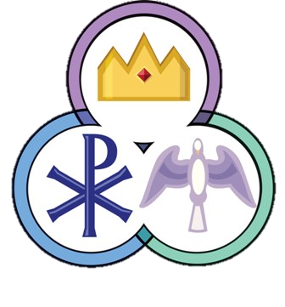Image result for heart clipart





