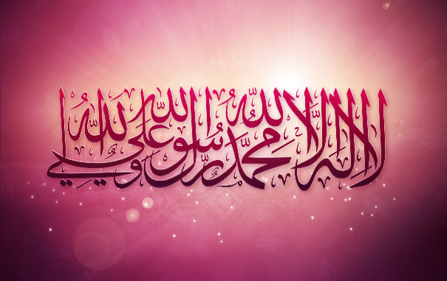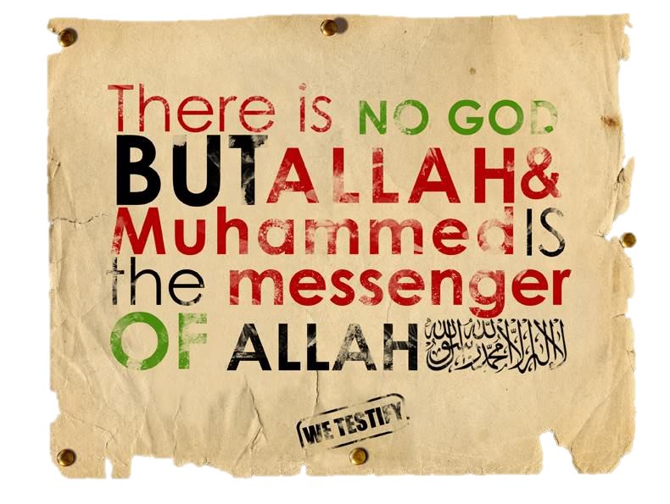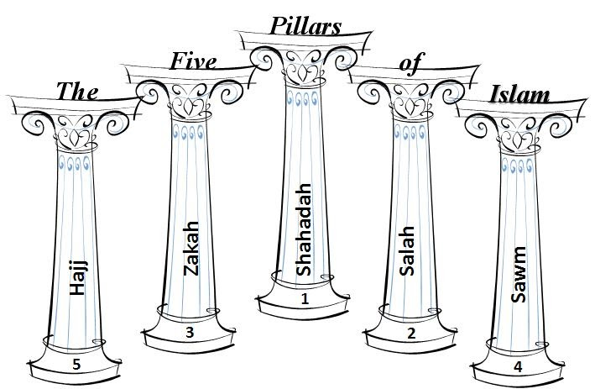Beatrix Antiqua Regular

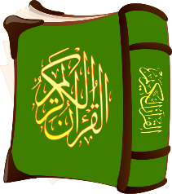

They must be carried out with niyyah, the true intention to submit to   
the will of God. Muslims say that there can be no doubt that they have been   
instructed by God to complete the Five Pillars: the Qur’an contains many   
references as to their importance and, in his last sermon, Prophet Muhammad   
makes clear mention of them:

“***O People, listen to me in earnest, worship God, perform your five daily prayers, fast   
during the month of Ramadan and offer Zakah. Perform Hajj if you have the means***.” (Hadith)



**Niyyah** means having the right intention to worship God. Muslims believe that it is important to have God consciousness (taqwa). They may not always be in the right mood to worship God, or they may feel unworthy to meet him, but when praying it is important to dedicate that time to being in his presence.

Sometimes there may be a strong feeling that God is present and at other   
times he may seem distant, but God is merciful and judges the desire   
to communicate with him, even if we feel we do not succeed.

Beatrix Antiqua Regular

The first pillar of Islam is the Shahadah. It declares that ‘there is no god but God,   
and Muhammad is the prophet of God.’ This statement forms the central support for   
the ‘House of Islam’: the other four pillars are all outward expressions of this deeply  
 held belief.

“God witnesses that there is no deity except Him, and [so do] the angels and those of knowledge – [that He is] maintaining [creation] in justice. There is no deity except Him, the Exulted in Might, the Wise.” (Qur’an 3:18)

Beatrix Antiqua Regular

For Muslims, the words of the Shahadah are heard throughout the day   
in countless aspects of their lives. They are announced in the adhan (call to   
prayer) from the minaret in the mosque and recited in each of the five   
daily prayers. These words are also known as the Kalimah prayer. They   
are the first words whispered into a new-born baby’s ear and, if possible,   
they are the last words a dying Muslim hears on their death-bed. Muslim   
soldiers have these words on their lips as they go   
into battle.

Beatrix Antiqua Regular

For Muslims, actions speak louder than words and it is not enough to just have faith   
in God. They believe that it is necessary to show religious commitment through the   
way they live their entire lives.   
Every action is a form of worship; this is called ibadah. People in Western countries sometimes   
think that religions are just sets of beliefs, or a collection of option faith-based activities.   
However, Muslims have always been very clear that Islam is a complete way of life; worship is   
a 24/7 reality, to be lived fully, not just as an afterthought to add on to our secular lives.

Beatrix Antiqua Regular]

Sunni Islam teaches that all Muslims have a duty to worship God by following the Five Pillars. These actions are all **ibadah**, acts of worship carried out with the intention of obeying God. They are:

1. **Shahadah**: the declaration of faith which says “There is no god but God and   
   Muhammad is his prophet.”
2. **Salah**: prayer, five times a day
3. **Zakah**: charity, giving money to the poor
4. **Sawm**: fasting during the month of Ramadan
5. **Hajj**: pilgrimage to Makkah

By following these rules, Muslims believe that they can show their obedience   
to the will of God. The Shari’ah (Islamic Law) sets out the Five Pillars as   
religious duties; they are seen as practical signs which demonstrate   
true submission to the   
divine creator.

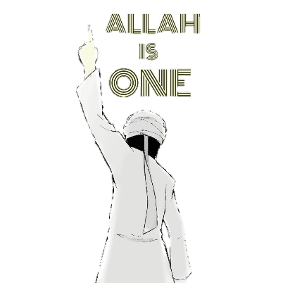

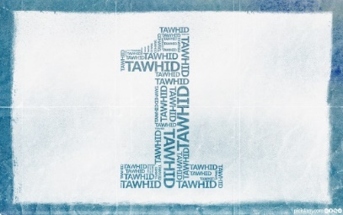

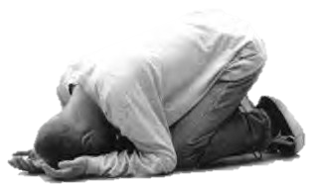







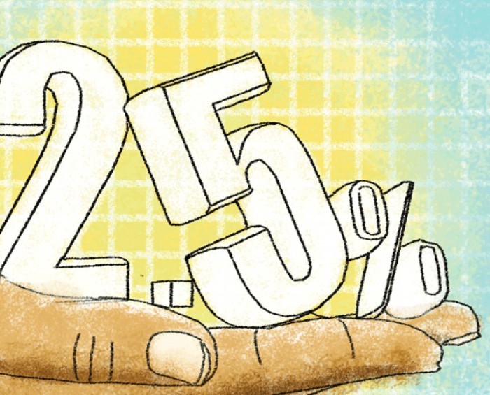

The second pillar of Islam is Salah, the practice of prayer. For Muslims, prayer is the most important way to worship God. It is a duty for all Muslims to pray five times a day. Muhammad called prayer the ‘pillar of religion’ and it reminds them to give thanks for God’s blessings and of the importance of submitting to God’s will. It is a physical, mental and spiritual activity that draws believers closer to God.

The Qur’an and the Sunnah give Muslims clear guidance on how and when to pray. Salah takes place five times a day.

Muslims must find somewhere with a room to stand, bow and prostrate themselves (kneeling with their face to the ground). This can be at the mosque, at home or anywhere safe and clean. Muslims pray by facing Makkah; this direction is called Qibla.

A rak’ah is a sequence of movements, following a set pattern, which make up the prayer routine. The different prayers during the day require different numbers of rak’ahs

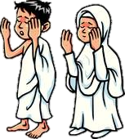

Beatrix Antiqua Regular

The fifth pillar of Islam is Hajj, the pilgrimage to Makkah. This is  
 the only pillar of Islam that Muslims don’t have to perform. It is compulsory for   
those who are able to make the journey, but the Qur’an only commands it as a   
duty for those who either have enough money to leave their homes for a lengthy   
period, or are physically and mentally fit enough to carry out this demanding ritual.

For most Muslims, to set out for the Hajj would be the ambition of a lifetime. Those who have   
succeeded in completing it often count it as the greatest achievement of their lives. Hajji   
(male) or Hajjah (female) is the special title given to someone who has successfully   
completed the Hajj pilgrimage. This is a great honour.

  
Makkah is considered by Muslims to be the holiest city on earth. Because it is the city of God, it has immense spiritual significance in Islam. Muslims believe that it is here that Prophet Ibrahim (Abraham) was commanded by God, in a dream, to sacrifice his son, Isma’il; Ibrahim overcame a test when the devil  
 appeared, trying to trick him into denying God’s word. Ibrahim threw stones to drive the devil   
away; Ibrahim’s wife, Hajar, searched frantically for water in the desert. Miraculously, an   
angel showed her the Zamzam well; Ibrahim built the Ka’ba as a place of worship   
to the one true God; Prophet Muhammad was born; Prophet Muhammad received the   
first revelations from God; Prophet Muhammad returned before his death to   
reclaim the city for God.

The third pillar of Islam is Zakah, the practice of charity, giving   
money to the poor. All Muslims are expected to be charitable as   
a regular duty, giving 2.5% of their wealth every year. They can be sure   
that God will reward them for their acts of giving.

Beatrix Antiqua Regular

The Qur’an makes a clear command: to give to those in need, to widows, orphans and travelers. It is an obligation and a form of worship to be generous and kind for the benefit of humanity. Zakah is closely associated with prayer; what value is it to pray for others if you are not prepared to share with them?

**Zakah is purity**

Giving a sign of cleansing and purity. The Qur’an teaches that money may have a corrupting influence; wealth can be an evil thing because it may cut us off from each other and from God. Zakah is a purifying influence, giving us the opportunity to share our wealth and offering us a means of purification.

“*The one who looks after and works for a widow and for a poor   
person is like a warrior fighting for God’s cause*.”

(Hadith)

Beatrix Antiqua Regular

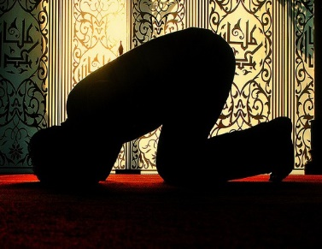



The fourth pillar of   
Islam is Sawm, the   
practice of fasting during the month of Ramadan. For many   
Muslims, it is the holiest month of the year, being a time dedicated to   
self-discipline and spiritual reflection. Ramadan holds a special place in   
the Muslim calendar, because it is believed to be the month in which the   
Prophet Muhammad received the first verses of the Qur’an, revealed to him by God. Fasting is the deliberate control of the body and Muslims are expected to refrain from eating, drinking (including water), smoking and sexual intercourse from dawn until dusk for the period of 29/30 days. They must also abstain from evil thoughts, harmful actions and unkind speech. **When to fast?** The beginning of Ramadan is marked by the appearance of the new (crescent) moon in the sky, signalling the start of a new month. It ends 29/30 days later with   
the beginning of the tenth month, Shawwal, heralding the start of celebrations   
for Id-ul-Fitr.According to the Qur’an, the fast must begin each day at first light   
and continue until dusk. At dawn, eating and drinking must cease at the   
moment when it becomes light enough to distinguish a black thread from a   
white one. Food and drink may only be consumed again at the end   
of the day, after dark.

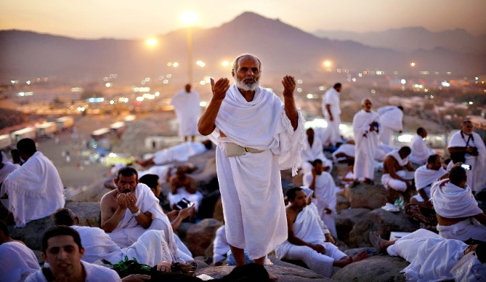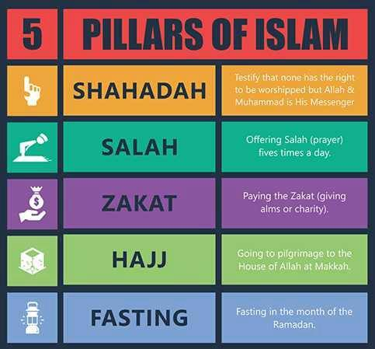

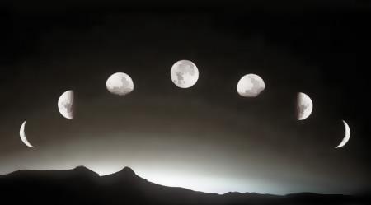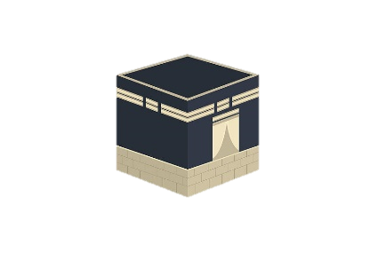

Beatrix Antiqua Regular

