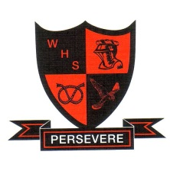
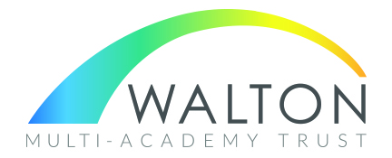
WALTON HIGH SCHOOL
The Rise, Walton on the Hill
STAFFORD, ST17 0LJ

Mixed 11 – 18 comprehensive with 1265 students on roll
including an Outstanding Post 16 of 200 students.

Examination Invigilators
Grade 2 - £11.79 per hour – Casual Contract

We are seeking to increase our team of casual exam invigilators to cover the
exam periods. The post is on a casual basis, invigilating GCSE and A levels and helping to support students through the provision, supervision and monitoring of internal and external
exams.

Duties will include issuing and retrieving examination papers, supervising candidates during school examinations at various times during the academic year, and responding to candidate’s queries. Mainly in May and June but also PPEs (Pre-Public examinations) in November, January, February and March.

Full training will be given.

The successful candidates should:

- Be flexible, highly organised, reliable and punctual with excellent attention to detail
- Must have good availability and commitment to support the exams department during the exam sessions
- Have excellent interpersonal skills and the ability to work in a team under the guidance of the Senior Exam Invigilator.

Experience of working in a high school would be an advantage.

Walton High School is an oversubscribed, high-achieving school. It is situated in a pleasant residential area on the edge of Cannock Chase and enjoys an excellent reputation.

Please see school website at www.waltonstaffs.com for application form and further details.

Previous applicants need not apply.

Closing date for applications: 3.30 pm on Friday, 1st November 2024.

Interviews to be held week commencing 4th November 2024.

This position is subject to an Enhanced Disclosure check under the Rehabilitation of Offenders Act 1974. Further details regarding this check are available from school or by visiting https://disclosure.capitarvs.co.uk/stoke
This school is committed to safeguarding and promoting the welfare of children and young people/vulnerable adults and expect all staff and volunteers to share this commitment.

In line with KCSIE 2023 and safer recruitment practices, the school will conduct an online search on all shortlisted candidates. This will be carried out before the interview which may identify any incidents or issues that have happened, and are publicly available on line, which we might want to explore with you at interview.

