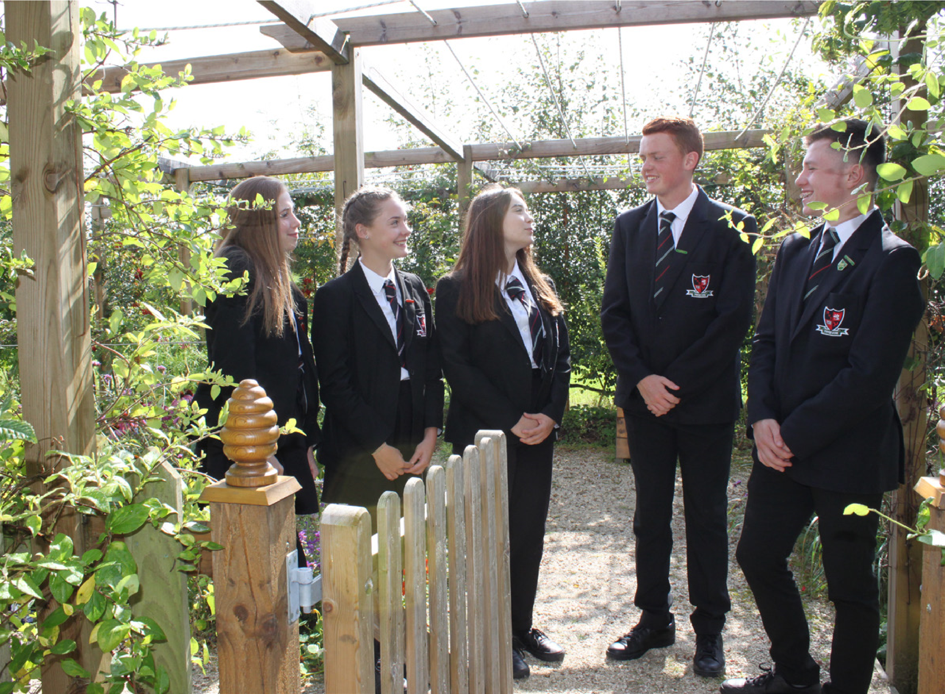


Teacher of Science
Chemistry Specialist
(Maternity Cover)
Application Pack


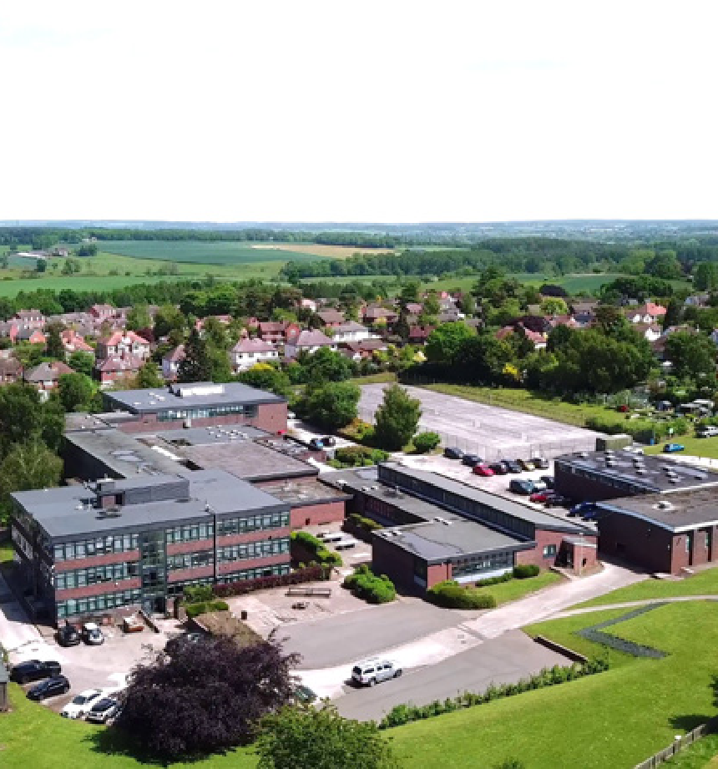
Contents
Welcome from the Headteacher 3
Welcome from the CEO 4
Introduction 5
About the School 6
School Aims 7
Teaching and Learning at Walton High 8
Key Information 17
What OFSTED say about our School 18
Job Description 19
Person Specification 21
Department Information 22 & 23
How to Apply 24


Welcome from the Headteacher
Mr Andy Leese
Headteacher
Dear Applicant
Thank you for expressing your interest in this exciting opportunity. I
am pleased to present this application pack which, I hope, will help
you to build a picture of our school.
Walton High School opened in 1967 and serves the south-eastern
area of Stafford. It is a school that prides itself on providing its
students with a caring environment in which they are keen to
learn. Parents are supportive of the school and rightly expect high
standards at all times.
The school continually achieves high academic results as well as a
variety of other successes. This is a reflection of the efforts of a hard-
working, talented staff who always strive to improve achievements
across all key stages.
If you feel you have the qualities we are looking for and are the right person to work at the school, we would be delighted to receive your application.

Welcome from the CEO
Walton Multi-Academy Trust is committed to the delivery of quality education for all children in our academies. The Trust’s prime responsibility is to set the vision, promote the ethos and develop the culture of our academies and we aim to ensure that each academy fulfils that vision.

We are determined to develop effective partnerships between our academies and to serve our local communities whilst encouraging each academy to retain and develop its unique character and identity. We are excited by the financial and practical benefits of a successful multi-academy trust and we intend for each of our academies to become financially stable and then financially secure.
We are very proud of our academies and of our leaders, governors, teachers, support staff and students. We are currently a small MAT of just two secondary schools (Walton High School and King Edward VI High School) and whilst we have ambitions to grow further, we are determined to retain the supportive culture which we hope we have established.

This is a really exciting time in the development of Walton Multi-Academy Trust and I am looking forward to working productively with you if you share our ambition, drive, ethos and commitment.

Neil Finlay, Chief Executive Officer

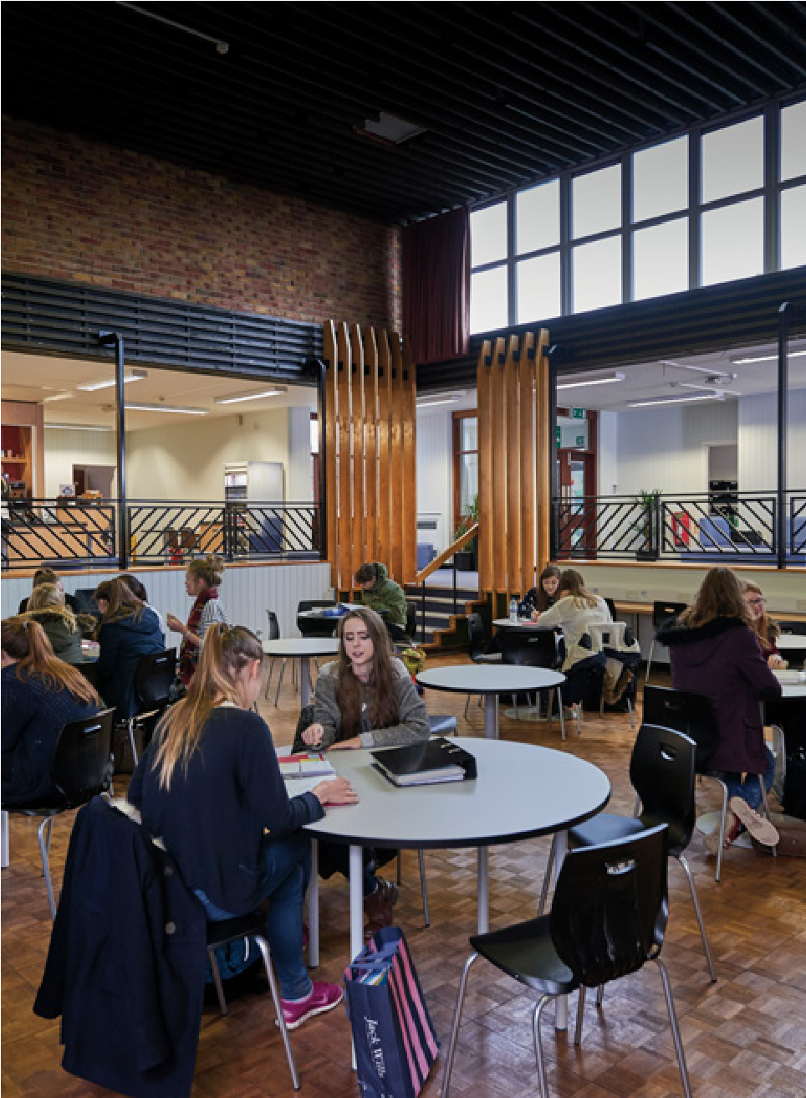
Introduction
Walton High School opened in 1967 and serves the south-eastern area of Stafford. It is a school that prides itself on providing its students with a caring environment in which they are keen to learn. Parents are supportive of the school but rightly always expect exacting standards. The school nestles on the northern boundary of Cannock Chase, an area of Outstanding Natural Beauty and the catchment is blessed with many desirable residencies. The school intake, while comprehensive in profile, certainly leans towards higher prior attainment. Most of our students either walk or cycle to school. Since the 1960s, the school has been served by only six substantive headteachers. This continuity has always been a feature of Walton’s culture. Additionally, Walton’s feeder schools are of an extremely high quality. The school has a PAN of 210 but we are regularly oversubscribed as we are in the current Year 7 and as we will be again in September 2024.
Because pupils like and trust their teachers,
they are confident in answering questions and attempting difficult tasks.
- OFSTED, 2019
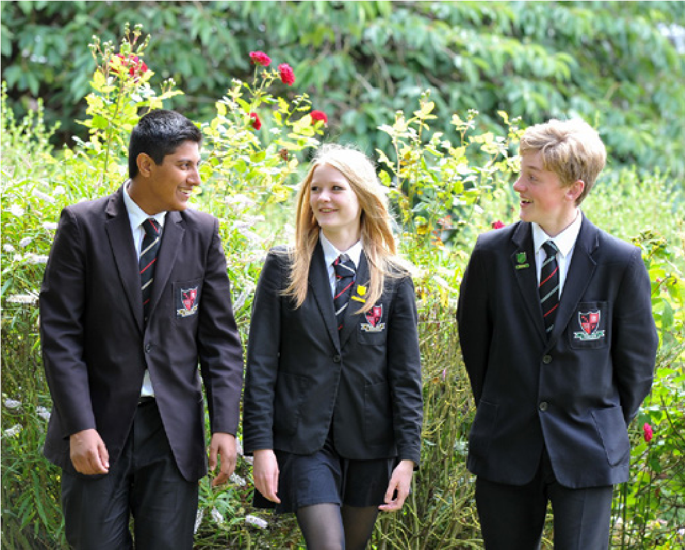

We have re-established our two-year Key stage 4 curriculum and a significant amount of work will be ongoing in departments. Walton is outward facing, having strong links with external partners in teacher training. Evidence informed practice is a hallmark of the school approach to improvement, particularly in teaching and learning. As a result of this practice, the school continually achieves high academic results as well as a variety of other successes. This reflects the efforts of a hardworking and talented staff who always strive to improve achievements across all key stages.


About our school
Walton High School prides itself on its high quality, supportive staff. We attract talented subject specialist teaching staff to interviews and we are able to retain staff once they join us. We believe this is because we provide a stimulating and rewarding environment to work in. We root all our decisions in evidence-based research, from teaching and learning, to behaviour and staff CPD. We also believe that our staff deserve a good work-life balance, so we have worked hard to remove unnecessary tasks from teachers and ask that they focus only on the things that research has shown make a real impact on learning.
The best thing about
our school is the quality of teaching.
- Student
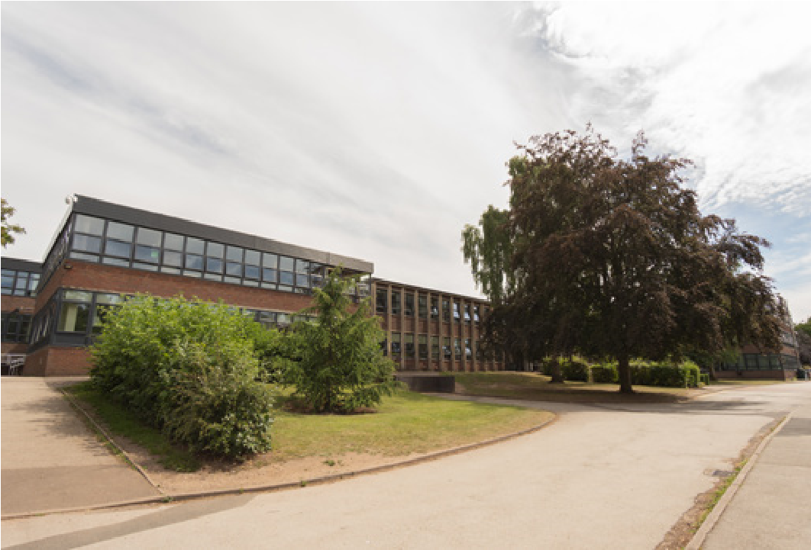
Walton is known for aiming high with its curriculum and academic experiences and we pride ourselves on the examination successes of our students. We do, however, invest heavily in the wider experiences of our students. We promote and support the wider curriculum in the areas of sports, arts, music, drama and theatre, gardening, knitting, STEM and DofE, to name but a few, and large numbers of our students are regularly involved. Walton is a school where extracurricular activities are seen positively by all sorts of students and We feel it is vital that we promote and participation rates are high.
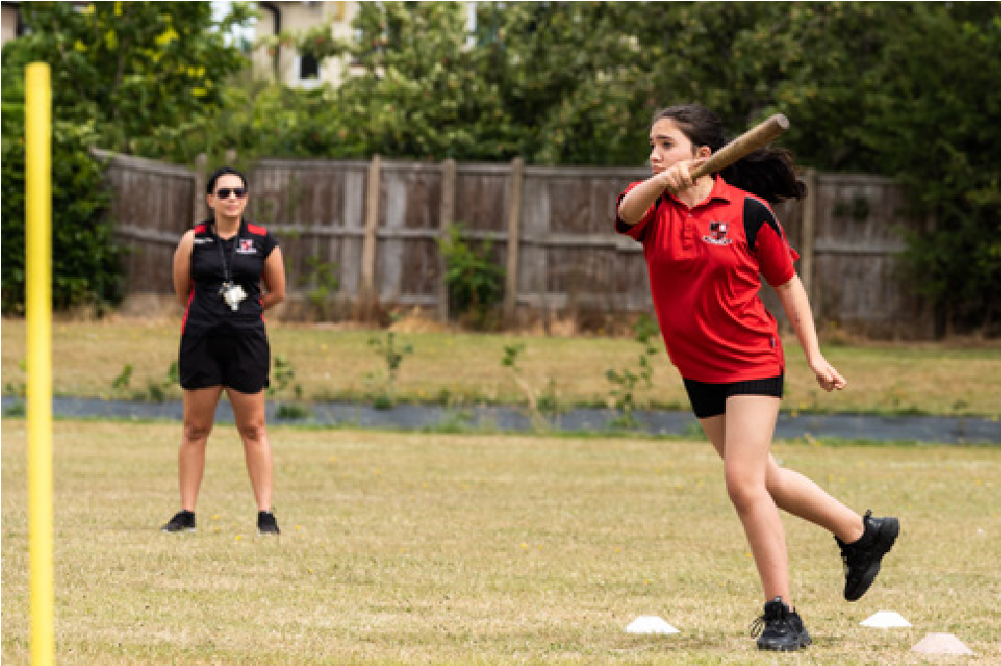
We feel it is vital to promote and sustain a collaborative style of working with outside agencies. Whether this is local primary and secondary schools, teaching school hubs or ITT providers, we believe it is important to work with everyone for the benefit of everyone. We also encourage our staff to pursue further qualifications such as NPQs or work with other agencies such as ITT providers so that they deepen and broaden their experiences, skills and knowledge.
School Aims
- To enable every individual to fulfil their potential

- To educate the whole student by fostering an ethos where academic success and the development of personal skills and attributes are equally important

- To create an environment that promotes mutual respect between staff and students

- To encourage creativity, flair, imagination and enthusiasm in our students

- To equip our students with the knowledge, skills and personal qualities that will best prepare them for their future lives
- To sustain a partnership with parents and the local community through effective communication to support our students
The school has a heavily invested Teaching and Learning Responsibility structure. Walton High School is one of two schools in the Walton Multi-Academy Trust. The other school is King Edward VI High School which is also located in Stafford. The CEO of the Trust is Neil Finlay, a former Headteacher at Walton.
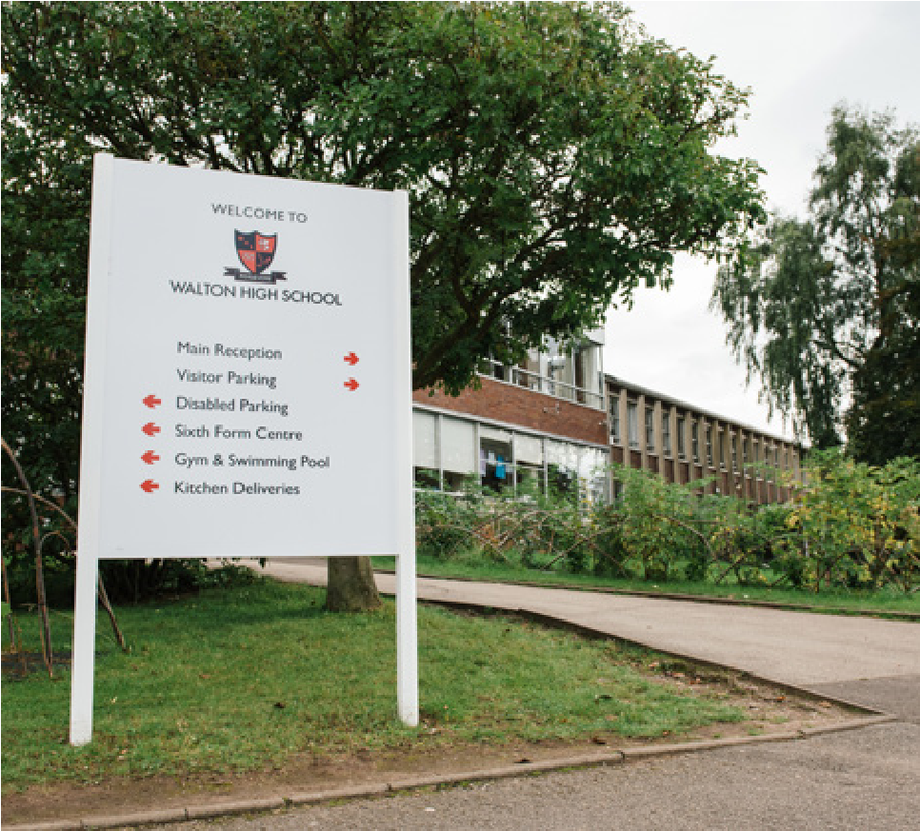
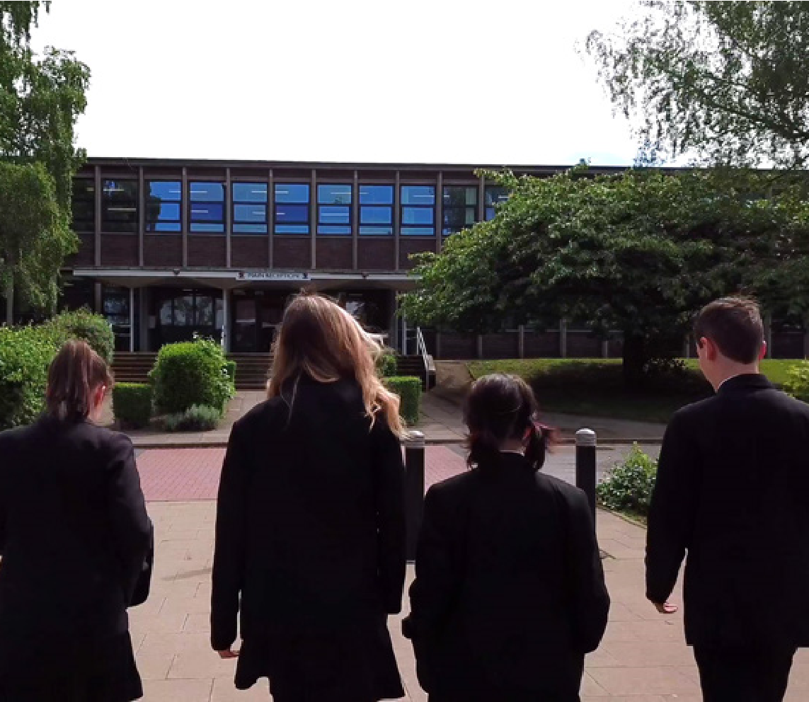
The school's estate is serviceable, but
the spine of the school is showing its age
after more than fifty years of operation.
In recent years CIF funding has led to
the refurbishment of several of our roofs,
a new central heating system and the
installation of LED lighting. Lettings include
the swimming pool and school hall for
Stagecoach, a local theatre company.
The school has an antiquated 1960s
gymnasium and does not have a modern
sports hall which brings several limitations;
however, the estate does possess around
25
acres of playing fields. These have
been extensively planted with trees by our
students over the years as a contribution to
making the school more sustainable.
We feel safe in school.
-
Student

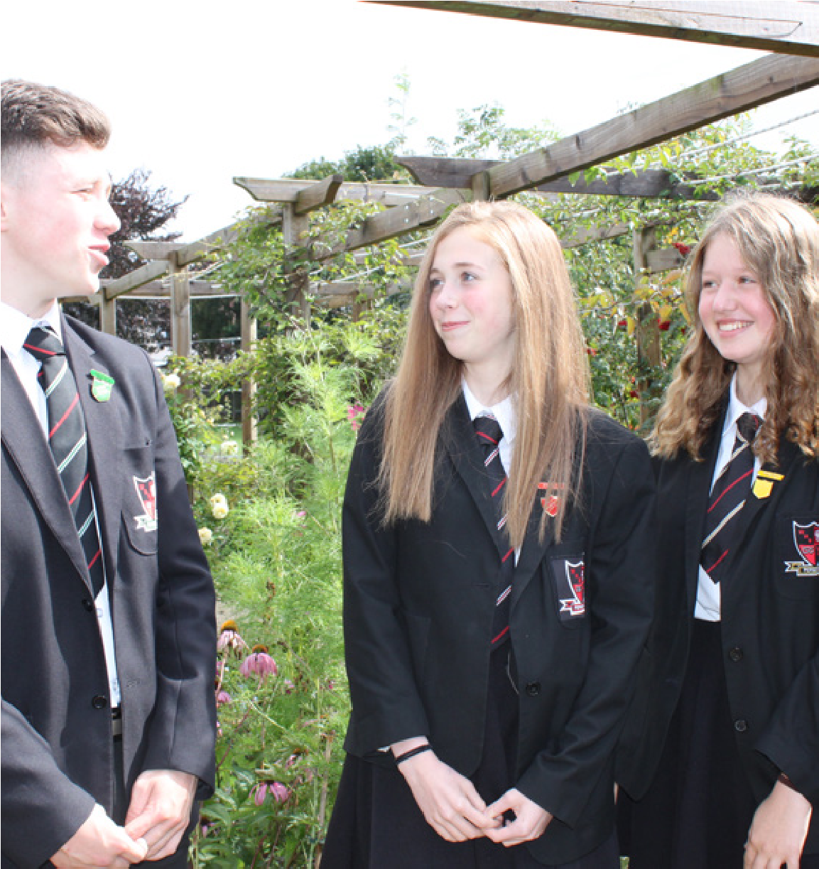
Teaching & Learning at Walton High

We are ‘evidence-informed’ in our approach’ to teaching and learning. This means that we are aware of, and utilising regularly, strategies with research has shown to have the biggest positive impacts on students’ learning and progress.

Below, we outline the main areas of our evidence-informed teaching and learning and the strategies within each area that teachers will be using.

The study facilities are
calm and productive which is important preparation for adult independence.
- Student
NB; we do not have a ‘one size fits all’ approach to teaching and learning. In other words, we do not expect all teachers across all subjects to teach lessons in exactly the same way. Teachers are the experts in their subject area and we ask departments to implement each strategy in a way which is most appropriate to their subject.

Positive Classroom Culture
Routines
- Routines make managing behaviour easier for classroom teachers.
- They should include routines for entry to lessons, beginning lessons, transitions between tasks and the end of lessons.
- Routines should be explicitly taught and rehearsed.

Teaching & Learning Framework

- Positive classroom culture
- Explicit instruction
- Managing cognitive load
- Questioning and checking for understanding
- Challenge
- Literacy
- Retrieval practice and spaced practice

Positive and preventative behaviour management
The focus of classroom management should be to reinforce positive behaviour and relationships and prevent negative behaviour. Techniques should include:
- Threshold - Meet your students at the door. Greet them positively and remind them of your expectations (enter quietly, equipment on desk, start work immediately).
- Means of participation - Explain exactly how you want pupils to complete a task/activity. This should include front-loading – giving behavioural instructions at the start of your instruction/request.
- Brighten lines - Make instructions very specific and clear, including clear time limits. Give the instructions once, then twice and ask students to repeat the instructions back to you. Ask if there is anyone who is still not clear about the task.
- Narrate the positive – To normalise the positive/expected behaviour, it needs to be heard constantly. This is instead of addressing those pupils who have not followed instructions.
- Pastore’s perch - This is a position in your room where all students will be in your field of view. After giving instructions, move to Pastore’s Perch to scan the room, checking all pupils are on task. Smile, nod, be seen looking and use non-verbal interventions if needed.
- Be seen looking - Making it obvious that you are looking around the room. Deliberately move your head around, raise your chin, swivel your head, stand on tip toes – make it clear you are scanning the room.
- 3:30:30 - For independent tasks, to ensure all pupils settle on the task. Step 1 - Go to Pastore’s Perch and stand and watch the class for 3 minutes – be seen looking and using least invasive intervention as required. Step 2 - Following the three minutes, start circulating the room. Interact with individual students who need support for 30 seconds. Step 3 - Stop and scan the room again for 30 seconds, before engaging with other students for 30 seconds again.
- Least invasive intervention - Rather than drawing attention to non-compliance and challenging in front of the whole class, take the least invasive intervention to correct behaviour. Examples include:
- Proximity - Use your own proximity to the pupil to redirect their attention.
- Gestures – raised eyebrows, hand signal, eye contact, tapping desk, etc.
- Positive group correction - a reminder to the whole class of the required behaviour (not the unwanted behaviour, e.g. “I need everyone listening”, “Everybody should have their pens down and eyes to me”.
- Anonymous individual correction – state that there are people not giving the correct behaviour but leave these students anonymous. For example, “listen and look at me please, we are just waiting for a couple of people”.
- Private individual correction – speak to individuals privately – in a low voice, next to them and if possible when other students are completing work.
Explicit Instruction
Explicit instruction is teacher led and fully guided.

Excellent subject knowledge  Explicit instruction requires teachers to have excellent subject knowledge.  Chunking  - Present new information in small steps/chunks.  - Practice/cementing knowledge/checking for understanding between each chunk.  Teacher-led clear and concise explanations  - Clear and concise.  - Including examples, non-examples and worked examples.  - Throughout explanations, use questioning to check attention and understanding.  - This may include explanations of new content and skills.  - This may include verbal explanations, reading or use of other sources such as videos.  Modelling  - Modelling is used when pupils are learning how to complete a complex task. It shows pupils the meaning of success criteria and how to achieve them.  - This may include teacher-led modelling, completing a model as a class with pupil involvement, or the deconstruction of exemplars. |  |  |  |  |  |  | Scaffolding  Scaffolds should be provided to ensure pupils are able to succeed. This may include:  - Teacher-led practice with questioning, discussion and support  - Verbal prompts and reminders  - Partially-completed questions or tasks  - Sentence starters or other writing aids  - Written checklists or step-by-step lists for completing the task  Practice  - Initial practice should be fully guided.  - Guidance-fading - As pupils progress through practice, this guidance should be reduced.  - Extensive independent practice should then be used to ensure success and automaticity.  Immediate feedback should be given on practice, including independent practice.
Managing Cognitive Load
Managing cognitive load helps to ensure that pupils’ limited working memories are not overloaded and that new content can be transferred to the long-term memory (learning!).
The Worked Example Effect  - Worked examples are more effective for learning new content than pupils completing tasks themselves.  Impact - move from fully completed worked examples to partially competed, to independent, to spotting and fixing errors.  The Modality Effect  - The working memory is made up of an auditory that deals with language processing including both spoken language and written text, and a visual that processes images.  - We can increase the capacity of the working memory, allowing learners to process more information without cognitive overload, by using both of these channels and presenting information in both visual and auditory formats.  Impact – Use images with spoken explanations when introducing new content (where appropriate).  The Redundancy Effect  - Redundant information will not benefit learning and so creates extraneous cognitive load. Therefore, it should be removed.  Impacts:  - Remove written text from diagrams where only the diagram is needed.  - Remove additional content that detracts from the to-be-learned material from initial explanations.  - Remove redundant information from resources/presentations. |  |  | The Split-Attention Effect  • Split attention occurs when learners have to split their attention between multiple sources of information, creating extraneous load.  Impacts:  - Ensure that all diagrams and labels are integrated.  - Integrate worked examples/models into resources.  - Allows pupils to read text themselves before offering a verbal explanation.  The Expertise-Reversal Effect  • Strategies that reduce cognitive load for novices become ineffective or can have a negative impact on learning for more expert learners.  Impacts:  - Do not provide scaffolds such as worked examples, additional guidance, etc.  - Chunking is no longer required – pupils can look at the topic as a whole.  - Use minimally guided instruction and problem-solving.
Questioning and Checking for Understanding
Wait Time  - Give pupils time after asking a question to think of an answer.  - Can be done by answering questions individually first or during a class discussion.  - 3-5 seconds after asking a factual question, longer for more complex questions.  - Improves the number of pupils willing to answer, confidence, quality of responses, reduces failures to give an answer.  Cold calling  - The teacher selects a pupil to respond to the question they have asked, calling on all pupils regardless of whether they have raised their hands.  - Say the chosen pupil’s name at the END of the question.  Reject Self-Report  - Pupils are not likely to accurately report their own understanding accurately.  - Do not ask pupils to self-report their understanding (“Does everyone understand? Thumbs up or thumbs down, etc.)  - Ask questions instead!  Whole-Class Response Systems  - Any strategy that allows teachers to assess the learning of all pupils at one time – mini white boards, hand signals, MCQs and letter cards. |  |  |  | - Hand the boards, pens and rubbers out as pupils enter the room or leave them on desks, ready to use at any time.  - Count down and then ask pupils to turn their boards over. This prevents pupils copying the answer from a peer.  - Allow pupils to write a question mark if they do not know the answer. This allows you to address what they do and don’t know.  - Address incorrect answers, misconceptions and common errors.  - Ask pupils to elaborate on/explain their answers.  Paired/small group discussions  - Encourage students to better formulate their thoughts by including short, contained pair discussions.  - Make it obvious/clearly instruct pupils on who they are working with.  - Use a cue to get pupils to start talking immediately. This can be a simple “go” or you can tell pupils which partner should be starting the discussion (e.g. pupils on the right hand share your ideas first). Use the same cue each time.  - Ensure that you inform pupils of the allocated time at the start of the discussion.  - Ask pupils to use the discussion to produce individual work – a summary of their partner’s main points, notes on the main answers they agreed on, etc.  - Check the ideas and understanding discussed in the turn and talk by following it with a further task/whole-class discussion.
Challenge |  |  |  |  |  |  | Literacy
- Challenging material  - Challenging tasks/activities – that make pupils think hard about the content.  - Sharing excellence – models, displays, exemplars  - Extension tasks  - Direct challenge – questioning/feedback from live marking to improve work  - Academic reading  - Oracy –have high expectations for pupils’ verbal response/contributions including the use of Tier 2 and Tier 3 vocabulary, correctness of responses (do not accept a partially correct answer, ask pupils to improve their answer), and the depth of responses.  - Challenging questioning – cold call, wait time, higher cognitive questions, no opt out.  - Ratio – strategies that ensure all pupils are involved and doing the cognitive work such as cold calling, everybody writes, whole-class response systems.  - Have high expectations for ALL pupils:  - Demand high standards of work and behaviour from all pupils.  - This is especially important for those sub-groups with negative stereotypes.  - It is important to avoid conveying low expectations indirectly, for example through praising poor work, avoiding asking challenging questions or giving too much help to pupils when they are completing tasks. |  |  |  |  |  | Vocabulary Instruction  - Every subject should provide vocabulary instruction for both Tier 2 and Tier 3 vocabulary.  - This may include:  - Explicit vocabulary instruction when reading.  - Frayer model - when introducing the new word, you look the definition, characteristics, examples and non-examples.  - Keyword spotlight - pupils put the word under a ‘spotlight’ by giving the definition, using the word in a sentence, drawing an image to represent the word and identifying connected words.  - Include vocabulary in retrieval practice.  - Reading  - All subjects, year groups and classes should read academic texts in lessons and as part of homework.  - Guided reading.  Explicit instruction for written tasks  - Modelling  - Shared-writing  - Deconstruction  - Part-completion tasks  - Scaffolding for written tasks  Guidance-fading
Retrieval Practice and Spaced Practice
Retrieval practice involves pupils retrieving previously learnt material from their long-term memory. The qualities of the most effective retrieval practice are as follows:
- Be supported by corrective feedback - Providing corrective feedback has been shown to overcome the limited impact of unsuccessful retrieval and increase the learning gains experienced by pupils. This is because it helps to cement correct responses and prevent errors or misconceptions going unaddressed. Therefore, feedback should always be given.

- Be ‘spaced’ from initial learning and repeated multiple times for the same content, again with ‘gaps’ in between each retrieval. This is because retrieving content after some forgetting increases the storage strength of this memory in the future. Multiple tests increase long-term recall and reduce forgetting more than just one test. This requires a retrieval practice curriculum where the retrieval is planned over time.

- Include both factual and higher-order questions and tasks. It may be beneficial to use factual questions during earlier retrieval practice and higher-order questions at a later time when pupils’ knowledge is more secure. Alternatively, both factual and higher-order questions can be used in the same retrieval task, with factual questions being used initially, leading up to high-order questions.
- Match the format of the final assessment (eventually) - The gains from retrieval practice are likely to be larger if there is a close match between the format of the retrieval practice and the final test.

- Completed from memory. This is because retrieval practice is effective as it allows pupils to retrieve information from the long-term memory and bring it back into the working memory, increasing future retention. This means pupils should complete any retrieval task from memory before notes are then used to check and correct their own work.
- Involve all pupils – This ensures that all pupils benefit from the retrieval practice. All pupils should therefore complete retrieval practice individually before paired/class discussions.
- Low stakes – This means that scores are not asked for/recorded in any way. It helps to reduce anxiety around testing or retrieval practice.
- Allow pupils to be successful – for pupils to benefit from the testing effect they need to be able to retrieve at least some of the content from their long-term memory. This can be achieved by providing initial scaffolds (see below) or not leaving too much time between initial learning and subsequent retrieval episodes.
- Provide scaffolding if required – This may include a larger number of prompts or closed questions. This enables pupils to retrieve the content.
- Be adequately challenging – However, if retrieval is too easy and too many hints are given, pupils will not benefit from the testing effect. This means that you should not give too many hints and that any prompts should be removed over time.

Spacing
- Spacing involves spreading learning opportunities out over time so that learning is revisited and not crammed all at once.
- Strategies for spacing include:
- Revisiting prerequisite prior learning before introducing new content.
- Spaced homework which covers a topic taught previously. This could be retrieval practice or any activity that requires pupils to use their prior learning (not necessarily from memory).
- Spaced retrieval practice.
- Review lessons where previous topics are re-taught.

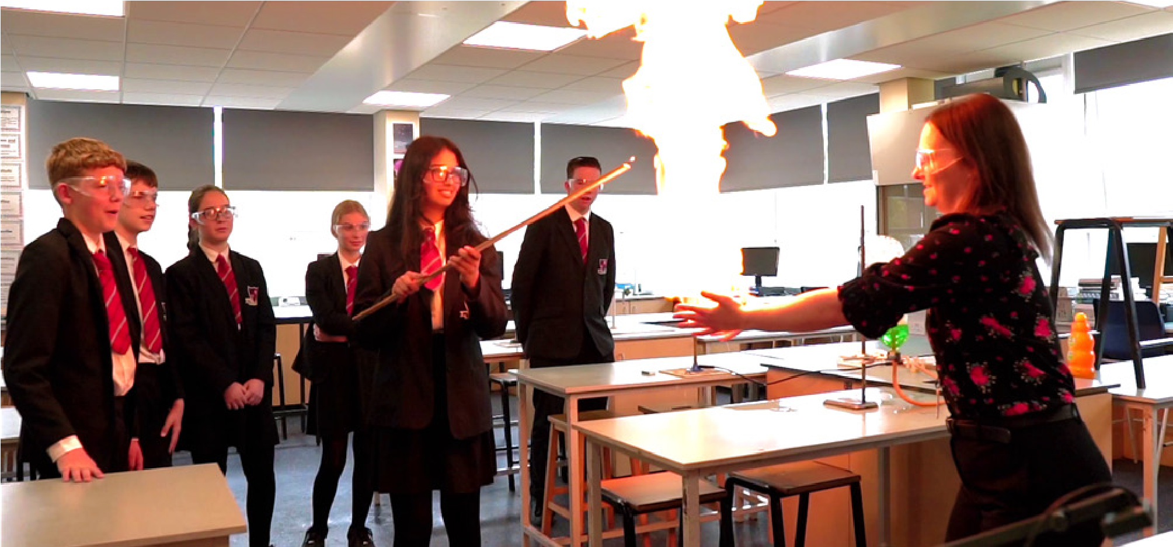
Feedback
The qualities of effective feedback include:
- Being focused on a specific task pupils have completed
- Timely
- Helps pupils to improve their performance and learning
- Is acted on by pupils
- Focus on formative feedback rather than marks/grades
Effective feedback may include:
- Provide structure/scaffolding before pupils complete tasks. – This ensures that all pupils are able to complete tasks to a high standard. This may include sentence starters or other writing aids, checklists or step-by-step lists for completing the task.
- Live modelling - This may include teacher-led modelling, completing a model as a class with pupil involvement or the deconstruction of exemplars.
- Live marking - As pupils complete work the teacher views individual work and points out strong elements, recommends an improvement or highlights an error. Pupils then improve their work immediately.
- Live whole class feedback – This may include using a visualiser to review a pupil’s work as a class, identifying good elements and areas to improve. It may also include giving feedback on common areas of weakness or misconceptions. Again, pupils should then use this immediately to improve their own work.
- Self-assessment – Pupils can be asked to assess their own work. This should be supported by guidance such as checklists or success criteria.
- Whole-class verbal feedback:
Step 1 - The teacher collects in and reads pupils’ work, noting down common misconceptions, common SPAG errors, main areas to improve, the main things pupils are doing well and any good examples of work to share with the class. This can be rough notes or you can use a whole-class verbal feedback sheet.
Step 2 – In the next lesson the teacher shares this information with the class. This could be through a PowerPoint slide, typed notes or verbally sharing your written notes. You should also share examples of good work through a visualiser, to show pupils how to improve their own work. Pupils should then improve their work.
Written marking – You may deem it important to provide written comments on selected pieces of work. Here, marking codes are effective - teachers use codes to mark pupils’ work. These are shared with pupils and pupils make corrections or improvements using the codes as prompts.

Key information

Status | Member of Walton Multi-Academy Trust
Last Ofsted | May 2019
Ofsted Judgement | Good
Published Admission Number | 210, arranged in 7 forms
Type of School | Secondary, mixed
Year School established | 1967
Age Range | 11 – 18
Number of Students on Roll | 1,265
Number of Students in Sixth Form | 210
% of SEND Students | 9.3% (125 students)
% of EAL Students | 4% (57 students)
% FSM Students | 6% (84 students)
% of Pupil Premium Students | 6.6% (89 students)
Link to exam results | Latest GCSE Results Latest A Level Results
School website | www.waltonstaffs.com

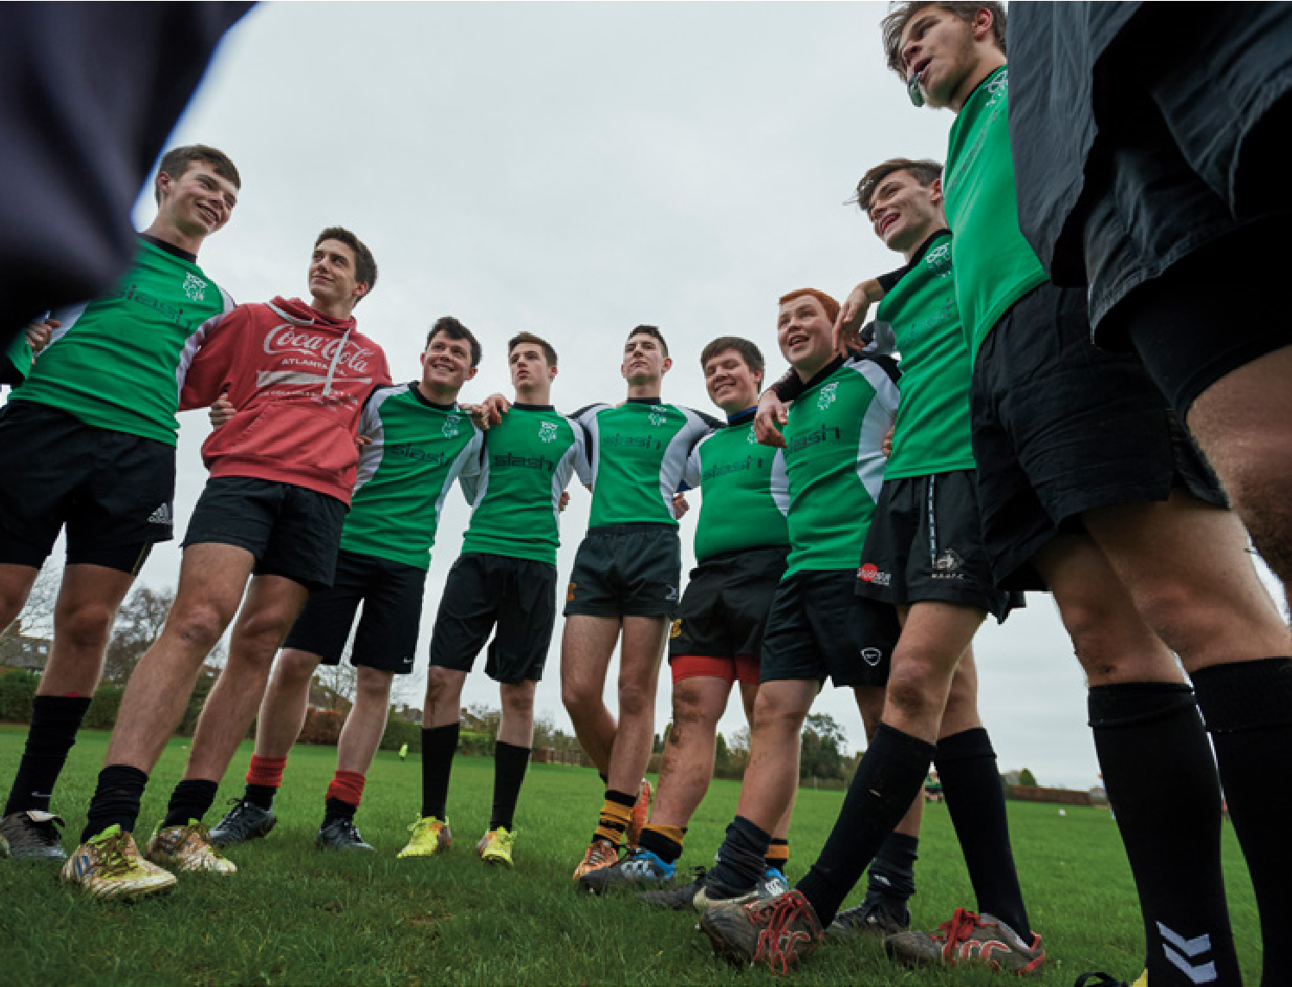
Walton Sixth Form is unbeatable because
of the wide range of subjects to choose from and staff you can talk to.

- Student


We really enjoy the
opportunities to get involved in trips, sports and activities.
- Student

What OFSTED say about the school
"The school’s stated aims are to ensure that pupils achieve well academically and develop the skills and attitudes
to be happy and successful members of society. The school is successful in achieving these aims." - OFSTED 2019
"The curriculum provides a very wide range of choices for pupils that successfully engages them in their learning. It is supplemented by a vibrant extra-curricular programme that pupils enjoy." - OFSTED 2019
"Pastoral care and support are strengths of the school. Staff know pupils well and are quick to provide support when it is needed. Pupils and parents value the school’s caring and supportive ethos" - OFSTED 2019
"Pupils trust the school’s staff and have confidence in them to deal with any problems, including bullying, when they arise." - OFSTED 2019

Teacher of Science (Chemistry)

Maternity Cover - Job Description

Date: | 20 January 2025
Title: | Teacher of Science (Chemistry)  (Maternity Cover)
Responsible to: | Headteacher
Line Manager: | Member of Leadership Group
Accountable for: | Students in class

DUTIES AND RESPONSIBILITIES:

- Teaching:
- Having regard to the curriculum for the school, and with a view to promoting the development of the abilities and aptitudes of the students in any class or group assigned
- Planning and preparing courses and lessons
- Teaching, according to their educational needs, the students assigned including the setting and marking of work to be carried out by the student in school and elsewhere
- Assessing, recording and reporting on the development, progress and attainment of students

- Other activities:
- Promoting the general progress and well-being of individual students and of any class or group of students assigned
- Providing guidance and advice to students on educational and social matters and on their further education and future careers, including information about sources of more expert advice on specific questions; making relevant records and reports
- Making records of and reports on the personal and social needs of students
- Communicating and consulting with the parents of students
- Communicating and co-operating with persons or bodies outside the school; and
- Participating in meetings arranged for any of the purposes described above

- Assessments and reports
- Providing or contributing to oral and written assessments, reports and references relating to individual students and groups of students

- Performance management
- Participating in arrangements made in accordance with regulations made under section 131 of the Act for the appraisal of performance and that of other teachers

- Review, induction, further training and development
- Reviewing from time to time methods of teaching and programmes of work
- Participating in arrangements for further training and professional development as a teacher including undertaking training and professional development which aim to meet needs identified in appraisal objectives or in appraisal statements
- In the case of a teacher serving an induction period pursuant to the Induction Regulations, participation in arrangements for supervision and training

- Educational methods
- Advising and co-operating with the headteacher and other teachers (or any one or more of them) on the preparation and development of courses of study, teaching materials, methods of teaching and assessment and pastoral arrangements

- Discipline, health and safety
- Maintaining good order and discipline among the students and safeguarding their health and safety both when they are authorised to be on the school premises and when they are engaged in authorised school activities elsewhere

- Staff meetings
- Participating in meetings at the school which relate to the curriculum for the school or the administration or organisation of the school, including pastoral arrangements

- Rarely cover
- Supervising and so far as practicable teaching any students whose teacher is not available to teach them as part of the rarely cover arrangements

- External examinations:
- Participating in arrangements for preparing students for external examinations, assessing students for the purpose of such examinations and recording and reporting such assessments; and participating in arrangements for students’ presentation for, and conducting, such examinations; but not routinely invigilating

- Administration
- Attending assemblies, registering the attendance of students and supervising students, whether these duties are to be performed before, during or after school sessions

Person Specification

Attributes | Essential | Desirable | Evidence
Education and qualification | - Science graduate  - Qualified teacher status  - Qualified to teach Chemistry at KS3, KS4 and KS5. | - The ability to teach Chemistry to A Level. | Application  form
Experience | - Successful teaching experience of Science at KS3, KS4 and KS5. | - Some experience of form tutor/PSHE work  - Experience of teaching A Level Chemistry. | Application form  Letter  References
Skills and abilities | - Knowledge of current National Curriculum programmes of study.  - Good oral and written communication skills.  - Good subject knowledge and sound classroom management, along with first rate organisation and time management skills are essential.  - Evidence of the ability to develop good working relationships with students.  - ICT skills.  - Ability to plan effective lessons and contribute to departmental planning.  - Ability to mark work giving appropriate feedback.  - To demonstrate excellent teaching and be committed to supporting high levels of student attainment.  - A knowledge of current research-informed practice. |  | Letter  References  Observed lesson  Interview  Written task
Motivation and personality | - Positive enthusiastic outlook.  - Able to work as a member of the departmental team and to be an active participant in the whole staff community.  - In tune with aims and values of Walton High School.  - Receptive to new ideas and able to generate them. | Willing to extend own skills/knowledge through further professional development.  Interest in developing extra- curricular activities with students. | Letter  References  Interview
Circumstances and health | - Good record of attendance and punctuality.  - Available January 2025 subject to routine health and protection of children checks.  - This school is committed to safeguarding and promoting the welfare of children and young people/vulnerable adults and expect all staff and volunteers to share this commitment.  - The interview will be used to assess your suitability to work with children and will include questions relating to safeguarding and promoting the welfare of children. |  | References
- Education and qualification | - Science graduate  - Qualified teacher status  - Qualified to teach Chemistry at KS3, KS4 and KS5. | The ability to teach Chemistry to A Level. | Application form

Science Department

Current Department Structure

Background Information
We are a large, vibrant and forward-thinking department consisting of 15 teaching staff and 2 technicians. We believe the quality of our teaching and learning in Science to be outstanding. The science department places evidence-informed practice at the heart of our teaching and learning strategy, such as the use of explicit instruction, managing of cognitive load, questioning and retrieval practice. Exam results in 2021/22 were some of our best ever, with 83% of students achieving 4+ and 57.6% achieving 5+ in Combined Science, well above the JCQ national averages. Our department’s performance is further exemplified in our Triple Science cohort results, with 75.4% of students achieving grade 7+ in GCSE Biology and 98.5% achieving grade 5+ in GCSE Chemistry, again well above national JCQ figures.

Science is a highly popular subject and we offer a variety of Science courses at Walton High School to cater for all learners. We strive to ensure that teachers are teaching within their subject specialism at GCSE. We also offer GCSE Astronomy as an options subject. The uptake of Science courses at A level is always high and teachers always teach their subject specialism. We offer A levels in Biology, Chemistry, Physics, Psychology and a BTEC Level 3 in Forensic Science and Criminal Investigations.

Science Curriculum at Walton High School

Course | Allocated Time
KS3 Science | 4 periods per week  (taught as 2 doubles)
AQA GCSE Combined Science  (taught over years 10 and 11) | 6 periods per week  (taught as 3 doubles by subject specialist teachers)
AQA GCSE Triple Science  (taught to students in years 10 and 11) | 6 periods per week  (taught as 3 doubles by subject specialist teachers)
Edexcel GCSE Astronomy  (taught as an option subject in year 10 and 11) | 3 periods per week  (taught as a double and single by a subject specialist)
AQA A level Biology | 6 periods per week  (taught as 3 doubles by subject specialist teachers)
AQA A level Physics | 6 periods per week  (taught as 3 doubles by subject specialist teachers)
AQA A level Chemistry | 6 periods per week  (taught as 3 doubles by subject specialist teachers)
AQA A level Psychology | 6 periods per week  (taught as 3 doubles by subject specialist teachers)
BTEC Level 3 Forensic Science | 12 periods per week  (taught as 6 doubles)

How to apply
Thank you for your interest in our school. The Headteacher looks forward to receiving your application. Please complete all sections of the application form in full.
In addition to completing an application form you are requested to submit a supporting letter. Your letter should be no more than 2 sides of A4 in length. Please outline: Your personal philosophy of education and how your experience to date has enabled you to meet the requirements of the Person Specification.
Your completed application, including your letter, should be emailed to: recruitment@walton.staffs.sch.uk
The deadline for applications is 9am on Monday, 18th November 2024
Interview date to be confirmed.
References will be taken up prior to interview using the contact details you supply on your application form.
Shortlisting will take place and successful applicants will be informed as soon as is practicable.
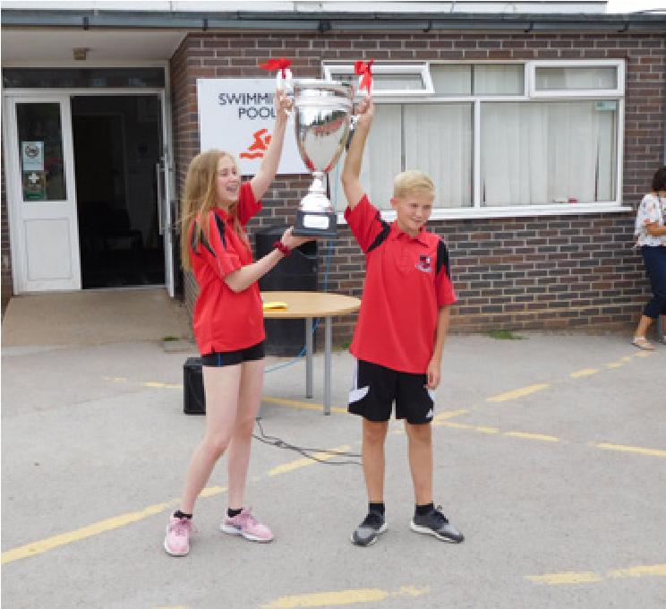
Further information about Walton High School can be found on the school website www.waltonstaffs.co.uk.

