Dear Parents/Carers

Please be aware of major changes within the Local Authority regarding attendance. From 19th August 2024 Staffordshire County Council have instructed schools to follow the below instructions. Please be aware they have made it compulsory to issue penalty notices, fines and court proceeding for late registration, absence leave and holiday leave. Please read the guidelines below:

The changes to the law are introduced through the Education (Penalty Notices) (England) (Amendment) Regulations 2024 and will come into effect from 19th August 2024. This means that any unauthorised leave taken after this date will be dealt with under the new Regulations, as follows:

**New two penalty notice limit in a three-year period**

The three-year rolling period starts for parents when the first penalty notice is issued to them after the

19th August 2024.

**First offence** – the first time a Penalty Notice is issued the amount will be £80.00 per parent, per child paid within 21 days. This increases to £160.00 per parent, per child if paid after day 21, until day 28th. Any non-payment of the Penalty Notice may be referred to the Magistrates Court.

**Second offence**: (within 3 years) – the second time a Penalty Notice is issued the amount will be £160.00 per parent, per child paid within 28 days. Any non-payment of the Penalty Notice may be referred to the Magistrates Court.

**Third offence** and Any Further Offences (within 3 years) – the third time an offence is committed a Penalty Notice will not be issued, and the case may be presented straight to the Magistrates’ Court under s.444 of the Education Act (1996) or other legal interventions considered. The Magistrates’ Court can order fines up to £2500.00 per parent, per child.

**National threshold for issuing penalty notices.**

You may have heard about the new national threshold for issuing penalty notices which has been set at 10 sessions (5 school days) of unauthorised absence in a rolling period of 10 school weeks. However, if in an individual case the local authority believes a penalty notice would be appropriate, they retain the discretion to issue one before the threshold is met. For example – where parents are deliberately avoiding the national threshold by taking several term time holidays below threshold, or for repeated absence for birthdays or other family events. Please be aware that headteacher can only permit leave that is deemed as exceptional – this does not include holidays.

**Impact of absence – Make every day count**

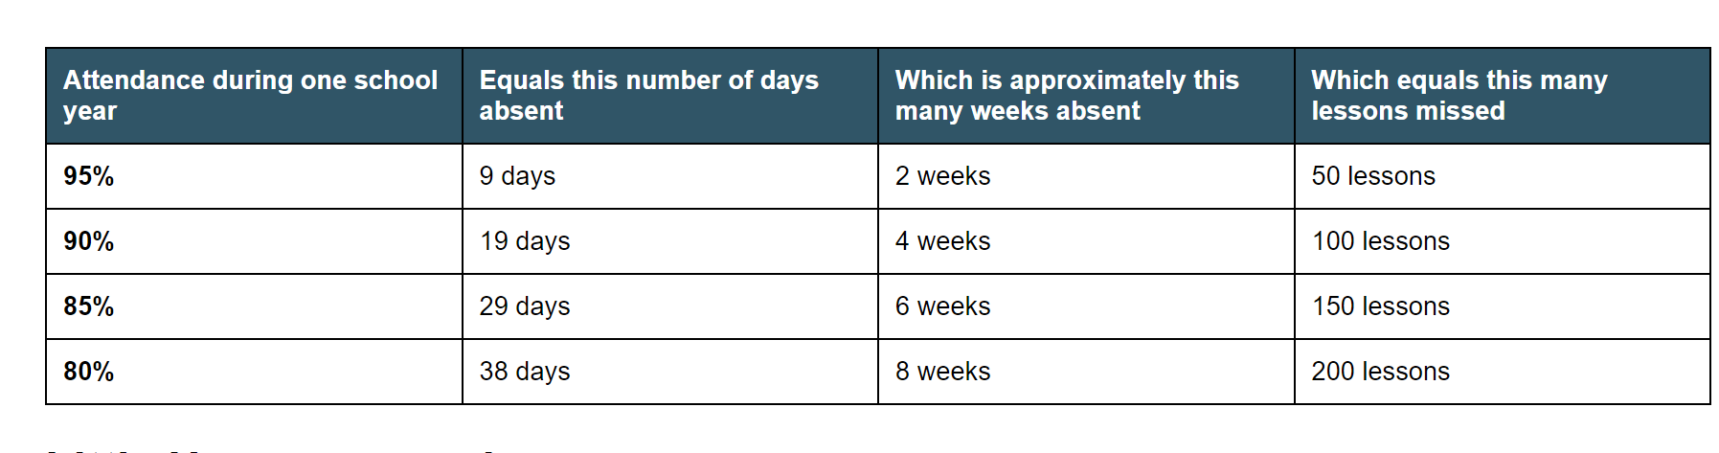Regularly being absent from school can lead to a significant loss of learning opportunities, potentially putting your child at a disadvantage later in life.

**Requests for leave in exceptional circumstances**

Statutory guidelines state: “Headteachers may not grant leave of absence during term time unless there are exceptional circumstances”. Requests for leave, in exceptional circumstances, should be made in advance of the event and in writing. Specific details should be included such as dates, and should be addressed to Mr Leese, Headteacher. If a leave of absence is granted, then it will be for a fixed period of time.

Regulations are clear that any lateness in the return to school may be deemed as unauthorised leave of absence. If a parent does not apply for leave, but we believe that the pupil has been taken on holiday, then we will write to the parent to express our concern. The parent will be expected to provide contrary evidence to support the absence by a specified date. Should this not be provided then the absence will be coded as unauthorised leave of absence and the relevant procedures will be applied. Retrospective approval for absence cannot be granted. It is similarly required that requests are made in advance, and in writing to the Headteacher, for absences caused by other events, such as participation in sporting or other educational representative activities. Supporting documentation regarding this, such as a copy of the selection letter or confirmation of an exam date, will need to be provided.

**Medical Appointments**

Please be reminded that wherever possible, doctor and dental appointments should be made outside the school day. Should this not be possible, please call the school absence line and provide the school with a copy of medical evidence, such as the appointment card. If no evidence of the appointment is forthcoming, it may mean that the absence is recorded as unauthorised. The student should sign out at reception and must sign in when returning to school following the appointment.

It is recognised that parents work hard to ensure that their child/ children attend Walton High School on a regular basis, and we appreciate your support.

Yours faithfully,

**MRS A CASHMORE, ASSISTANT HEADTEACHER**

**MR A LEESE, HEADTEACHER**