Effective Revision Techniques
A Parent and Student Guide

HOW TO USE THIS BOOKLET

Dear parents, carers and students,
This booklet has been created so that we can work collectively to provide you with the best opportunities to prepare for your public examinations.
The exam period may seem like a long time away, but one of the most effective revision strategies is time – it has been proven that cramming information does not work in the long-term. Students will quickly forget information that has been crammed, the day or night before an examination. This technique can also lead to increased stress, which then leads to forgetting. We want to avoid this happening.
We have put this revision techniques booklet together as a guide for you and your parents. It outlines the most effective revision techniques that you can try over the next few months. Starting your revision early will lead to greater success in your examinations.
This booklet will work in tandem with a programme of support that will be provided during tutor time, where the techniques highlighted in this booklet will be explained and explored in more detail.
Good luck to you all over the coming weeks and months.
Kind regards,
Miss Riley
Acting Assistant Headteacher/Director of the Quality of Education

CONTENTS PAGE

- Making a revision timetable 4-6
- Your revision space 7
- Your memory 8
- Forgetting 9-10
- Least effective revision strategies 11-12
- Most effective revision strategies - Retrieval Practice 13-14
- Most effective revision strategies – Spacing 15
- Most effective revision strategies – Interleaving 16-17
- Using Flashcards effectively 18-19
- Summarising Information – Cornell Note Taking 20-21
- Online revision platforms 22
- Wellbeing during revision and exam time 23

MAKING A REVISION TIMETABLE

How do I start?
- Start by adding in activities that are compulsory (school, sports clubs, work, meal times etc.)
- Then add in sleep – be mindful of giving yourself enough sleep (around 8 hours per night) and finishing your revision with time to socialise or relax before you go to sleep in the evening.
- Add in time in the evening, mornings or free periods (for Sixth Form) where you can revise. Aim to do each subject in 25 minute slots.
- Dedicate time to each of your subjects – this may be on a weekly basis, or may repeat every two or three weeks.
Some tips for creating an effective revision timetable that you can stick to are:
- Start revising early and create a revision timetable that works backwards from the start of your exams.
- Schedule time for breaks, school, sleep and socialising. It is important that your revision timetable is realistic, so that you can stick to it. Working 24 hours a day, 7 days a week, will not only leave you physically but mentally exhausted as well.
- Don’t be afraid to revisit your revision timetable and adjust if something is not working for you.
Some example revision timetables:
Below are some revision timetables which you could use to base your own revision timetable on.
Remember that everyone’s circumstances are unique, so you must build a revision timetable around your lifestyle and what will realistically work for you.
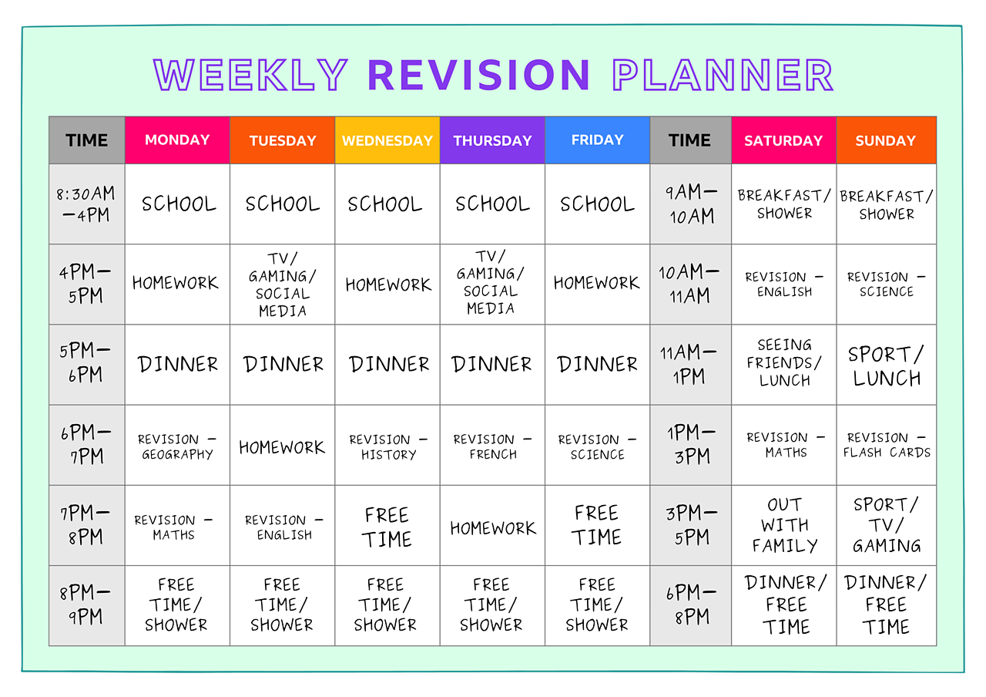
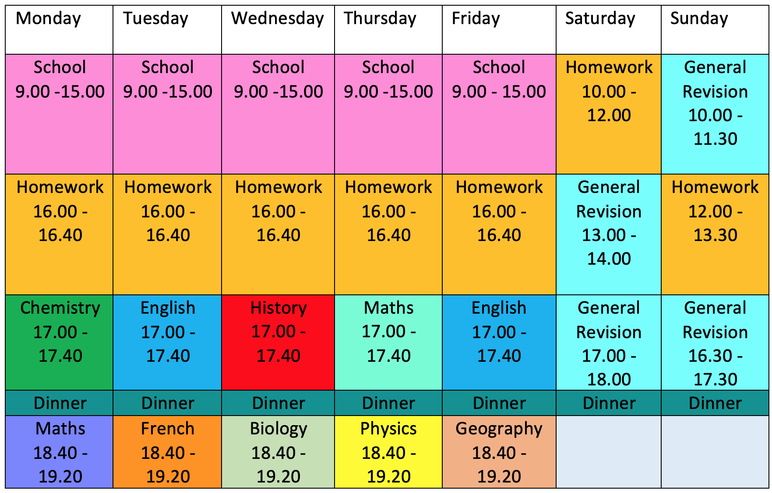

For some more information, please visit:
How do I make a revision timetable for my exams? - BBC Bitesize
Making a revision timetable that actually works - The Uni Guide
How To Make A Revision Timetable (That Actually Works) - Think Student

YOUR REVISION SPACE

Studies have found that the best study spaces mimic how you will be sitting your exams – at a desk or table, with minimal distractions and working in silence:
- Avoid revising on your bed – this can confuse your brain in thinking that your bed is a space where full concentration is needed. This will make it even harder to fall asleep at night!
- Sit up straight – avoid slouching by having a comfortable chair to work in.
- Keep your study area tidy – studies have found a direct link between messiness and procrastination.
- Organise the space – spend 10 minutes at the start and end of each day ensuring that all notes, books and paper is filed away in an organised space.
- Study in a well lit area – where there is light, melatonin will be produced. Melatonin is a hormone that keeps us alert.
- Remove distractions – remove your phone, computer, games console from the area when you are studying. Your phone needs to be out of sight!

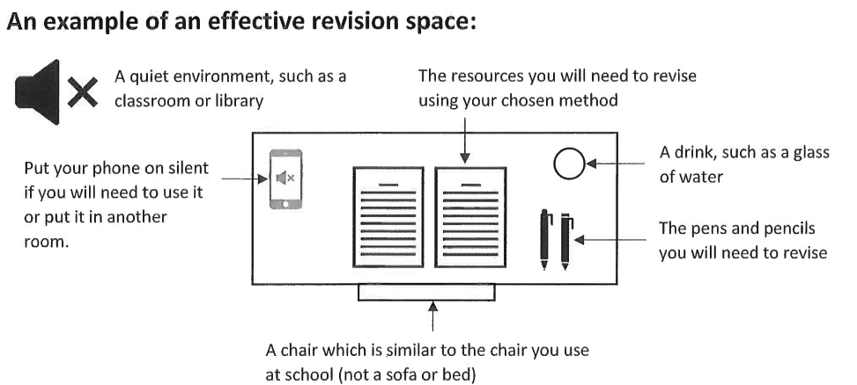

YOUR MEMORY

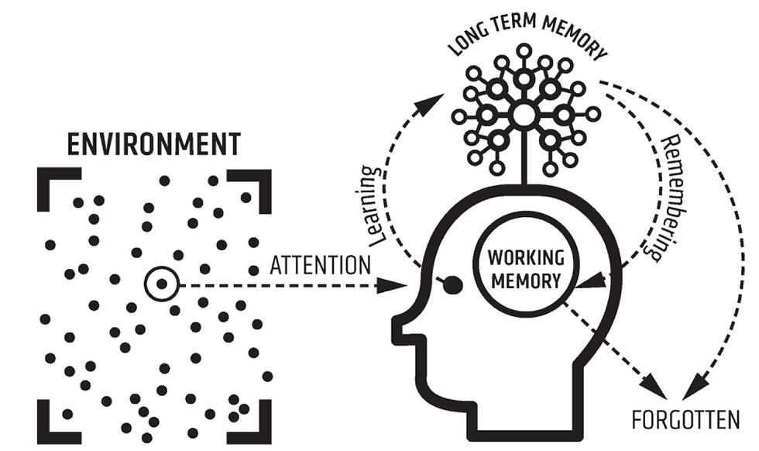

We process new information in our working memory. However, our working memory is very limited in its capacity – it can only hold up to 4-7 new pieces of information before becoming overloaded.
Our working memory can also become overloaded by our environment e.g. being in a noisy environment, or listening to music when we revise.
When we learn new information (sometimes called encoding), the information gets stored in our long-term memory. Our long-term memory is thought to have unlimited capacity, and be a store of all of our memories, knowledge and information. However, if we don’t frequently move information from our long term memory, back into our working memory, it can be forgotten.
The process of moving information from our long-term memory into our working memory is called remembering or retrieval. We want to make this process as easy as possible in readiness for our exams. This is why we revise using activities that will help this process – moving information that is stored in our long-term memory into our working memory, and then back again. The methods outlined in this booklet are the most effective way to help this process happen, so that you can get the most out of your revision.
FORGETTING

Forgetting is both natural and normal. Research shows that we will forget most new information within 24 hours of first learning it.

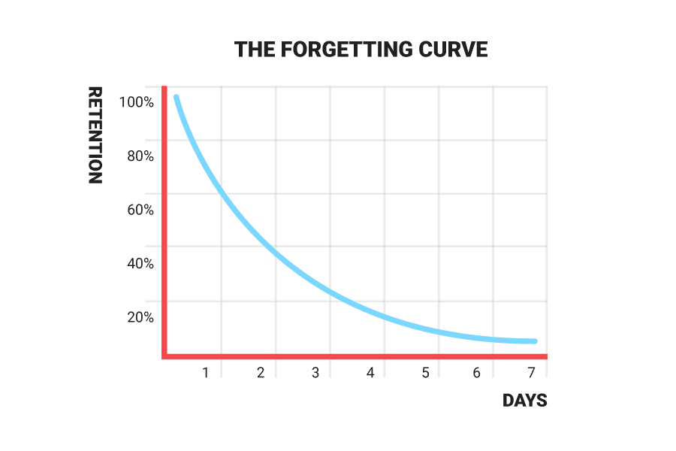
We want our students to be able to disrupt this normal forgetting cycle. Further research shows that if we review information periodicially, then each time we review it, the slower that we will forget the information. This repeats itself each time we review the same piece of knowledge.
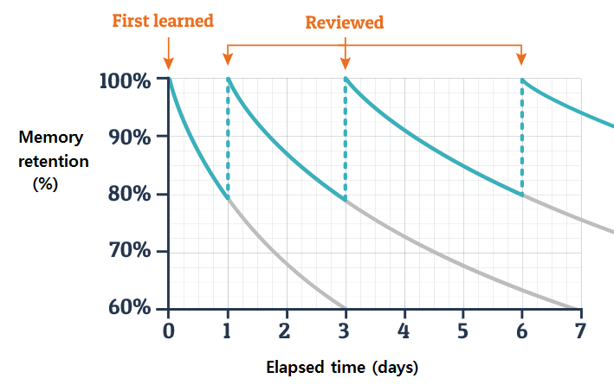
What does this mean for revision?
It is very powerful to be aware of how quickly you forget things, and that reviewing information will disrupt this natural process.
Through your revision you need to ensure that you are:
- Engaging in retrieval practice
- Spacing out your learning, and not learning everything in one chunk
- Reviewing your learning daily and weekly in the build up to your exams

The rest of this guide lists some of the most and least effective ways to revise.
The most effective revision strategies are designed to:
- Prevent you from forgetting key information and knowledge
- Promoting the movement of information and knowledge from your long-term memory, to your working memory.

Every time your revise, review or retrieve something, you are making it more difficult to forget, but are also making it easier to remember in the long term.

THE LEAST EFFECTIVE REVISION STRATEGIES

- Re-reading notes and highlighting key points

According to research, 84% of students admit to using this technique to revise, and 55% claim it is their favourite technique!

What does the research say?

A study in 2006 (Roediger and Karpicke) compared the learning of three groups who used a combination of re-reading and retrieval practice to prepare for a test. When asked, those who just relied on re-reading believed it was an effective strategy for learning and felt really confident about the final test. The results said the opposite, though - those who used retrieval practice did at least 30% better in the final test.

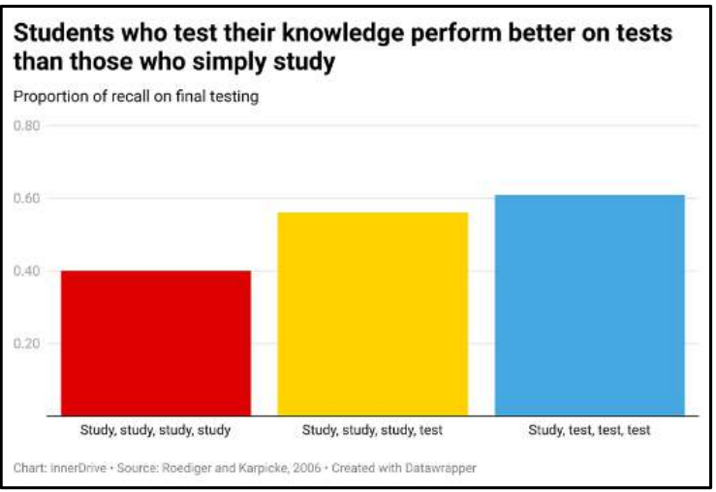

- Listening to music when revising

According to research, 47% of students believe music helps them concentrate and 29% claim it keeps them calm.

What does the research say?

A 2014 study (Perham and Currie) compared four study groups: one group working in silence; another revising to songs they liked; a third group revising to songs they didn’t like; the final group listening to music without lyrics. Those revising in silence performed significantly better than those listening to songs with lyrics, and it made no difference if they liked the songs! Despite what many students think, listening to your favourite songs is not the best way to revise; music takes up processing space in the brain, leaving less space to process revision materials.

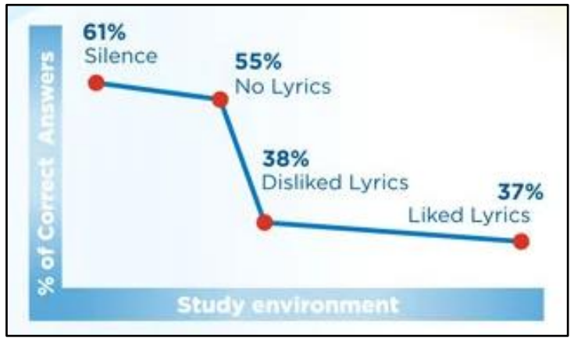

The key to effective revision is simple – lots of testing (known as retrieval practice), completed in silence.

THE MOST EFFECTIVE REVISION STRATEGIES – Retrieval Practice

Retrieval practice is a learning strategy where we focus on getting information out. Through the act of retrieval, or calling information to mind, our memory for that information is strengthened and forgetting is less likely to occur.
Retrieval is trying to remember information you have previously learned, so you can access it easily at a later date. When we are asked a question, our brain makes connections to other things we know. By repeating the question regularly, those connections are strengthened, and eventually the information transfers to our long-term memory.
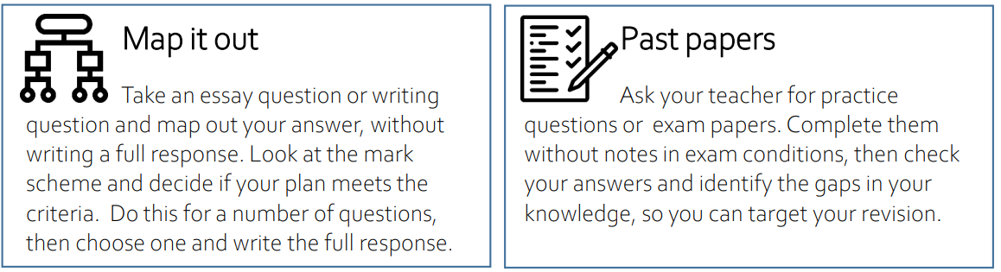
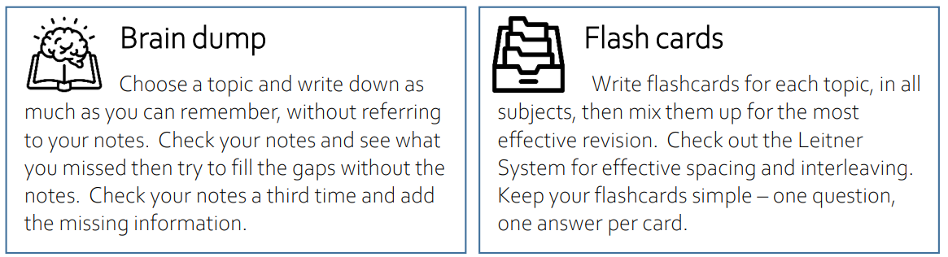
There are many revision techniques that we can use to ensure that we are incorporating retrieval practice:

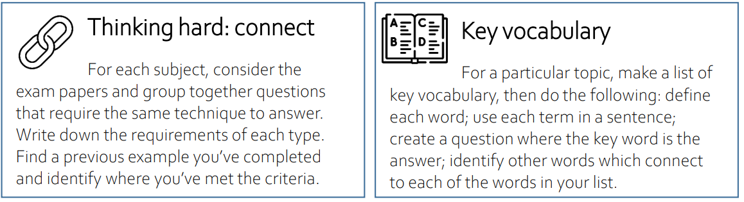
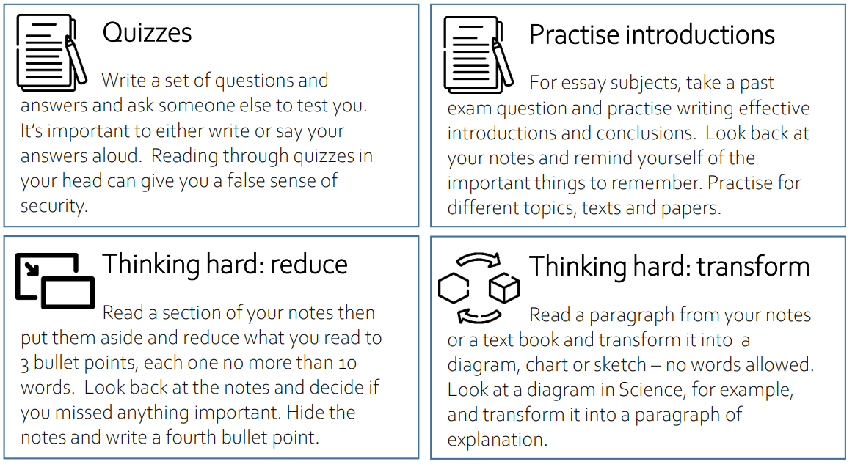
The most important points to remember when implementing retrieval practice into your revision is:
- Do it from memory (cover your notes) – the harder you have the think, the more effective the retrieval practice and the stronger the memory will become.
- Mark your work and correct it – this way you will know what you could remember, and what you couldn’t.
- Repeat it over time – over time, repeating the same retrieval task (e.g. quizzes, flashcard questions) will mean that you can recall more and more from your memory.

THE MOST EFFECTIVE REVISION STRATEGIES – Spacing

Spacing is cutting up your revision into smaller chunks and spacing them out over a period of time. It is much more beneficial than cramming an entire subject in a day. An hour of Physics each day for 5 days is much more effective than 5 hours in one day!
To commit something to memory, it takes time and many repetitions. This is where spacing can help, as revision for the same subject happens over a longer period of time, so repetition can occur.
Why is spacing beneficial?
• Doing something little and often – spacing – beats doing it all at once, or cramming.
• The time in between revision allows you to forget and re-learn the information, which cements it in your long-term memory
• We can learn more information over time than in one longer session
Optimal spacing times
• Research suggests there is an ‘optimal gap’ between revision sessions so you can retain the information
• If the test is in a month, you should review the information around once a week. If the test is in a week, create time once a day.
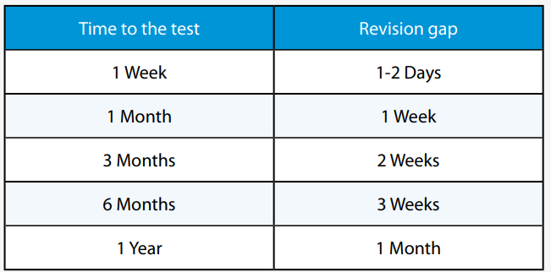
THE MOST EFFECTIVE REVISION STRATEGIES – Interleaving

Interleaving is where you mix up the subjects and topics you revise: 30 minutes of Shakespeare, 30 minutes of algebra, 30 minutes of Poetry, 30 minutes of Ratio - rather than an hour of English and an hour of Maths.
In the diagram below, the top boxes show “blocked” revision, where a student has revised for a long period of time for one skill or subject.
Research shows that it is much more effective to revise using “interleaving”, which is shown on the bottom of the diagram. This is where topics or skills are mixed up when they are studied, and then repeated over time.
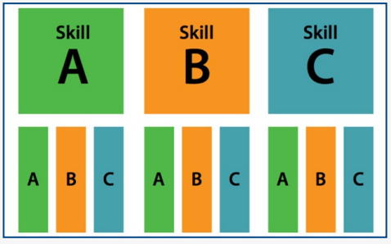
INTERLEAVING
BLOCKING

What are the benefits of Interleaving?
• Strengthens memory recall
• Your brain is continually changing focus and attempting to find different responses to bring into your short-term memory
• By revisiting material from each topic several times, in short bursts, you can increase the amount you remember in the exams
• Each time you revise information it strengthens your memory recall
How to apply Interleaving to your revision
1. Break units down into small chunks and split these over a few days rather than revising one whole topic all at once
2. Decide on the key topics you need to learn for each subject
3. Create a revision timetable to organise your time and space your learning

USING FLASHCARDS EFFECTIVELY

Flashcards are an effective way to incorporate retrieval practice and active recall into your revision. They can be as simple as a question on the front, and the answer on the back.
Flashcards are effective because they allow for repetition and spacing, but also for self-reflection. You will know straight away if you got the answer correct or incorrect.
Some teachers will give you a list of “core questions”, which you can use as questions for your flashcards. You can also use Apps, such as “Anki” which will make flashcards for you.
How to make flashcards
- Ensure that the flashcards have a question or key term on one side and the answer or definition on the other - the flashcard must work the memory - if flashcards only contain notes then no retrieval practice will be happening
- Ensure the right questions and knowledge are on the cards
- Keep information as short as possible
- Write clearly. You should be able to read what you wrote at a very quick glance
- Use different coloured cards or pens to categorise your flashcards. For example, use a different colour for each subject or topic. This can help your brain to categorise information better
- Make your flashcards as soon as you’ve learnt or revised the topic for the first time

Studies have found that it is more effective to complete a stack of flashcards in one sitting, rather than carrying them around with you and glancing at them every once in a while.
You can use flashcards to space and interleave your revision too. For example, you can answer flashcard questions on History for 25 minutes, and then answer flashcards for Food Technology for 25 minutes afterwards.
The Leitner System for Organising Flashcards
The Leitner System uses spaced practice to ensure that you cover the flashcards that you do not know as well more often. It is a proven effective way to use flashcards for your revision.

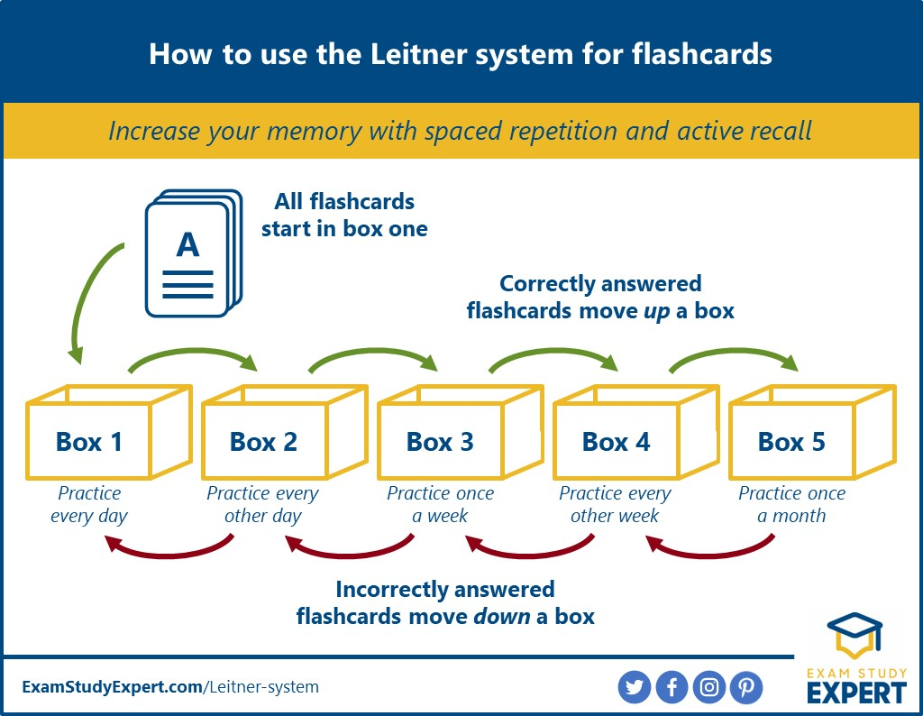

When students answer a question correctly on a flashcard, that card moves up a box. When a student answers a question incorrectly on a flashcard, that card moves down a box.
This will ensure that questions that the students are getting incorrect are revisited more frequently. It also ensures that the questions that students are getting correct are still revisited, but less frequently, in order to prevent forgetting.
SUMMARISING – CORNELL NOTE TAKING

One of the most effective methods to take notes is using the Cornell Note Taking Method. Recent research has shown that implementing Cornell Note Taking during revision or in the classroom helps students to obtain higher grades.
This method of note-taking requires you to summarise and self-question. These are two important stages of learning that improves the movement of information into your long-term memory. The organisation of the notes themselves, when written in the Cornell way, allows you to continually revisit summaries of topics and questions for self-testing.
What is Cornell Note Taking?
- First, divide your A4 page into three sections.
- Around 1/3 from the bottom of the page, draw a line across the page.
- Divide the rest of the page into two vertical columns – with the left hand column taking up around 30% of the width, and the right hand column taking up around 70% of the width.
- Your paper should now look like this:

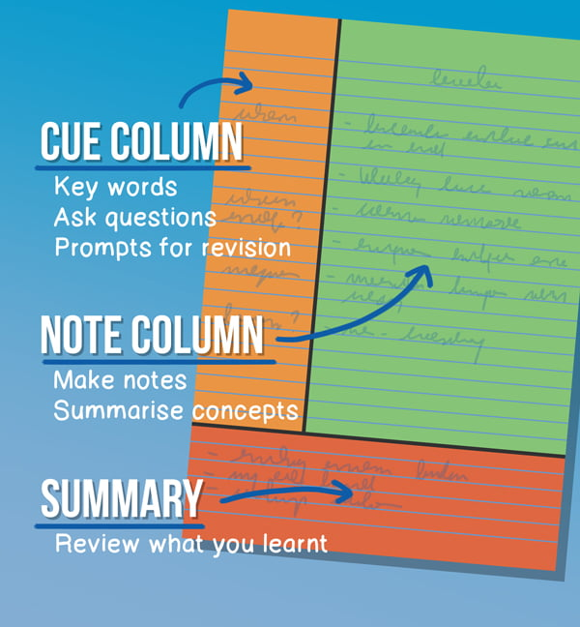
Now that your page is divided up correctly, you can use this method to support your revision by:
Making notes
The larger, right hand column should be used to make notes on your revision topic, or during your lesson. Keep these notes concise, and make them a summary of the main topics covered in this part of your revision. Do not simply copy out notes from a textbook, but promote active thinking by putting them into your own words.
Summarising Further
Summarise your notes further by writing the key takeaways at the bottom of the page. This will require you to think hard about what is the most important pieces of information.
Asking Questions
As soon as you have finished writing and summarising your notes, you should write a list of questions in the left-hand column which you will ask yourself at a later date (as part of spacing and retrieval practice). Writing questions is an important part of this process as you will need to consider the information that you have just revised.
Practice
When revisiting this topic, you can cover the right-hand side of your notes page and answer the self-written questions from the left-hand side. For maximum effect, you should say your answers out loud or write your answers down (rather than answer them in your head) as this forces you to organise and link information together, like you will have to in an exam.

ONLINE REVISION PLATFORMS

As a student at Walton High School, you have access to the following online revision platforms, and can log in using your school email account and password:
- Educake
- BBC Bitesize
- Seneca Learning
- GCSEPod
- Dr Frost Maths
- Revisely
These online revision platforms allow you to engage in all of the effective revision strategies described above, including self-testing.
For more information on the use of GCSEPod, please use the following links:
GCSE Pod - Walton High School Stafford (waltonstaffs.com)
GCSEPod - Year 11 Parents (loom.com)

WELLBEING DURING EXAM AND REVISION TIME

The build up to exams, and the exam period itself, can be a stressful time for students and their families. Good preparation and revision is key to helping reduce exam anxiety and stress.
Below are other strategies that you can use to ensure that your physical and mental health are best supporting you during exam and revision time:
- Diet – food fuels your brain. Maintain a balanced diet during exam and revision periods, and stay hydrated.

- Sleep – Research has shown that sleep deprivation has a negative impact on memory, concentration and performance in exams. Make sure that you are getting between 8-10 hours of sleep per night.

- Exercise – Break up your revision with exercise. This can be doing a sport that you enjoy, or by simply going on a 15 minute walk.

- Relaxation – It is essential that you give yourself time to switch off from exams and revision. Do what you enjoy – see your friends, read a book, or watch a film.

- Limit your screen time – Having your phone around you during your revision and exam time will cause a distraction, even if you don’t want it to! Just having your phone nearby when you revise results in 20% less concentration. Mobile phones can also affect your sleep habits. Use your mobile phones, but in shorter doses and be mindful of your screen time, especially during revision and exam periods.

REFERENCES

Make It Stick: The Science of Successful Learning. Mark A.McDaniel. Peter C. Brown. Henry L. Roediger III. (2014)

Strengthening the Student Toolbox. Study Strategies to Boost Learning. John Dunlosky. (2013)

Teaching and Learning Illuminated. Bradley Busch and Edward Watson. (2023)

A Parents’ Guide to the Science of Learning. Bradley Busch and Edward Watson. (2022)

www.lovetoteach87.com

Revision Strategies – Worcester Sixth Form College (Revision Strategies.pdf)

https://libguides.cam.ac.uk/wolfsoncollege/revision

www.innerdrive.co.uk

http://examstudyexpert.com

