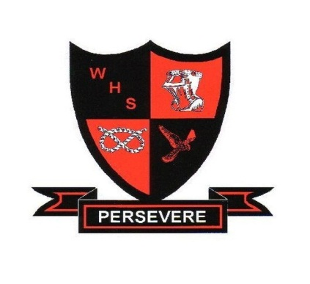

Walton High School,
The Rise,
Walton on the Hill,
Stafford
ST17 0LJ

Date as postmark

Dear Applicant

COVER STAFF – permanent / CASUAL contracts
start date – december 2023
35 hours per week - term time only (8.15 am – 3.45 pM)
Grade 7, Scale 15 – 22 (£13.41 - £15.26 per hour)
(£19,734 – 22,456 per annum)

Thank you for your interest in the above post.

Please see attached documents:
- Application form
- Recruitment monitoring form
- Job profile/ person specification

If you would like to apply for the post, please complete the recruitment monitoring form and the application form in full and send it to the Business Manager (recruitment@walton.staffs.sch.uk) .
Please indicate which position you are applying for. A curriculum vitae will not be accepted.

Your letter of application should be about 1 side of A4 and should address the requirements of the Job Description and Person Specification.

Closing date: 9.00 am on Friday, 1st December 2023
Interview date: To be confirmed

Please be aware that all correspondence will be by e-mail where an address has been provided on the application form.

We look forward to receiving your application.

Yours sincerely

Mr B Fletcher & Dr J Rowley
Acting Headteachers

