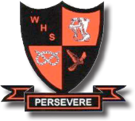
Walton High School
Science Department

Current Department Structure
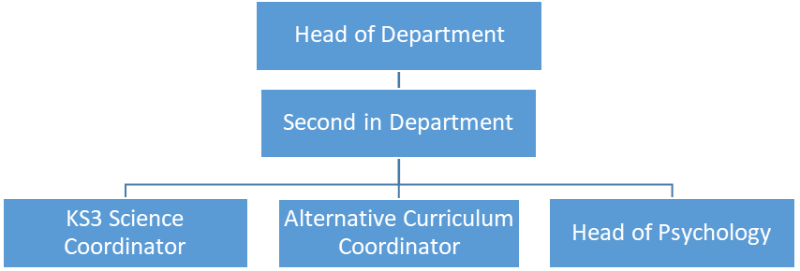

Background Information
We are a large, vibrant and forward-thinking department consisting of 15 teaching staff and 2 technicians. We believe the quality of our teaching and learning in Science to be outstanding. The science department places evidence-informed practice at the heart of our teaching and learning strategy, such as the use of explicit instruction, managing of cognitive load, questioning and retrieval practice. Exam results in 2021/22 were some of our best ever, with 83% of students achieving 4+ and 57.6% achieving 5+ in Combined Science, well above the JCQ national averages. Our department’s performance is further exemplified in our Triple Science cohort results, with 75.4% of students achieving grade 7+ in GCSE Biology and 98.5% achieving grade 5+ in GCSE Chemistry, again well above national JCQ figures.

Science is a highly popular subject and we offer a variety of Science courses at Walton High School to cater for all learners. Our KS3 curriculum is condensed to a 2-year course and is based on the national curriculum (although our 2 year KS3 is currently undergoing a curriculum review). Currently, in year 9 our students embark on full GCSE Science study. We strive to ensure that teachers are teaching within their subject specialism at GCSE. A group of selected students will study the Triple Science pathway (usually 30%+ of the cohort), while the majority of students study the Combined Science route. We also offer GCSE Astronomy as an options subject. The uptake of Science courses at A level is always high and teachers always teach their subject specialism. We offer A levels in Biology, Chemistry, Physics, Psychology and a BTEC Level 3 in Forensic Science and Criminal Investigations.

Science Curriculum at Walton High School

Course | Allocated Time
KS3 Science  (condensed course taught in years 7 and 8 – although this is currently being reviewed) | 4 periods per week  (taught as 2 doubles)
AQA GCSE Combined Science  (taught over years 9, 10 and 11) | 6 periods per week  (taught as 3 doubles by subject specialist teachers)
AQA GCSE Triple Science  (taught to a select group of students in years 10 and 11) | 6 periods per week  (taught as 3 doubles by subject specialist teachers)
Edexcel GCSE Astronomy  (taught as an option subject in years 9, 10 and 11) | 3 periods per week  (taught as a double and single by a subject specialist)
AQA A level Biology | 6 periods per week  (taught as 3 doubles by subject specialist teachers)
AQA A level Physics | 6 periods per week  (taught as 3 doubles by subject specialist teachers)
AQA A level Chemistry | 6 periods per week  (taught as 3 doubles by subject specialist teachers)
AQA A level Psychology | 6 periods per week  (taught as 3 doubles by subject specialist teachers)
BTEC Level 3 Forensic Science | 12 periods per week  (taught as 6 doubles)

