Name:

OCR Media Studies GCSE

Paper 1
Section A: Television
5 Questions
Cuffs & Avengers

Section B: Promoting Media
4 Questions
The Lego Movie & videogame

Paper 2
Section A: Music
5 Questions
MOJO, music videos & Live Lounge

Section B: News
5 Questions
The Observer print & online

The Theoretical Framework

Language = ways in which media text communicate meanings  Mise-en-Scene - lighting, setting & location, costume & make-up, facial expression & body language and positioning of characters in the frame (proxemics).  Camerawork - camera shots (close-up, establishing, mid, long, extreme close-up, over the shoulder, high angle, low angle etc.) & camera movement (zoom, pan, tilt, crane, arc, handheld, dolly etc.)  Sound - analysis of diegetic & non-diegetic sound including soundtrack, music, sound effects, dialogue, voiceover, sound editing, volume and pace of sound.  Editing = includes types of cut (straight cut, cutaway, cross cutting, cutting on action etc.) transitions (fade through black, dissolve, iris, wipe, invisible cut etc.), pace and shot length. | Industry = the media companies & business  Production = the making of the media text  Distribution = stage when a product is made available to audiences (includes promotion)  Circulation = how many people consume the media text  Marketing = advertising and promoting to the target audience  Regulation = control of an industry by an authority that checks rules  Globalisation = to operate on a global scale  Conglomerate = large organisation that owns a number of different companies  Convergence = the coming together of media technologies  Diversification = to operate in different media industries
Audience = who an audience is and how they respond to media texts  Target audiences = who the industry is aiming the media text at  Audience demographics = age, gender, social status, economic wealth etc.  Audience theory = Uses & Gratifications theory - Surveillance, Personal Identity, Social Relationships & Entertainment.  Polysemic meaning = how a text can be interpreted and understood in different ways  Active audiences = audiences involving themselves in the production of a text usually through social media  Passive audience = audiences who don’t engage with a text and passively accept messages | Representation = how the media portray events, issues, individuals and social groups.  Events e.g. news events, cultural celebrations  Issues e.g. feminism, ownership, regulation  Individuals e.g. gender, celebrity, music artists  Social groups e.g. teenagers, women, the police  Stereotypes = repeated (often negative) depictions of people/social groups  Mis-representation = When a group of people are represented inaccurately  Heteronormative = representation of straight relationships as ‘the norm’  Multiculturalism = representations of mixed ethnicity  Under-representation = When a group of people are not represented enough or at all

Paper 1. Section A: Television
5 Questions. Cuffs & Avengers

Questions 1 - 3 are based on a clip of Avengers or Cuffs that you are shown in the exam. You will watch the 3 minute clip four times over 30 minutes. You will have time in between viewings to write notes and prepare your responses.

Question 1 (5 marks)
Focused on one element of media language: soundtrack, editing, mise-en-scene or camerawork.
Preparation: Watch 3 min clips of The Avengers & practice identifying two examples of each element of media language. Be able to EXPLAIN what meaning is created for the audience.

Camerawork  1.  2. | Editing  1.  2.
Soundtrack  1.  2. | Mise-en-scene  1.  2.

Camerawork  1.  2. | Editing  1.  2.
Soundtrack  1.  2. | Mise-en-scene  1.  2.

Question 2 (10 mark)
An analysis of the unseen clip asking for an evaluation and opinion. The question will state ‘Analyse how far the extract depicts …..’ You can use all four aspects of media language to answer this question. Give specific examples from the clip to support your view. You must make a clear judgement about ‘how far’.
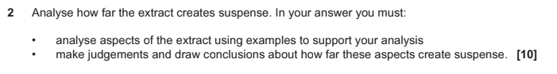
Preparation: Watch a Cuffs or Avengers clips & consider how aspects of media language work together to create a certain mood or theme.

This could be: humour, suspense, excitement, a close relationship, heroes and villains. Spies, the patriarchy etc.

Mood created in the clip & specific reference to text | Media language examples | Personal judgement - does it create this mood effectively?
C

E

S

M

C

E

S

M

C

E

S

M

Question 3 (15 mark)
You must analyse the clip & make a clear judgement. In this question it states ‘full course of study’ this means you should mention something about each key concept (LIAR). language, Industry, audience, representation).
You should include analysis of how the extract reflects ‘media contexts’ this means how it reflects the real world & time that the show was based. E.g Avengers reflects changing feminism, the cold war, post WW2 etc.
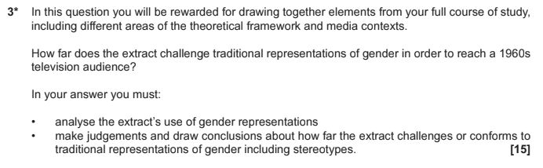
Preparation: Visit the 3 min clips again & develop your longer response style.
 | Clip 1 | Clip 2
Language
Industry
Audience
Representation
Media Contexts
Judgement & Conclusion
Question 4 (5 marks)
This question is a knowledge based question about any area of the theoretical framework (LIAR language, Industry, audience, representation).
Preparation: The exam guidance suggests that this question might be about representations. Please prepare for a range of potential questions across all aspects of the theoretical framework.

 | Point | Explanation/Example
Two ways audiences can watch TV after its initial broadcast | 1
 | 2
Two ways television programmes are funded | 1
 | 2
Two ways television is regulated | 1
 | 2
The difference between commercial & PSB TV | 1
 | 2
Two ways the BBC spend their licence fee | 1
 | 2
Two ways that the police are represented on British TV | 1
 | 2
Two ways that the uses and gratifications theory applies to television. | 1
 | 2

Question 5 (10 marks)
This question is based on context. You could be asked about Cuffs from 2015 or The Avengers 1964.
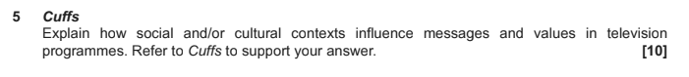
Preparation: Be prepared with specific examples from Episode 1 ‘Luck of the Draw’ that cover a range of potential media contexts.

Context | Example(s) from Cuffs - characters/storylines/representations
Gender roles
Attitude to sexualities
Multiculturalism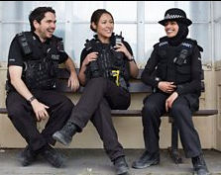
Changing attitude to age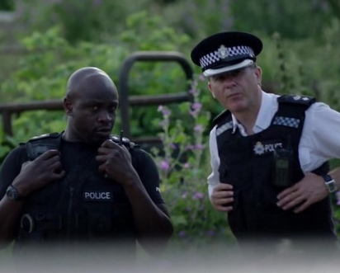
Police & criminals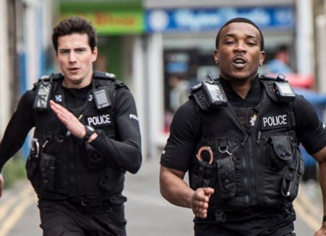
Context | Examples from The Avengers
The Cold War and Fear of Russian Spies

Patriarchy

Feminism

Equality and diversity

Class

Paper 1. Section B: Promoting Media
4 Questions. The Lego Movie & videogame.

Question 6 (1 mark)
This question tests your knowledge of the film & video game industry and the companies involved in The Lego Movie & videogame.
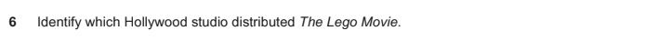
Preparation: write a short definition of each of the following terms/companies. What is their involvement in the Lego Movie franchise?

promotion
franchise
distribution
conglomerate
tent-pole production
synergy
vertical integration
platform
feminism
stereotype
Warner Bros
TT Fusion
WB Games
BBFC
PEGI
VSC
ASA
DC Comics

Question 7 (4 marks)
This question tests your knowledge of the film & video game industry. You must explain using examples from The Lego Movie franchise naming the companies involved and industry terminology.
Preparation: Explain each of the following. Give examples from The Lego Movie franchise.

 | Explanation | Example
Two ways of marketing a film | 1
 | 2
Two advantages of being a media conglomerate | 1
 | 2
Two ways tent-pole productions are beneficial for a company | 1
 | 2
Two benefits of releasing a videogame linked to a film | 1
 | 2
Two benefits of vertical integration | 1
 | 2
Two benefits of horizontal integration | 1
 | 2
Two ways media texts are regulated in the UK | 1
 | 2

Question 8 (10 marks)
This question tests your ability to explain about industry, audience or both.
Preparation: Make notes about each of the following industry & audience ideas giving specific examples from The Lego Movie & Lego Movie videogame

 | Example from The Lego Movie | E.g. Lego Movie Videogame
Active audiences

Passive audiences

Surveillance (U&G)
(Education)

Entertainment (U&G)
(Escapism)

Personal Identity (U&G)

Personal Relationships (U&G)

How the promotion targeted a family audience

How different audiences are targeted by promotion

Benefits of a tent-pole production for WB & audiences

Explain how regulation can shape promotional texts

Question 9 (10 marks)
This question will test your ability to analyse the promotional material for The Lego Movie. This could be the ensemble poster, the character posters, the trailer or the Dancing on Ice advertisement slot.
Example:
9. Refer to the Lego Movie trailer. Analyse how genre conventions and media language are used successfully. [10]

Preparation: Complete the following analysis notes about media language use in the trailer

 | Two examples from The Lego Movie trailer & audience effect
Camerawork  camera shot & movement | 1  2
Editing  cuts & pace | 1  2
Mise-en-scene  setting/facial expression/costume | 1  2
Soundtrack  dialogue/voiceover/ soundtrack | 1  2
Genre conventions  intertitles/ content/ action-adventure | 1  2
Narrative  quest/Todorov disequilibrium/  Propp roles | 1  2

Paper 2. Section A: Music
5 questions. Live Lounge, music video & MOJO.
Question 1 (1 mark)
This question tests your knowledge of the music industry including regulation & ownership.
Preparation: write a short definition of each of the following. What is their link to the music set texts?

MOJO magazine
Bauer media
BBC
IPSO
Diversification
Conglomerate
Radio 1
PSB
Royal Charter
Ofcom
Niche market
Mass audience
Diversity
Distinctive
Convergence
Genre conventions
Globalisation
Product Placement
Multiculturalism
Celebrity culture
Mode of address

Question 2 (4 marks)
This 4 mark explanation question will either be about BBC Radio 1’s Live Lounge or your set pair of music videos (Somebody to You, Black Magic). It is likely to test audience or industry knowledge. You must include specific examples from the set text to support your ideas.
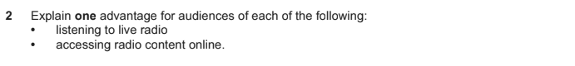
Preparation: Practice writing about Live Lounge & audience.
 | Explanation | Example
Two ways Live Lounge meets the BBC’s PSB requirements Royal Charter)  reflect UK diversity/ innovative/ distinctive/ promote UK talent | 1
 | 2
One advantage of  - Live radio  - Online radio content  analogue/ digital/ web/ BBC  Sounds/ Youtube/ Socials | 1
 | 2
Two ways radio shows are promoted to an audience  analogue/ digital/ web/ BBC  Sounds/ Youtube/ Socials | 1
 | 2
Two ways audiences can actively engage with radio shows | 1
 | 2
Two ways that LIve Lounge demonstrates convergence | 1
 | 2
Two ways Live Lounge appeals to the target audience of 15-29 year olds. | 1
 | 2
Two ways Live Lounge reflects audience diversity | 1
 | 2

Question 3 (10 marks)
This extended question will be about music video or Live Lounge. You will have to give specific examples from the set text. It is likely to be about audience or representations.
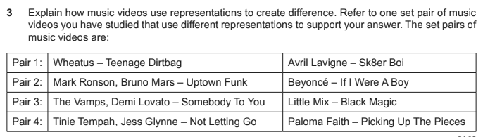
Preparation: Practice in relation to Music Videos. Complete the following table with explanations & examples.

Area of representation | Somebody to You | Black Magic
Relationships
Masculinity
Femininity
Youth/Age
Stereotypes
Place/Country/The City
Ethnicity
Celebrity

Question 4 (5 marks)
Unseen front cover from MOJO magazine provided in the exam focused on language or representation.
Preparation: Complete analysis of the MOJO front covers focusing on language & representations
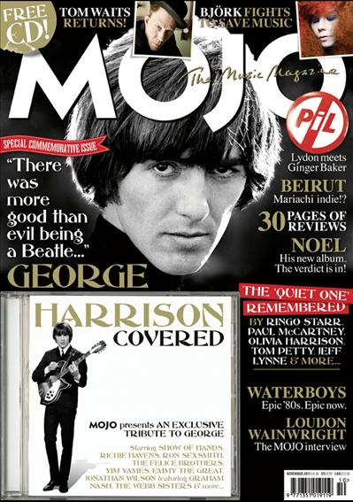 | Magazine conventions
 | Text/Font
 | Image
 | Representation of classic rock
 | Representation of musicians
 | Representation of gender

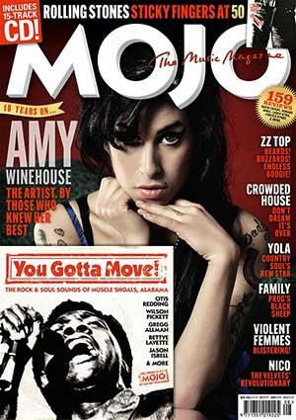 | Magazine conventions
 | Text/Font
 | Image
 | Representation of classic rock
 | Representation of musicians
 | Representation of gender

Question 5 (15 marks)
This is an extended question focused on media language. You will be asked to compare Extract 1 (MOJO magazine) and another front cover from a different music magazine. You should be able to analyse both extracts using terminology as well as give a clear judgement about the question.
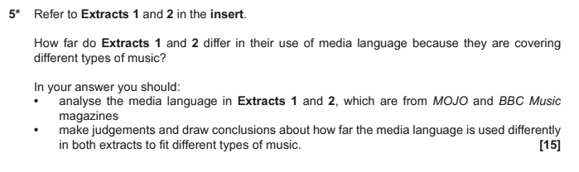
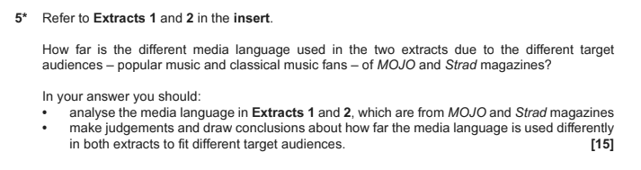
Preparation: Compare and contrast the two covers overleaf across language & representation. Use magazine codes & conventions to assist you.

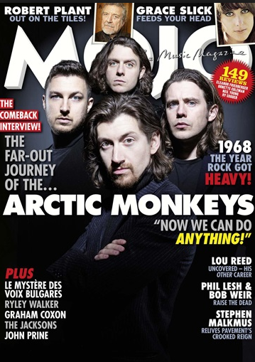
Sell lines

Insert image

Slogan

Masthead

Puff

Main image

Direct mode of address

Anchorage

Call Out

Coverlines

Buzzwords

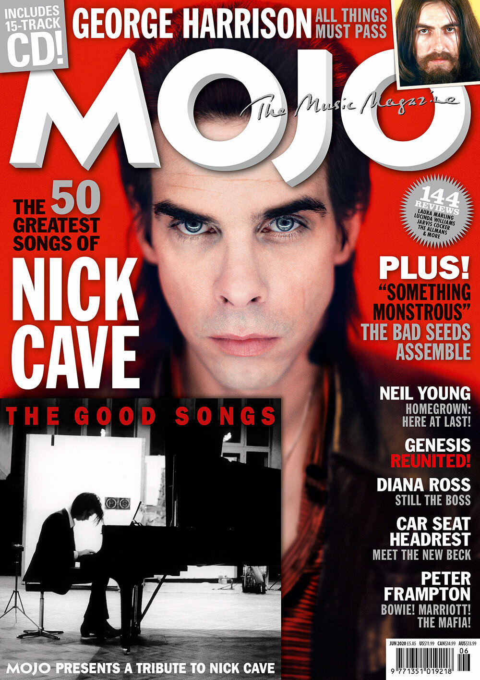 | 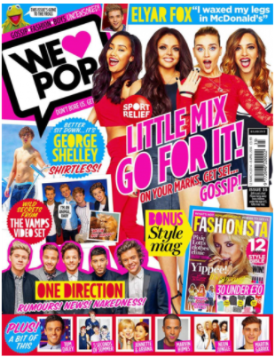
Magazine conventions

Text/Image/Colour

Representation of music genre

Representation of music stars

Representation of gender

Judgement & Conclusion - are they more similar or more different?

Paper 2. Section B: News
5 questions. The Observer 1960s & contemporary print & online.

Question 6 (1 mark)
This question tests your understanding of the newspaper industry.
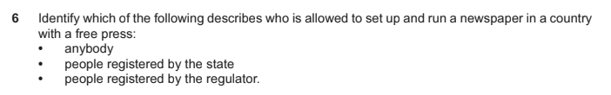
Preparation: Write a definition of each of the following. What is their link to The Observer?

Press freedom
IPSO
IMPRESS
Guardian Media Group
The Scott Trust
Broadsheet
Tabloid
Hybrid
Paywall
Conglomerate
Impartial
Right wing
Left wing
Clickbait
Hard/soft news
Asymmetrical layout
Intertextuality
Serif/sans serif
Skybox
Ideologies

Question 7 (4 marks)
This further tests your understanding of the newspaper industry. You should include real examples from The Observer & other news industry knowledge to support your answer.
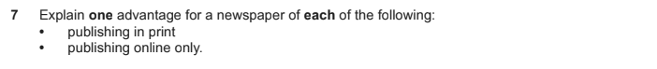
Preparation: revise print editions, online news such as social media and websites.

 | Explanation | Examples
Explain two ways the print newspaper industry have diversified online | 1 | Online
 | 2 | Social Media
One advantage for a newspaper to  - Have an online edition  - Use social media | 1 | Online
 | 2 | Social Media
Explain why a newspaper would shut down its print edition and be online only | 1 | Online
 | 2 | Social Media
Explain two ways online newspapers are funded | 1 | Online
 | 2 | Social Media
Explain how the Observer incorporates hard and soft news | 1 | Online
 | 2 | Social Media

Question 8 (5 marks)
This question will ask you to analyse the unseen extract in your exam insert. The analysis could be any key concept and will want you to use examples from the extract & media terminology.
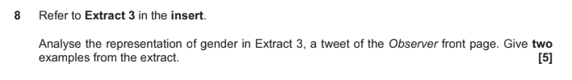
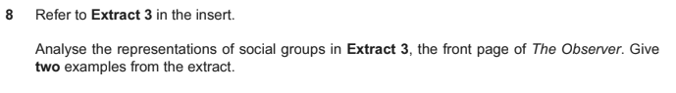
Preparation: The exam could include an extract such as a front cover or The Observer, a screenshot of the website or their social media channels.

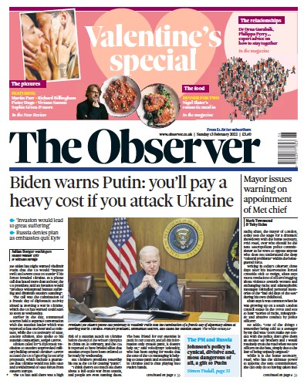 | Genre conventions
 | Image/Colour/Layout
 | Content/stories/topics
 | Representation of women
 | Representation of politicians
 | Representation of lifestyle
Values & ideologies of The Observer reflected through the front cover stories

Question 9 (15 marks)
You must analyse the extract & make a clear judgement. In this question it states ‘full course of study’ this means you should mention something about each key concept (LIAR).
You should also include analysis of how the extract reflects ‘media contexts’ this means how it reflects the real world and time that the newspaper was written. 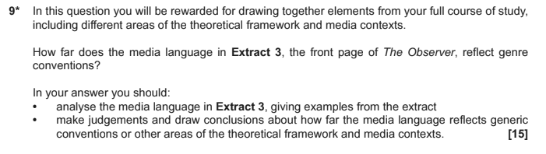
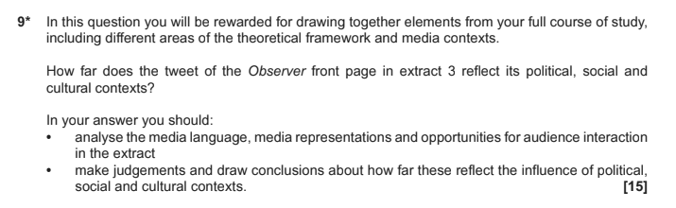
Preparation: again, we don’t know what the extract will be, but you must draw on your knowledge from the whole topic, using the extract to support your answer.

Consider how this front cover reflects contemporary ‘media contexts’.
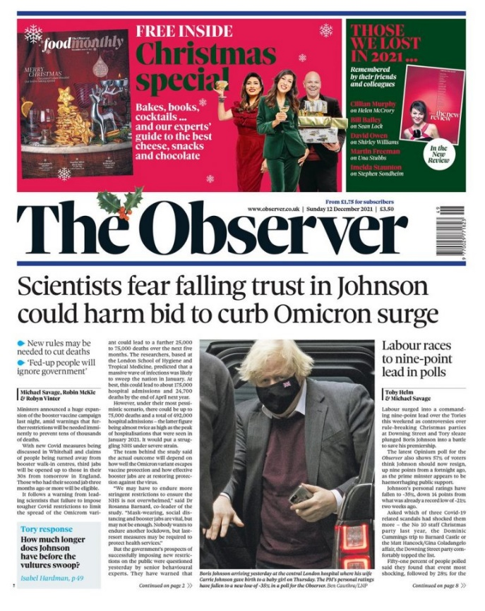 | Gender roles
 | Multiculturalism
 | Lifestyles
 | Democracy/Liberal viewpoint
 | Consumerism
 | Celebrity culture
Question 10 (10 marks)
This question wants you to explore media contexts in more detail. It could be based on historical contexts as below but could also be about contemporary news - or both.
Preparation: This question is similar to question 5 of paper 1 in the TV Crime Drama unit. Relating contexts to what is seen in newspapers. Complete the following table with headlines and stories from across the three set historical covers.

Context | Example story / Headline(s)
Gender equality

Patriarchy

Political change

Political divisions

The Cold War

Rise of student protest

Union strikes

Anti-racist movements

Multiculturalism

Patriotic society/Royalist

End of questions.

Checklist for revision & preparation
Paper 1 Section A: Television
Revise camerawork terminology
Revise editing terminology
Revise mise-en-scene terminology
Revise soundtrack terminology
Prepare for Question 1 = media language in Avengers
Prepare for Question 2 = media language & judgement
Revise examples for Avengers LIAR
Prepare for Question 3 = Avengers & judgement
Prepare for Question 4 = Television industry & audience
Revise context examples from Cuffs ‘The Luck of the Draw’
Prepare for Question 5 = media contexts in Cuffs
Paper 1 Section B: Promoting Media
Revise film & videogame industry terminology & companies
Prepare for Question 6 = one mark industry terminology
Revise content examples from The Lego Movie franchise
Prepare for Question 7 = industry knowledge & examples
Prepare for Question 8 = industry & audience knowledge & examples
Rewatch The Lego Movie trailer & revise media language terminology
Prepare for Question 9 = media language in the trailer

Paper 2 Section A: Music
Revise music industry terminology & companies
Prepare for Question 1 = one mark music industry
Revise content examples from Radio 1’s Live Lounge
Prepare for Question 2 = Radio 1’s Live Lounge & audience
Revise representation examples from both music videos
Prepare for Question 3 = music videos & representations
Revise magazine genre conventions
Prepare for Question 4 = MOJO magazine language & representations
Prepare for Question 5 = Magazine comparison
Paper 2 Section B: News
Revise news industry terminology & companies
Prepare for Question 6 = one mark news industry
Revise content examples from online & social media Observer
Prepare for Question 7 = The Observer online & social media industries
Revise genre conventions of newspapers
Prepare for Question 8 = newspaper language & representations
Revise content for The Observer
Prepare for Question 9 = Newspapers & media contexts
Revise historical context examples from the 1960s Observer
Prepare for Question 10 = Historical contexts

