Year 11 Media Studies
Retrieval Booklet
Paper 1
TV Crime Drama
Historical crime drama = Avengers - ‘The Town of No Return’, Series 4, episode one ITV 1965
Contemporary crime drama = Cuffs - Series one, episode one BBC1 28 October 2015 8pm Promoting Media
Advertising and Marketing = The Lego Movie poster campaign and trailer
Film Industry = The Lego Movie
Videogames = The Lego Movie Videogame

TV Crime Drama
What are the conventions of TV Crime drama? Draw a mind map of these.

TV Crime Drama Conventions

What is Todorov’s 5 Stage narrative theory?

Draw out the 5 stages for the Cuffs episode

Draw out the 5 stages for the Avengers episode.

What is Public Service Broadcasting?

What is the remit for the BBC?

How is this different to the remit for ITV?

Explain how both ITV and the BBC are forms of Public Service Broadcasting; refer to the set episodes for evidence and examples.

Add all of the social context to the mind map in one colour, then in another colour, add on examples from the set episodes:

The positive representation of an openly gay couple in Cuffs, Jake and the Lawyer
The legalisation of gay marriage in England

Cuffs

Emma Peel is, in some ways, represented as a strong female lead, she fights and leads aspects of the narrative

The rise in feminism in the 1960s

Avengers

Fill in the grid with the four areas of the Uses and Gratifications theory and then give examples of how the set episodes of TV Crime Drama, provide these uses for the audience:

Uses and Gratifications | Examples linked to the set episodes

List all of the Media Language terms you can remember for each micro element:
Sound: | Editing:
Cinematography: | Mise-en-scene:
Promoting Media

Terminology:
What is synergy?

Give an example linked to The Lego Movie:

What is meant by media ownership?

What is a conglomerate?

What is a first look deal?

What is a tent pole film?

What is digital convergence?

What is intertextuality?

Give an example linked to The Lego Movie:

What is meant by these stages of the film making process?
- Production

- Distribution

- Marketing

- Exhibition
What is meant by cross media content?

Define horizontal integration:

Give an advantage and disadvantage of horizontal integration:

Define vertical integration:

Give an advantage and disadvantage of vertical integration:

Define target audience:

The Lego Movie:
Who owns Warner Brothers?

Who owns The Lego Movie?

Name other companies that Warner Brothers own:

Who has a first look deal with Warner Brothers?

The Lego Movie is what type of film for Warner Brothers?

Who provides age ratings for films in the UK?

What age rating did The Lego Movie get?

Who plays the voice of Vitruvius?

Who plays the voice of Emmet?

Who plays the voice of Wyldstyle?

Give two reasons that The Lego Movie is part of a franchise.

Give 3 examples of Propp’s character roles in The Lego Movie

The Lego Movie Marketing Campaign
How does each character poster, represent the character and display a genre convention?
Emmet’s poster:
Character representation:

Genre convention:

Wyldstyle’s poster:
Character representation:

Genre convention:

Vitruvius’s poster:
Character representation:

Genre convention:

Lord Business’s poster:
Character representation:

Genre convention:

What are the genre codes of The Lego Movie ensemble poster?

How does the ensemble poster appeal to young and old audiences?

Which of the 5 stages described by Todorov is not in the trailer and why?

Which genre codes are displayed in the trailer and how?

Which channel was the TV Advert break campaign screened?

During which show and why?

Which companies took part?

Who paid for the advert time space?

What was the impact of the advert for The Lego Movie?

How many people saw the advert?

Ways the Lego movie appeals to a family audience
Ways the posters tell us the genre of the film
Ways the posters help us understand characters
Key terms you could link to the Film Industry
Aspects of Propp’s character theory
Aspects of Todorov’s theory

The Lego Movie Videogame
Who developed the Lego Movie Videogame?

Who published the game?

Which platforms can it be played on?

What genre is the game?

What mode is the game?

Who gives games their age rating in the UK?

The game was launched the same week as the movie, why was this?

List at least three reasons to release a game on a mobile phone:

Name 2 similarities between the movie and the game.

Players do not have to have watch The Lego Movie before playing the game. Name 1 advantage to this.

Why include DC superhero characters?

Why release the game on all major platforms and mobile devices?

Do you think the movie or the game would have the younger target audience? Explain your answer
How does the Lego Movie Videogame provide audiences with each of the Uses and Gratifications?:

How could you link passive and active audience theory to the Lego Movie Videogame?

Passive:

Active:

Paper 2
Music
Music Magazines = MOJO
Music Video = Little Mix, Black Magic and The Vamps, Somebody to You
Radio – Live Lounge, Radio 1
News
Online, Social and Participatory News = The Guardian/Observer website and social media pages
Contemporary news = 2 contemporary Observer front Covers, One complete contemporary print edition of The Observer
Historical news = 3 historical news front covers, set by the exam board:
- The Observer 30 October 1966
- The Observer 6 November 1966
- The Observer 20 October 1968

Music
MOJO Magazine:
Who owns MOJO Magazine?

What is the term for when a company branches out into other industries?

Who is the target audience for MOJO Magazine?

Which demographic are the target audience?

Which psychographics might the target audience be?

What is meant by the ‘lean back moment’?

How often does MOJO come out?

What type of layout does it have?

What is meant by the term House style?

What is a Masthead?

What is a cover line?

What is a main cover line?

What does anchorage mean?
What is the pug and puff?

What impact does the use of numbers have on a front cover?

What is a ‘call out’?

What is the slogan?

Give an example of a graphic that may feature on a magazine:

Give an example of a Buzzword:

Which audience types would fall under the category A and B?

Give an example of how a magazine can reflect its genre:

Look at this front cover and annotate and analyse the use of technical, symbolic and written techniques:

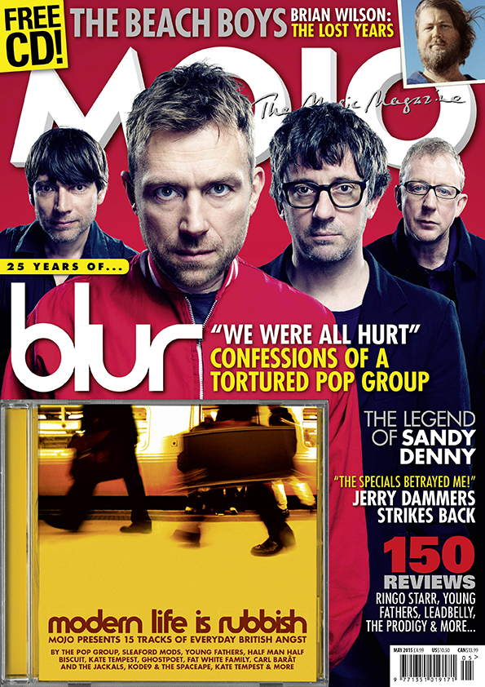

Compare the representations of musicians in these two magazine front covers, use media language in your answers:
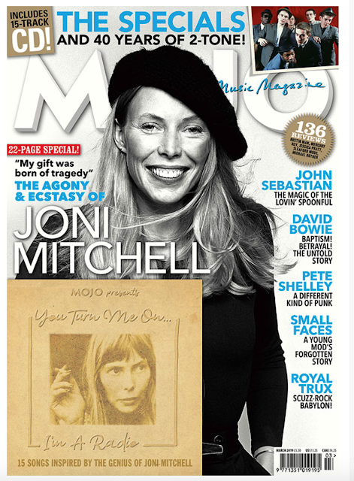

What reasons can you give that these magazines represent music artists differently?

Give three ways in which magazines can gain revenue:
1.
2.
3.

How has MOJO magazine tried to diversify?

Analyse how this magazine front cover could fulfil the four areas of the Uses and Gratifications theory:
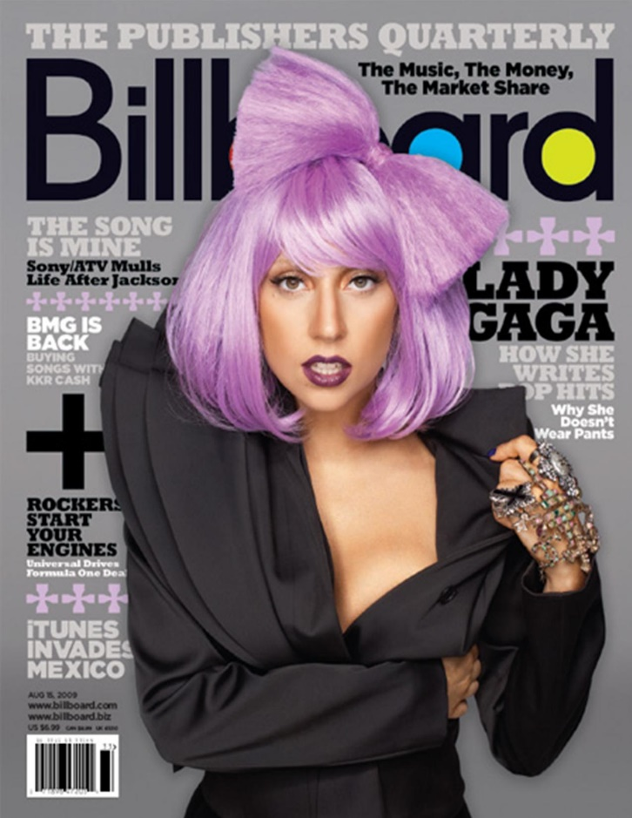 | Escapism:
 | Surveillance/education:
 | Personal Identity
 | Personal relationships:

Music Video = Little Mix, Black Magic and The Vamps, Somebody to You
Define the term convention:

Mind map the conventions of pop music videos:

Conventions of Pop music videos:

What are the three types of music video?
1.
2.
3.
Which type of music video is The Vamps, Somebody to You and how is it conventional?

Which type of music video is Little Mix, Black Magic and how is it conventional?

What is Laura Mulvey’s Male Gaze theory?

How could you apply this theory to our two set music videos?

What are the elements of Goodwin’s theory and how is it evident in our videos?
Element of the theory | Example from Black Magic | Example from Somebody to you

How are the micro elements used in our two videos?

How is mise-en-scene used to create different representations between the two videos?

What is meant by star image?

What is meant by star persona?

What are the intertextual references in the two videos?

What product placement features in the Little Mix video

Analyse a prop, explaining its impact on the narrative

Which type of lighting is used in the Little Mix video and why?

Which type of lighting is used at the end of The Vamps video and why?

What are the key ideologies of the Little mix video?

What are the key ideologies of The Vamps video?

Radio – Live Lounge, Radio 1

What is the difference between commercial and PSB radio?

Who is Lord Reith?

Who regulates Radio 1?

Which stations play the Live Lounge?

Who currently hosts the Live Lounge?

Who hosted it before these presenters?

What is the format of the Live Lounge?

How does the Live Lounge encourage audience interactivity?

How does the Live Lounge appeal to a youth audience?

How is the Live Lounge funded?

What does BBC stand for?

How many national radio stations does the BBC have?

Give four examples of how the Live Lounge is convergent:
1.
2.
3.
4.
What are the BBC’s Public Purposes?
1.
2.
3.
4.
5.

What is the remit of Radio 1?

How does the Live Lounge meet this remit and the Public Purposes?

What are the reasons for the declining listening figures of radio?

Why is this a problem for the BBC?

Explain one advantage for audiences of each of the following:
• listening to live radio

• accessing radio content online.

Identify the word that describes the coming together of different platforms, such as when radio programmes are available online:

How many followers does Radio 1 have on YouTube and Twitter?
YouTube:
Twitter:

Which audiences does Radio 1 target?

Which audiences does Radio 1Xtra target?

How are Radio 1 and Radio 4 different to each other

Apply Radio and our set episode of the Live Lounge to the Uses and Gratifications theory.
 | Radio overall | Stormzy Live Lounge episode
Escapism/entertainment
Personal Identity
Personal Relationships
Surveillance/Education

What are some of the biggest challenges for the BBC Radio 1 breakfast show today?

News
Online, Social and Participatory News = The Guardian/Observer website and social media pages

Explain one of the uses and gratifications of online news using Blumler and Katz’s theory:

Explain three ways that online newspapers can gain funding:
1.

2.

3.

When The Observer uses twitter to share news, what are the features offered by online technology that are not available to the print newspaper?

What is participatory culture?

How does online news encourage this?

How can online news create representations? Analyse this example of a tweet to answer this question:

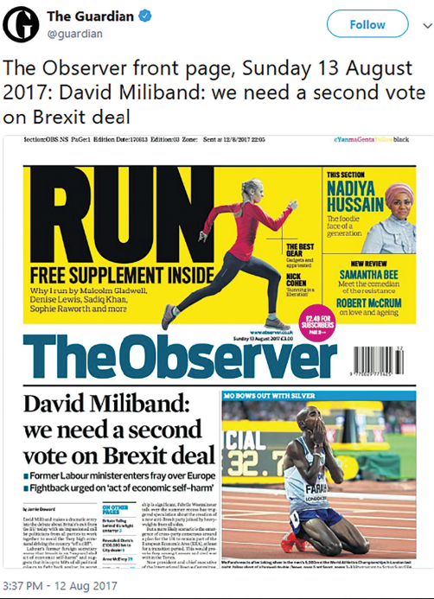

Contemporary news = 2 contemporary Observer front Covers, One complete contemporary print edition of The Observer
What are the conventions of a print broadsheet paper?

What are the conventions of a print tabloid paper?

Which is The Observer classed as and why?

Identify the trust that owns the Observer newspaper:

Who is allowed to set up and run a newspaper in a country with a free press?

Identify the word that describes the way newspapers increasingly operate on a world-wide scale:

Explain one advantage for a newspaper of each of the following:
• publishing in print

• publishing online only

What are the political and social contexts of The Observer?

How does The Observer reflect British culture?

Which demographic of people are most likely to buy The Observer and why?

Use this front cover to practice retrieval of the following questions on contemporary Print News:
- How far does the media language in the extract, the front page of The Observer, reflect genre conventions?
- Analyse the representations of social groups in the extract, the front page of The Observer. Give two examples from the extract.
- How far does the front cover of the Observer in the extract reflect its political, social and cultural contexts?
Answer these questions one the following pages
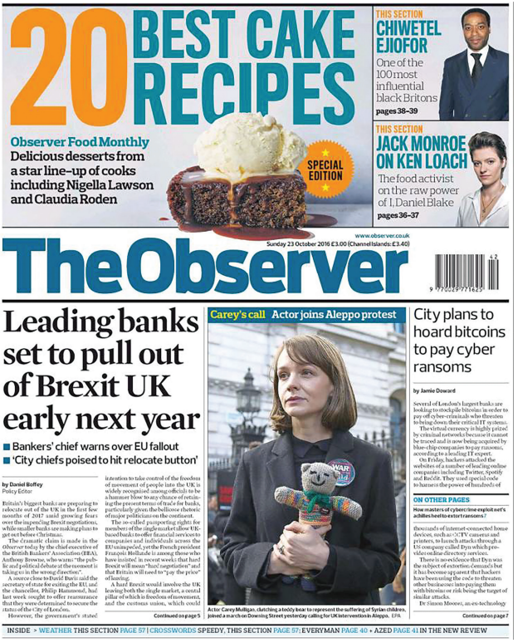
- How far does the media language in the extract, the front page of The Observer, reflect genre conventions?

- Analyse the representations of social groups in the extract, the front page of The Observer. Give two examples from the extract.

- How far does the front cover of the Observer in the extract reflect its political, social and cultural contexts?

Historical news = 3 historical news front covers, set by the exam board:
Recall a headline from each of our front covers:
- The Observer 30 October 1966

- The Observer 6 November 1966

- The Observer 20 October 1968

Recall an image from each of our front covers:
- The Observer 30 October 1966

- The Observer 6 November 1966

- The Observer 20 October 1968

Give an example of sensationalist language from one of the front covers:

Give an example of patriotic language from one of our front covers:

Create a mind map to reflect how historical contexts influence the representations in newspapers from the 1960s, referring to examples and stories from the papers:

The Observer 30 October 1966

The Observer 6 November 1966

The Observer 20 October 1968

Historical newspapers

