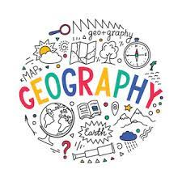
Important information about Y9-11 Geography
Teachers and classes
Course specification
Schemes of work
End of topic test and mock exam termly dates
Revision materials
Geography revision club timetable
Exam technique

Classes and teachers
Most classes may have two teachers. For Y10 and 11, the single period will be retrieval work and the double will be new content.
Y9
Form | Teacher(s)
9.1 | Mr D Egan
9.2 | Miss C Somerfield
9.3 | Mr D Egan
9.4 | Miss C Somerfield
9.5 | Mr D Egan
9.6 | Mr D Egan
9.7 | Mr D Egan and Miss C Somerfield

Y10
Double – (Lead teacher) | Single
10B - Mr D Egan | Mr D Egan
10C – Mrs S.Wilde | Mr D Egan
10D - Mrs S.Wilde | Mr D Egan
10F - Mrs S.Wilde | Miss C Somerfield

Y11
Double – (Lead teacher) | Single
11A - Mrs S.Wilde | Mrs S.Wilde
11B1 – Mrs H Beeson 10B2 - Mrs S.Wilde | WHOLE CLASS - Mrs S.Wilde
11C - Mrs H Beeson | Mrs H Beeson
11D - Mrs S.Wilde | Mrs S.Wilde

Contacts
N. White (Head of Geography) – n.white@walton.staffs.sch.uk
S.Wilde (Second in department) – s.wilde@walton.staffs.sch.uk
H.Beeson (Second in department) – h.beeson@walton.staffs.sch.uk
D.Egan – d.egan@walton.staffs.sch.uk
Qualification breakdown:
Paper 1 Physical Geography = 35%
Paper 2 Human Geography = 35%
Paper 3 Pre-release decisions and fieldwork (CMV and Stafford) = 30%
GCSE GEOGRAPHY COURSE SPECIFICATION
Exam board: AQA

UNIT 1: Living with the PHYSICAL environment
Or Holderness Coastline
A: Urban Issues and Challenges  UNIT 2: Living in the HUMAN environment | B: The Changing Economic World | C: The Challenge of Resource Management
THE URBAN WORLD  - Megacities  - Rio de Janeiro: social, economic and environmental challenges  - Improving Rio’s environment  - Managing the growth of squatter settlements  - Planning for Rio’s urban poor | THE DEVELOPMENT GAP  - Our unequal world and measuring development  - The DTM and population pyramids  - Causes of uneven development  - Uneven development: wealth and health, and migration  - Reducing the gap: aid and intermediate technology, fair trade, debt relief and tourism  - CASE STUDY Jamaica | RESOURCE MANAGEMENT  - Global distribution of resources  - Provision of food in the UK  - Provision of water in the UK  - Provision of energy in the UK
URBAN CHANGE IN THE UK  - Where do we live?  LONDON  - Urban change creating social and economic opportunities  - Urban change and impact on the environment  - Social inequality  - New housing  - Stafford regeneration | NIGERIA: A NEWLY-EMERGING ECONOMY  - Exploring Nigeria  - Nigeria in the wider world  - Balancing a changing industrial structure  - Impacts of Transnational corporations  - Impact of international aid  - Managing environmental issues  - Quality of life | WATER MANAGEMENT  - Global water supply  - The impact of water insecurity  - How can water supply be increased?  - NSWTP China CASE STUDY  - Sustainable water supplies  - Hitosa, sustainable management CASE STUDY
URBAN SUSTAINABILITY  - Planning for urban sustainability  - Sustainable living in Freiburg  - Sustainable traffic management  - Curitiba Integrated Transport system | THE CHANGING UK ECONOMY  - Changes in the UK economy  - Post-industrial economy  - UK science and business parks  - Environmental impacts of industry, Car industry  - Changing rural landscapes  - Changing transport infrastructure  - North-south divide  - UK in the wider world
NB: Y11 – The fieldwork element has been removed from Paper 3 2022 so this part is not applicable.
UNIT 3: Geographical Applications and Skills
Issue Evaluation | Fieldwork | Geographical Skills
This is a synoptic section which has a pre-release resource booklet for study | - Investigating processes and management  - Primary data collection  - Processing and presenting data  - Analysing and reaching conclusions  - Evaluating fieldwork  - All must be completed for both physical and human fieldwork in Brighton | - Cartographic skills  - Graphical Skills  - Statistical Skills

GCSE Fieldwork locations
Two fieldworks are required during the course, each focusing on human and physical Geography. Both fieldworks will have classroom prep and write up time before and after the excursions.
Physical fieldwork (Y10)
Carding Mill Valley, Shropshire
River investigation – collecting data about the characteristics of the river such as width, depth and velocity.

Human LOCAL Fieldwork (Y11)
Investigation into Stafford town centre’s regeneration of the Riverside area and it’s impact on the main high street.

GCSE Timetable
NB: This may be subject to change due to unforeseen circumstances.
Current Y10/11 may differ slightly due to Year 9 now being in Key Stage 3 altering the order:

2023/24 GCSE End of topic test and Mock exams
Year | End of topic tests | Mocks
9 | Oct 23 – Resource mgt  Apr 23 – Natural Hazards | July 23 – End of Y9 test:  Resource mgt  Natural Hazards –  Tectonics & climatic weather & climate change  Coasts
10 | Oct 23 - Living World - Rainforest  Mar 24 - Deserts | June 23 –  Living World  Urban  TBC topic from Y9
11 | Oct 23 – Urban  Feb 24 - Economic World | Nov 23– mixture of Paper 1 and 2 TBC nearer the time  Resource management  Living World  Coasts  Urban  March 24 –  Economic World  Natural Hazard  Urban  TBC  April 24 – Paper 3 mock  Pre-release booklet (March 24) and Geog skills
NB: These are rough timelines, end of topic test dates are set in line with teaching.

GCSE Revision guide materials
Each year CPG AQA Geography materials will be on offer to purchase, the bundles will on Parentpay accompanied with an information letter with prices and weblinks.
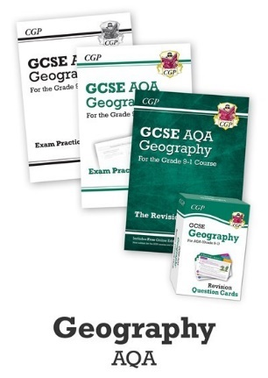

Praise within the department
Class teachers will identify students based on their effort and achievements across the lessons to email to students and parents a praise card (nb. These will come from the email addresses above).
Laminated book marks to help with revision will also be handed out.

HOW TO EFFECTIVELY REVISE WITH GCSEPOD – CONTENT UNDERSTANDING
GCSEpod won’t help with exam technique but it is excellent for content revision.
AQA - https://members.gcsepod.com/content?subject_id=6016&exam_board_id=1010
- Watch each clip in the topic. No notes are required. You could watch a couple a night over 2 weeks.
- When you have finished the clips - Watch the clips again but before you press play create a map / list of what the clip is about. Press play and add to your work the facts you missed in a different colour.
- Mixture for revision – Your choice, identify your weak areas and focus on those topics.
Y9
Sept – Oct 1st half term  Natural Hazard – Climatic weather  Watch  Repeat | Nov – Dec 2nd half term  Natural Hazard – Tectonic clips  Watch  Repeat | Jan – Feb 3rd half term  Natural Hazard – Climate change  Watch  Repeat
Mar – Apr 4th half term  Coasts  Watch  Repeat | Apr – May 5th half term  Coasts  Watch  Repeat | June – July 6th half term  Glaciation and Mixture for end of year test  Watch  Repeat
Y10
Sept – Oct 1st half term  Glaciation and Natural hazards  Watch  Repeat | Nov – Dec 2nd half term  Glaciation and Coasts  Watch  Repeat | Jan – Feb 3rd half term  Living World - Rainforests  Watch  Repeat
Mar – Apr 4th half term  Living World – Deserts  Watch  Repeat | Apr – May 5th half term  Urban and River processes for fieldwork  Watch  Repeat | June – July 6th half term  Mixture for end of year test  Watch  Repeat
Y11
Sept – Oct 1st half term  Urban  Watch  Repeat | Nov – Dec 2nd half term  Economics  Watch  Repeat | Jan – Feb 3rd half term  Economics and Resource management  Watch  Repeat
Mar – Apr 4th half term  Mixture for GCSE exam  Watch  Repeat | Apr – May 5th half term  Mixture for GCSE exam  Watch  Repeat | June – July 6th half term  Mixture for GCSE exam  Watch  Repeat
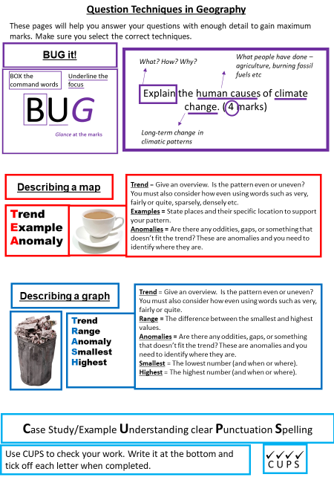
Exam technique tip
