How to use GCSE Pod for KS3 Consolidation and Challenge
- Follow this link to GCSE Pod: https://www.gcsepod.com/

- Click “login” and use your school email and password to login to the site. You will need to click onto this button to do this:

- Once on GCSE Pod, you can use the following links to access a number of playlists of Podcasts to consolidate and challenge your KS3 knowledge:

Maths: https://members.gcsepod.com/shared/podcasts/title/13626/82160

English Literature: https://members.gcsepod.com/shared/podcasts/title/13644/82101

English Language: https://members.gcsepod.com/shared/podcasts/title/13640/82051

Science: https://members.gcsepod.com/shared/podcasts/title/13655/82411

Geography: https://members.gcsepod.com/shared/podcasts/title/13624/82402

History: https://members.gcsepod.com/shared/podcasts/title/13633/82406

Religious Studies: https://members.gcsepod.com/shared/podcasts/title/13660/82503

Computer Science: https://members.gcsepod.com/shared/podcasts/title/13671/82675

ICT: https://members.gcsepod.com/shared/podcasts/title/13661/82528

French: https://members.gcsepod.com/shared/podcasts/title/13628/82404

German: https://members.gcsepod.com/shared/podcasts/title/13656/82469

Physical Education: https://members.gcsepod.com/shared/podcasts/title/13658/82480

Technology: https://members.gcsepod.com/shared/podcasts/title/13665/82571

Food: https://members.gcsepod.com/shared/podcasts/title/13669/82653

Music Theory: https://members.gcsepod.com/shared/podcasts/title/13666/82602

How can GCSE Pod help with KS3 Consolidation and Challenge?
- Students can watch the playlists of podcasts for specific subjects, using the links above.

- Students can use the Check and Challenge Quizzes to self-assess their understanding after accessing some Podcasts. These quizzes are self-marking and give instant feedback. To access Check and Challenge Questions:

- Click on this logo after the set of podcasts that have been viewed:

- The screen that appears like this, shows that students can access hints, can see how difficult the question is, and can check their answer before moving onto the next question.
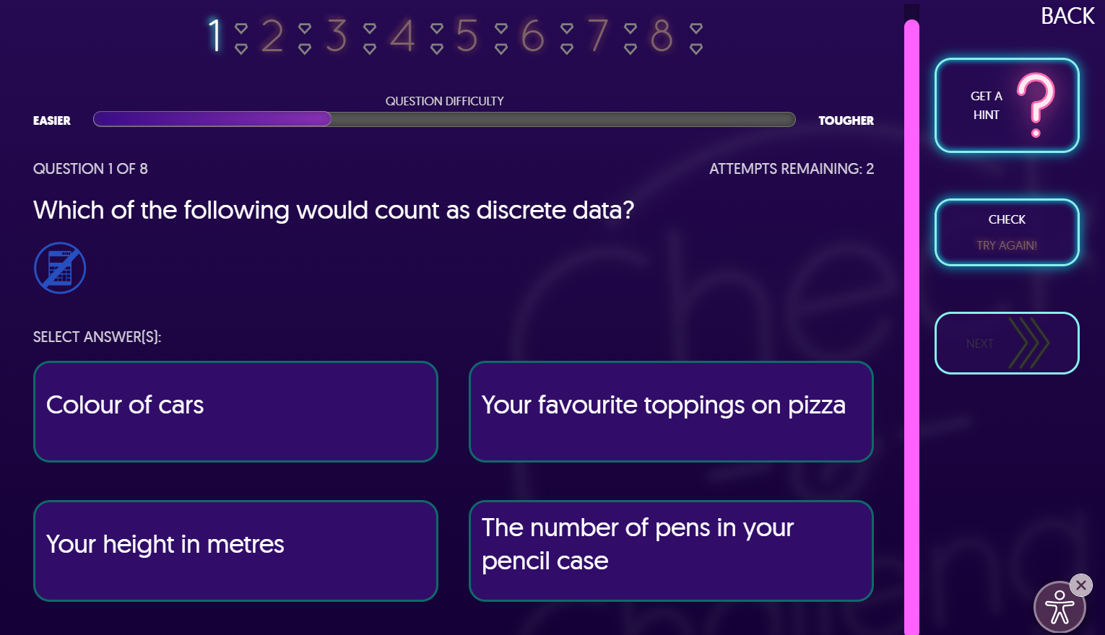

- An explanation is given for any incorrect answer, and students have to select the correct answer before they can move onto the next question.
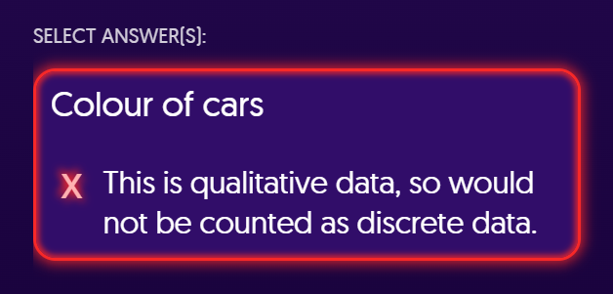

- Students can access and download workbooks for each subject.

- Click on the “Extra Resources” button on the top banner after watching the podcasts.
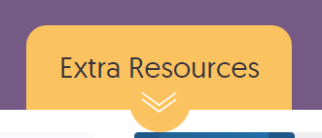

- Download the workbook by clicking on the pink button. This gives students access to material to help them consolidate KS3 knowledge, and prepare for the next key stage.

