How to use GCSE Pod to Support Learning at GCSE
- Follow this link to GCSE Pod: https://www.gcsepod.com/

- Click “login” and use your school email and password to login to the site. You will need to click onto this button to do this:

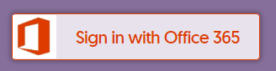

- To search for a specific Pod set by your teacher, or from the Pod Code Documents, simply copy the Pod code and paste it into the search bar at the top of the web-page.

- This will produce a list of Podcasts and Activities, so select what is relevant to your learning:

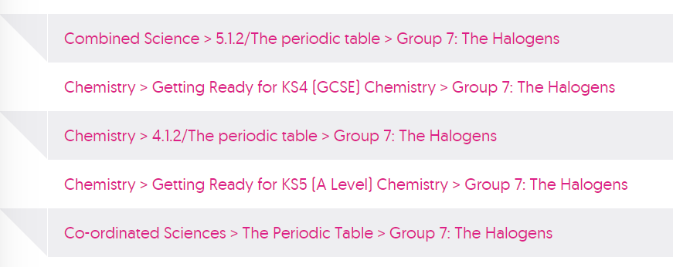

How can GCSE Pod support my learning?
- Students can watch playlists of podcasts for specific subjects, by searching within each subject or by using subject-specific codes (see documents)

- Students can use the Check and Challenge Quizzes to self-assess their understanding after accessing some Podcasts. These quizzes are self-marking and give instant feedback. To access Check and Challenge Questions:

- Click on this logo after the set of podcasts that have been viewed:

- The screen that appears like this, shows that students can access hints, can see how difficult the question is, and can check their answer before moving onto the next question.
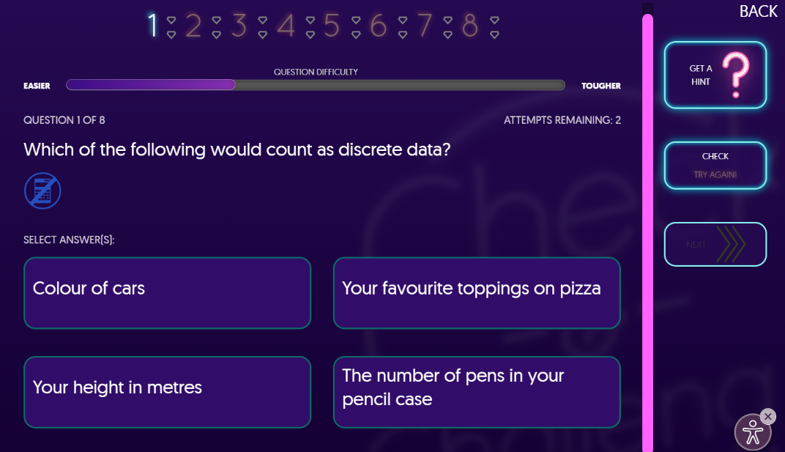

- An explanation is given for any incorrect answer, and students have to select the correct answer before they can move onto the next question.
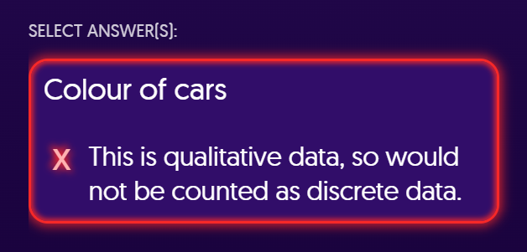

- Students can access and download workbooks for each subject.

- Click on the “Extra Resources” button on the top banner after watching the podcasts.

