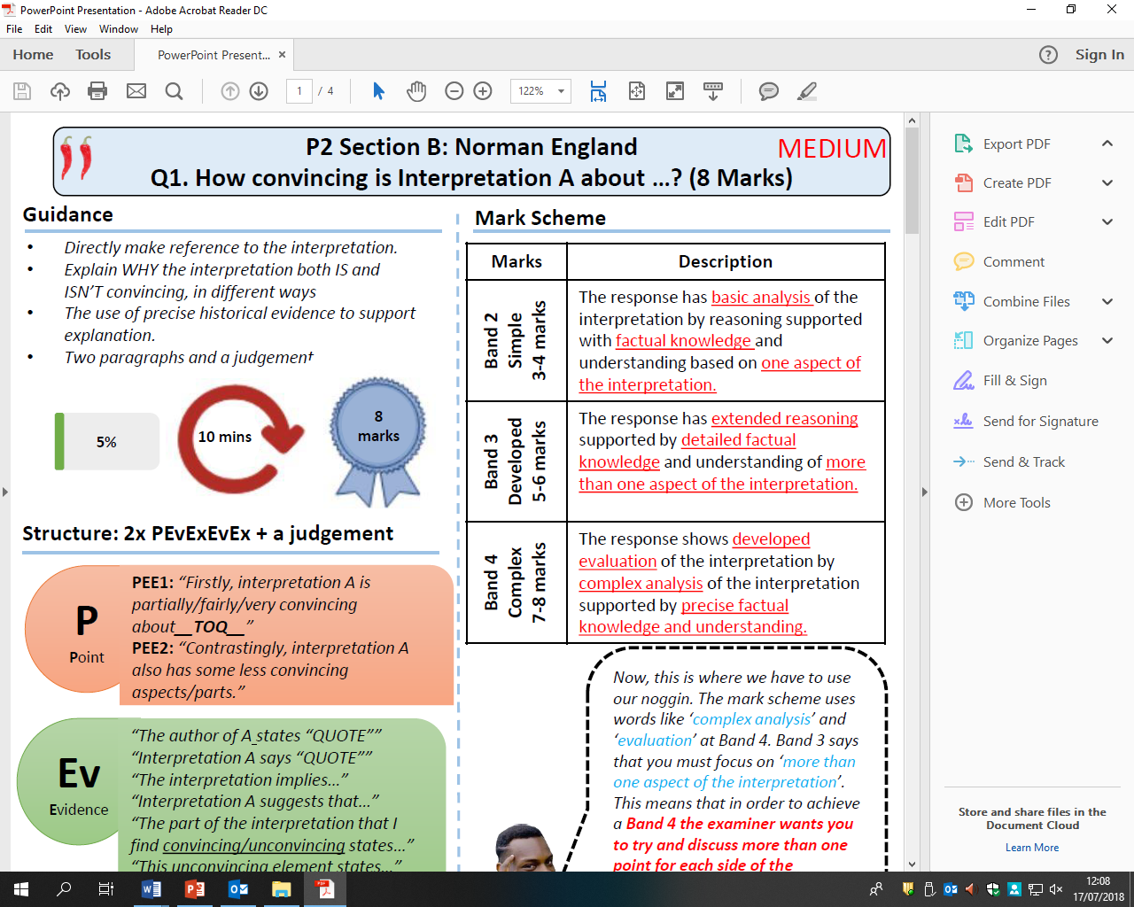

How convincing is Interpretation C about the way that William dealt with rebellions?

Explain using Interpretation C and your own contextual knowledge