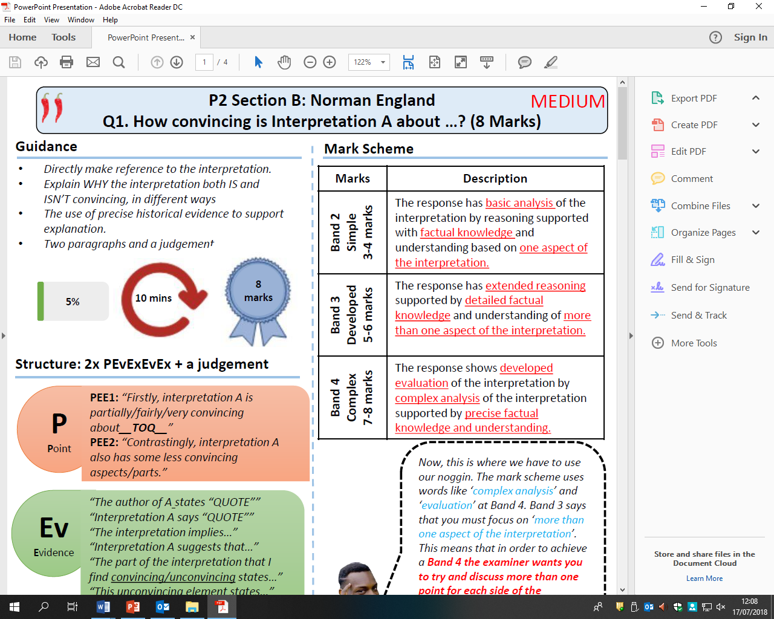

How convincing is Interpretation C about rebellion of Hereward the Wake?

Explain using Interpretation C and your own contextual knowledge