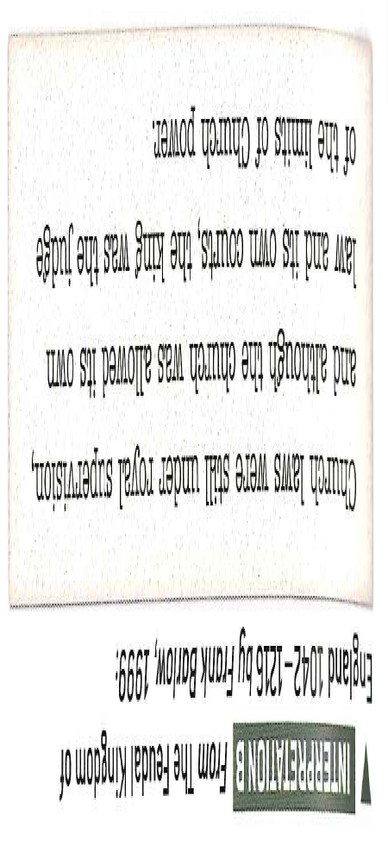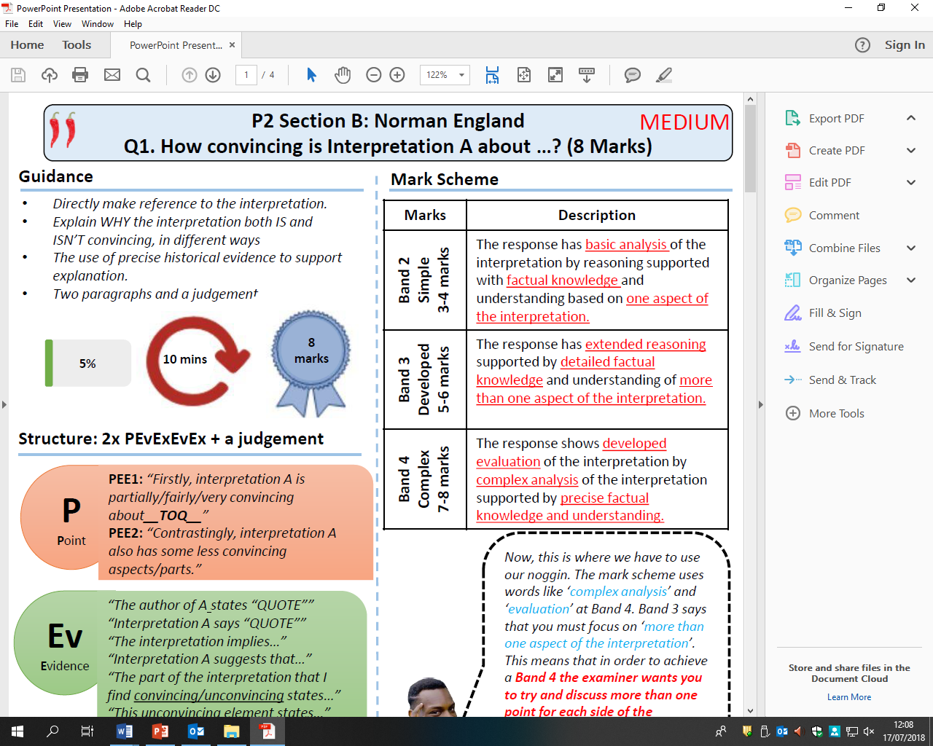

How convincing is Interpretation B about the role of the Norman Church?

Explain using Interpretation B and your own contextual knowledge