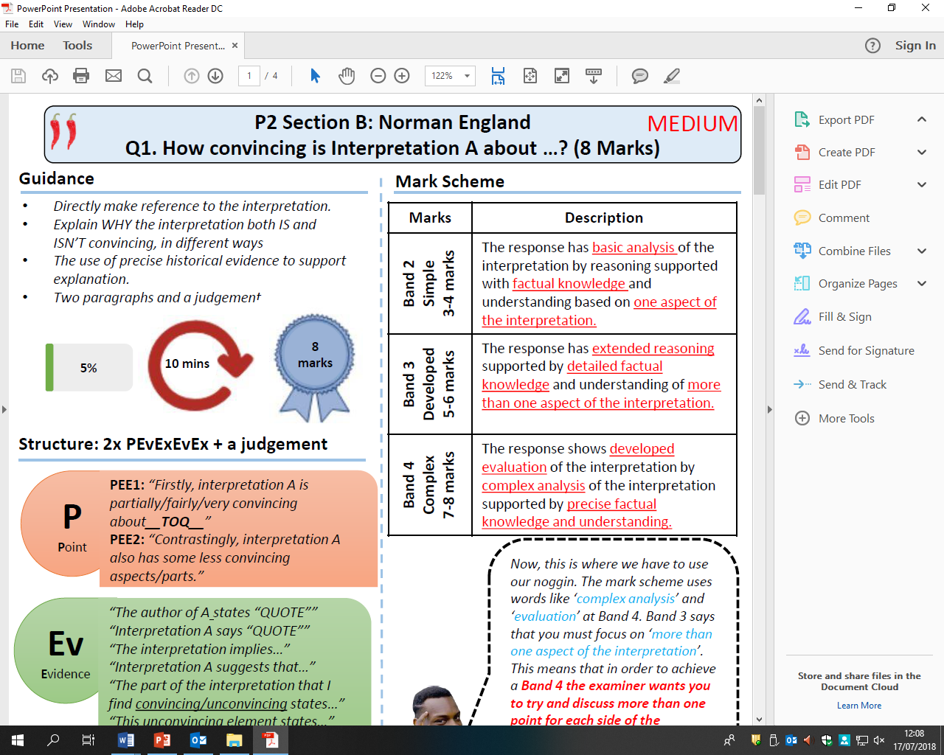

How convincing is Interpretation B about Norman Motte and Bailey castles?

Explain using Interpretation B and your own contextual knowledge