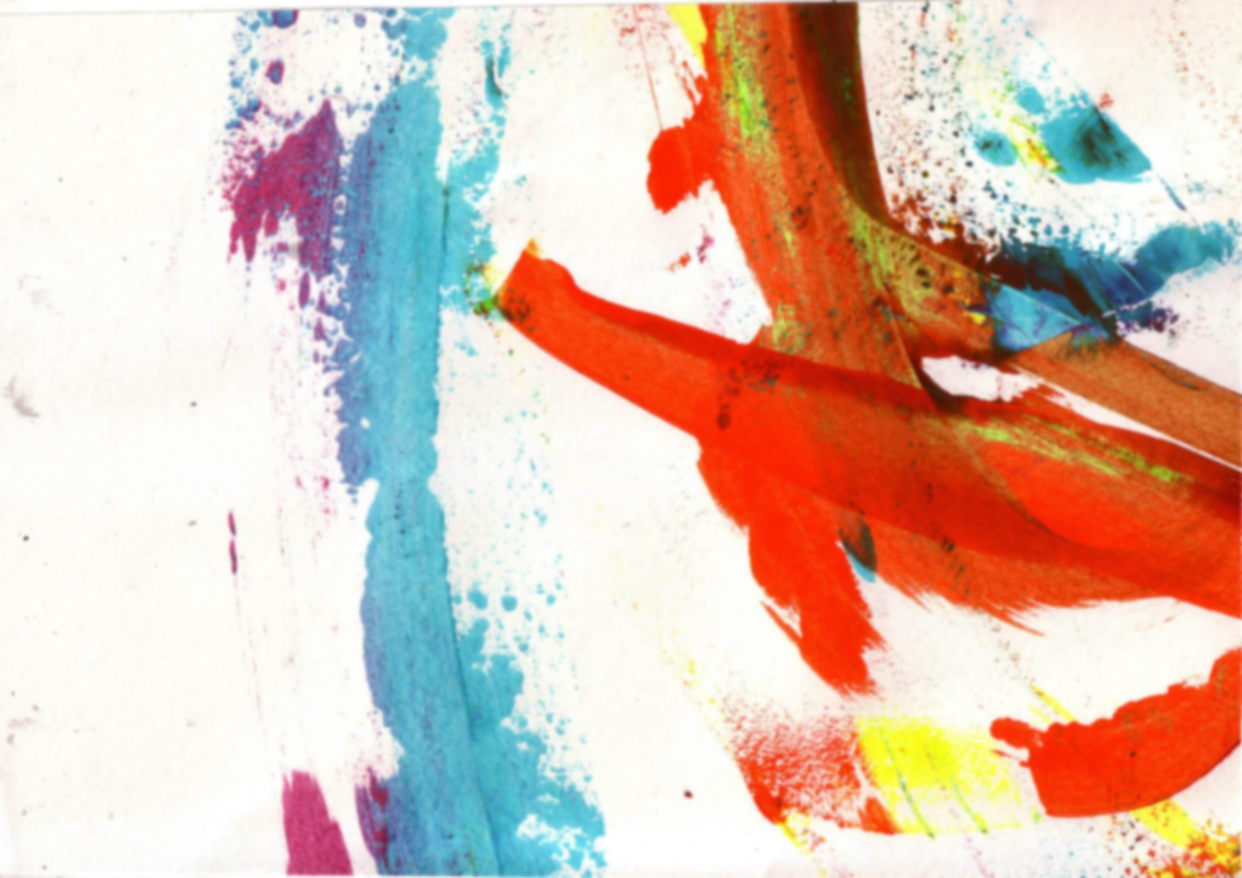
These are your homework tasks for this term. Your teacher will tell you which homework to complete each week so you may not complete them in this order.
As well as these tasks, you will be expected to collect and bring in a variety of readily available materials to prepare for classwork. When your teacher asks you to collect something, make sure you write this down in your planner.
If you’re looking for an additional challenge, look at the bubbles on this page for some extension tasks!

Year 9 Homework
Term 3 – Wrapped and Packed

All additional resources are available online or in the shared area at school!
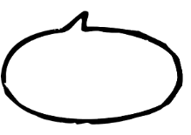
What other examples of
Collage artists can you find?
Create a title page for Wrapped and Packed.  on the next page in your sketchbook.  Follow the ‘How to create a title page’ guidelines to help you. | Complete an assessed drawing of a crushed can to fill a single page of your sketchbook.  You will be marked on Tone, Accuracy and Detail. | Find some information about the artist Kurt Schwitters. You could find a website, watch a video clip… | Create an artist page about the artist  Kurt Schwitters  Follow the ‘How to create an artist page’ guidelines to help you.  What other artists can you find that look at  Still Life  Do some research and find some examples. | Respond to your teacher feedback comments and take action! | Complete a double page collage in your sketchbook based on the work of Kurt Schwitters. There should be no white gaps. | Present the Colour theory you have learnt in lessons into your sketchbook.  This could be a colour wheel, colour swatches and written theory.  Give it a go! Make a piece of artwork in the style of the artist!

Collect object and/or take photographs for a still life based on the work of Audrey Flack. | Print 4 images of Audrey Flack’s work and bring them to your lesson.  Why not try...  Looking at Gavin Turk’s bin bag.  Could you make a drawing or sculpture from rubbish? | 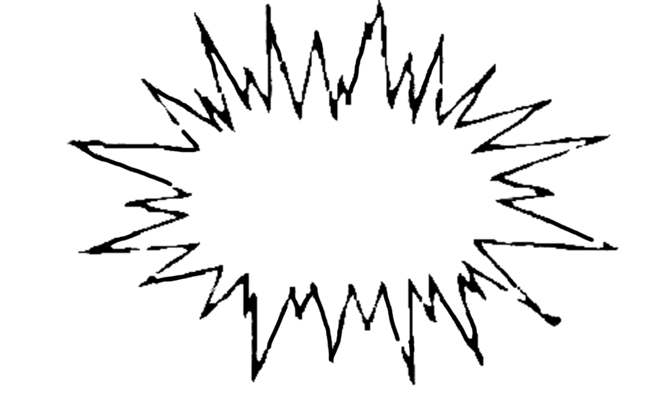  Collect and bring in old packaging for example, cup with straw, paper bag, chip box, sandwich container. | Collect and present source imagery that you want to add to your packaging. Use both images and text. What do you want your theme to be? | Evaluation of final your unit of work. | 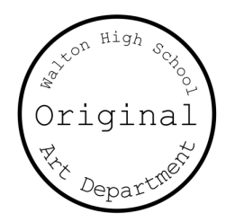  Want to learn some more about art? Investigate the Memento Mori room at Tate Kids! Head over to: http://kids.tate.org.uk/games/memento-mori/
