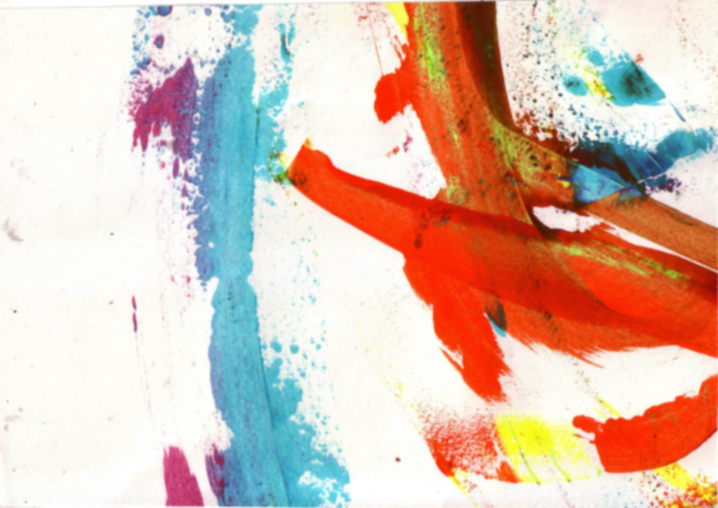
Year 9 Homework
Term 1 – Toys & Sweets
These are your homework tasks for this term. Your teacher will tell you which homework to complete each week so you may not complete them in this order.
As well as these tasks, you will be expected to collect and bring in a variety of readily available materials to prepare for classwork. When your teacher asks you to collect something, make sure you write this down in your planner.
If you’re looking for an additional challenge, look at the bubbles on this page for some extension tasks!

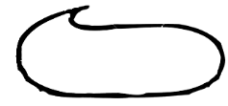
All additional resources are available online or in the shared area at school!
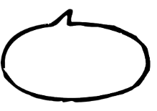
What other examples of Installation Art can you find?
Create a title page for ’Sweets and Toys’ on the first page in your sketchbook.  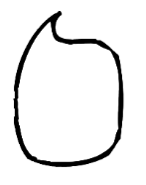  Follow the ‘How to create a title page’ guidelines to help you. | Complete an assessed drawing relating to Toys & Sweets. Your teacher will tell you what to draw.  Why not try... creating your own photographic still life of a selection of Toys & Sweets? | 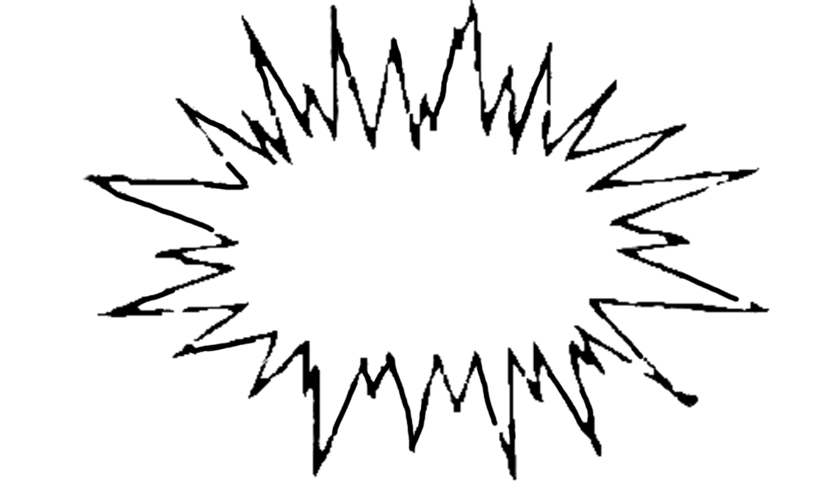  Complete the two tasks on page 1 of homework booklet, ‘Conceptual Art’.  What other artists can you find that look at Toys & Sweets?  Do some research and find some examples. | Complete the three tasks on page 2 of your homework booklet ‘The Readymade’. | Complete the two tasks on page 3 of your homework booklet ‘Installation Art’.  Give it a go! Make a piece of artwork in the style of the artist! | Create a collage of toys or sweets from your past. | Complete the two tasks on page 4 of your homework booklet ‘Poppies’.

Complete the task on page 5 of your homework booklet ‘The Written Word’. | Create an artist page about the artist Sarah Graham.  Follow the ‘How to create an artist page’ guidelines to help you. | Respond to your teacher feedback comments and take action! | Complete the tasks on page 6 in your homework booklet ‘Pop Art’. | Look at the work of Jeff Koons.  Look at the artist resource on our website and in the shared area.  Want to learn some more about art? Investigate the Memento Mori room at Tate Kids! Head over to: http://kids.tate.org.uk/games/memento-mori/ | Evaluation of final piece and Toys & Sweets project.  