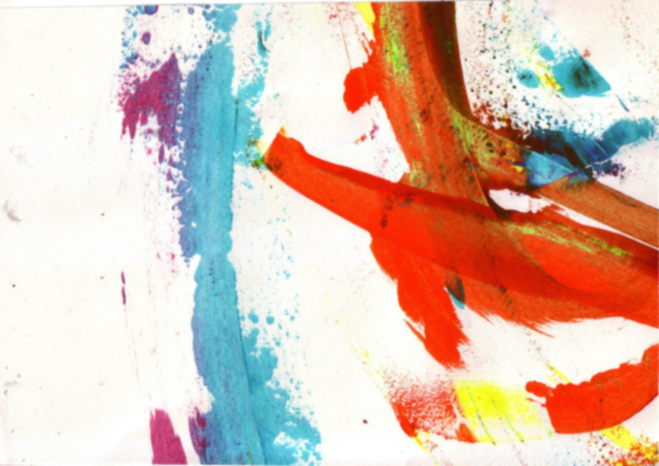
These are your homework tasks for this term. Your teacher will tell you which homework to complete each week so you may not complete them in this order.
As well as these tasks, you will be expected to collect and bring in a variety of readily available materials to prepare for classwork. When your teacher asks you to collect something, make sure you write this down in your planner.

Year 10 Homework
Term 1 – Supporting Unit

All additional resources are available online or in the shared area at school!

Take photographs and bring in objects  of items that reflect your personality. For example album covers, sports equipment, make up, personal possessions. | Prepare gallery booklet ready for The gallery visit. | Finish the presentation of your gallery booklet. Give it the ‘wow’ factor, the busier the better. Collage things you have collected, finish drawings etc. | Finish Jigsaw piece started in class. | Take your own Portrait photography. Present the contact sheet in your sketchbook and enlarge your 3 most successful photos. | Finish presenting portrait theory on a double page in your sketchbook. | 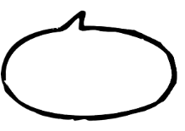  Present 2 of the 3 three artists looked at in class as artist research pages in your sketchbook. Use the Mood/Process/Content/Inspiration format.  ARTISTs:  John Stezaker, Julie Cockburn and Heikki Leis

Make a Flip book person in your sketchbook. With a minimum of three layers.  Your teacher will show you examples of this. | Finish portrait started in Class | Manipulate 3 of your original photographs based on the work you are producing in class. | Finishing off week!!  Have you got any work still to complete??  Are you up to date responding to your feedback? This is how you improve your grade. | Produce a mind map based on your chosen theme for identity. | 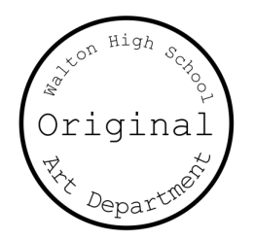  Create a Pinterest board based on your personal theme.  Create a hard copy mood board based on all of your original research.

