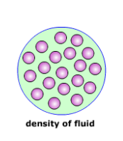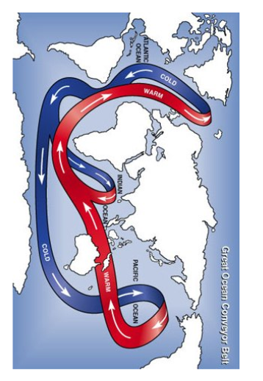[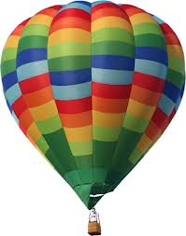](http://www.google.co.uk/imgres?q=hot+air+balloon&um=1&hl=en&tbo=d&rls=com.microsoft:en-gb:IE-Address&biw=1619&bih=762&tbm=isch&tbnid=rjQqobPvmIqu8M:&imgrefurl=http://www.devonandsomersetballoons.co.uk/&docid=SytSVtuToTFi3M&imgurl=http://www.devonandsomersetballoons.co.uk/Sites/Devon%20and%20Somerset%20Balloons/library/files/1-dands_balloon.png&w=376&h=478&ei=JGPGUIePLYX80QW_jICgAg&zoom=1&iact=hc&vpx=620&vpy=136&dur=443&hovh=253&hovw=199&tx=69&ty=106&sig=106201589725563118382&page=1&tbnh=149&tbnw=118&start=0&ndsp=39&ved=1t:429,r:5,s:0,i:162)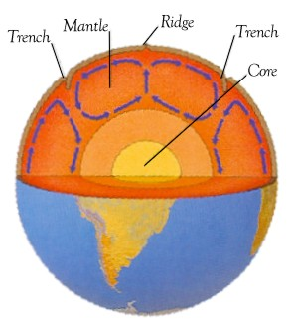

Density of gas particles

Density of gas particles

Density of gas particles

Density of gas particles

**Apply this to these**

The gas or liquid particles are now moving….

The density of the air is…

The gas or liquid particles are now moving….

The density of the air is…

**CONVECTION**

The gas or liquid particles are now moving….

The density of the air is…

The temperature of the gas is_______________

How fast are the gas or liquid particles moving?

Describe the density of the air.

