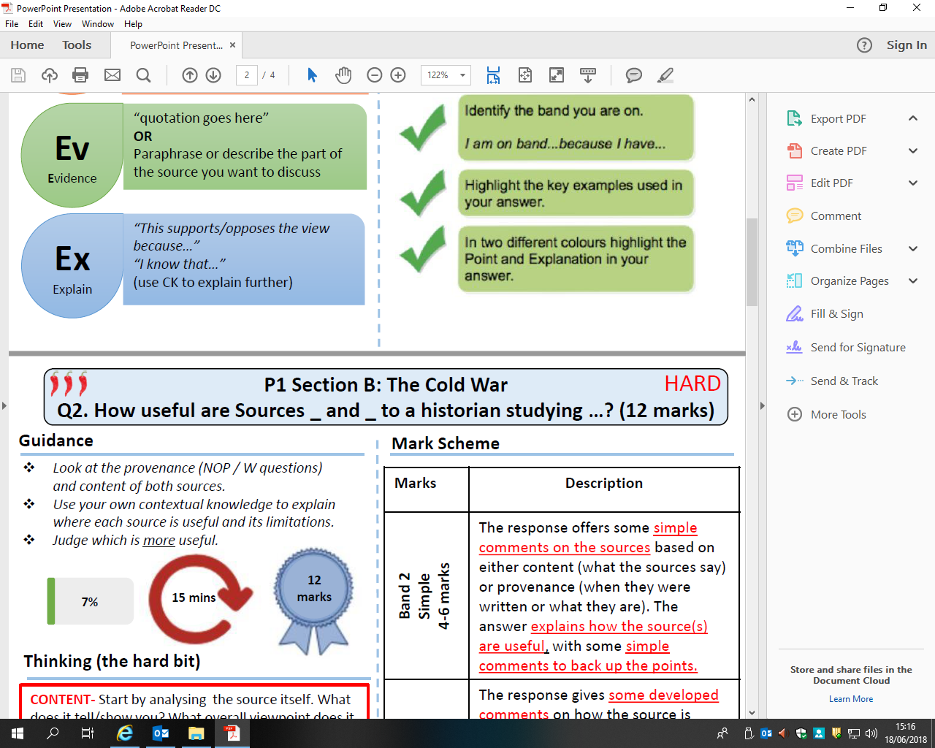[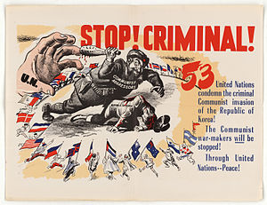](https://www.google.co.uk/url?sa=i&rct=j&q=&esrc=s&source=images&cd=&cad=rja&uact=8&ved=2ahUKEwijw6uc3YfcAhXBUBQKHX35B90QjRx6BAgBEAU&url=https://en.wikipedia.org/wiki/United_Nations_General_Assembly_Resolution_498&psig=AOvVaw1uuZtzoZR7AGexysQ1YP4Q&ust=1530872124554612)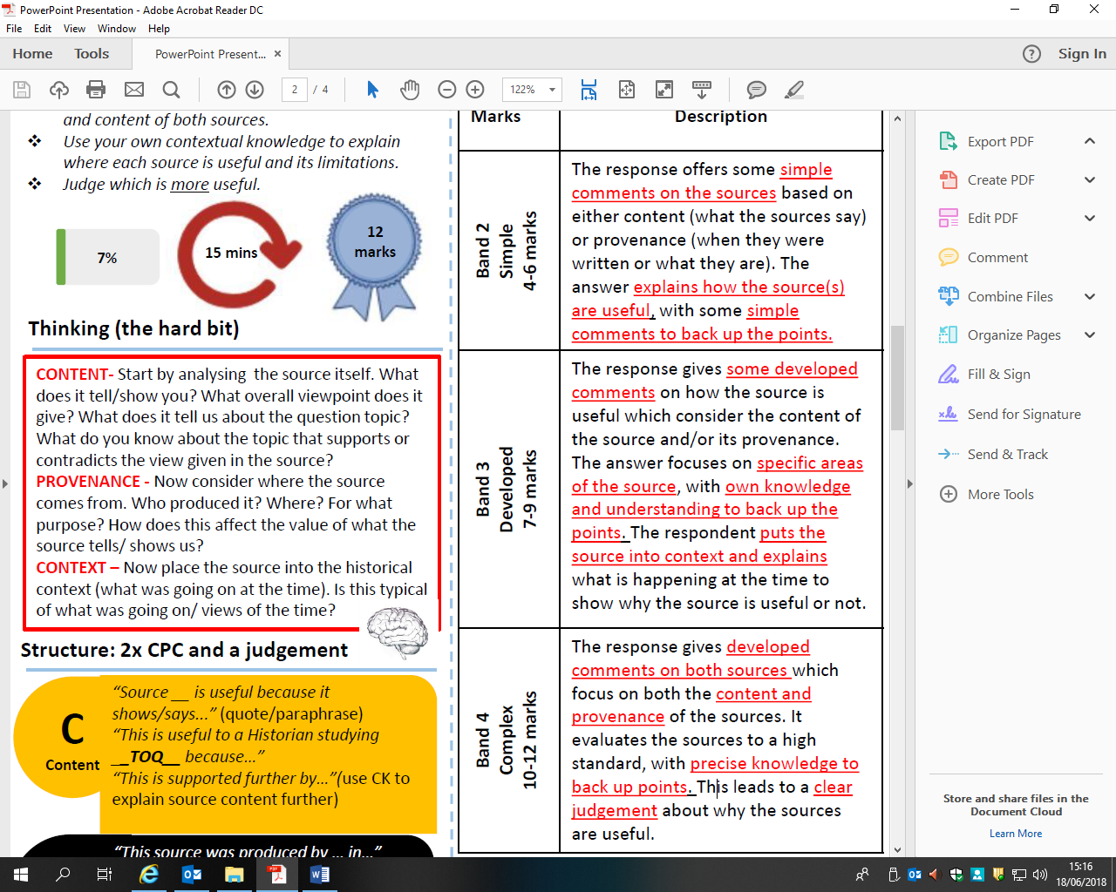

**Source A**

A United Nations poster, published in October 1950.

Study Source A. Source A supports the United Nations intervention in Korea. How do you know?

Explain your answer using Source A and your contextual knowledge.

E