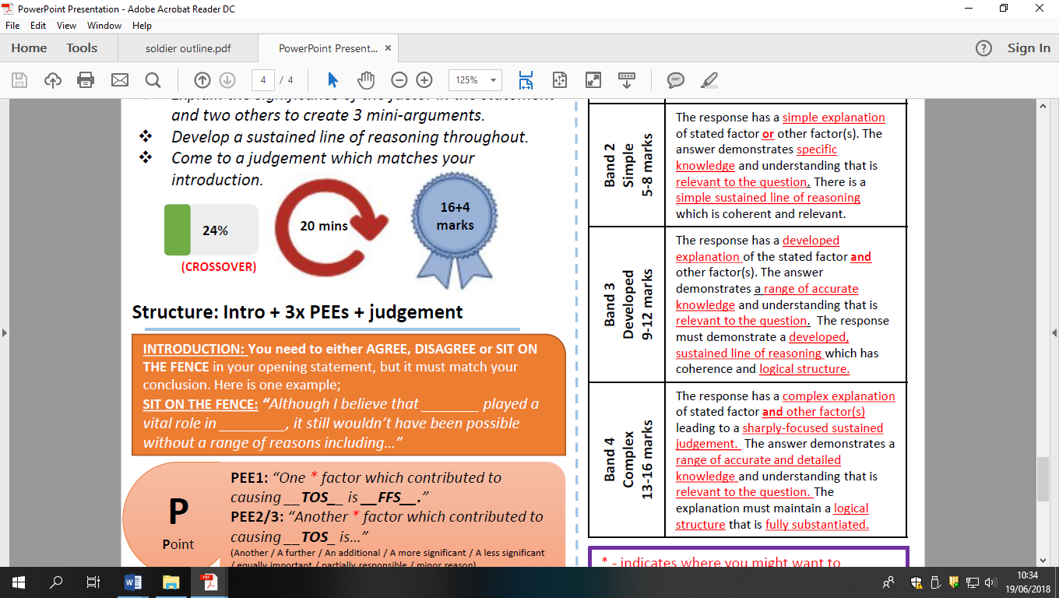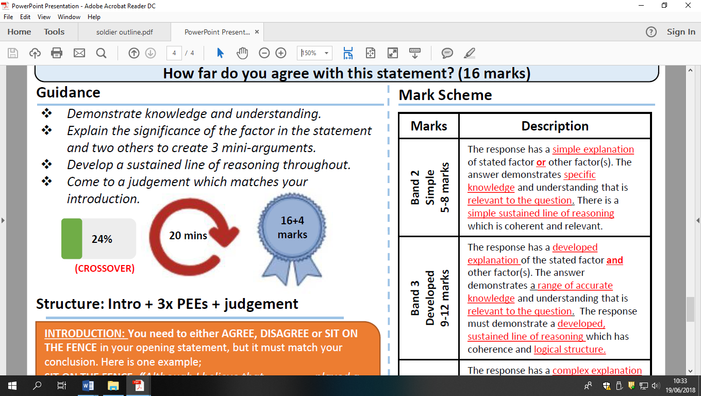

The lack of American involvement in Hungary in 1956 shows there was a thaw in the Cold war in 1950s HFDYA?