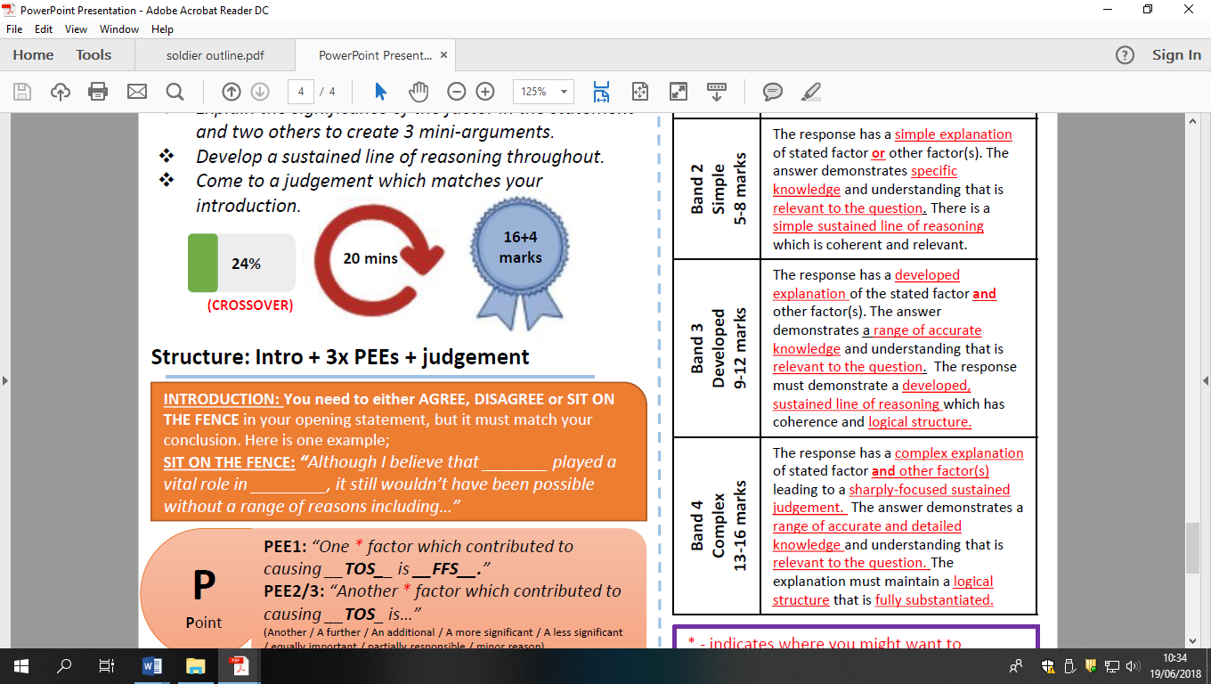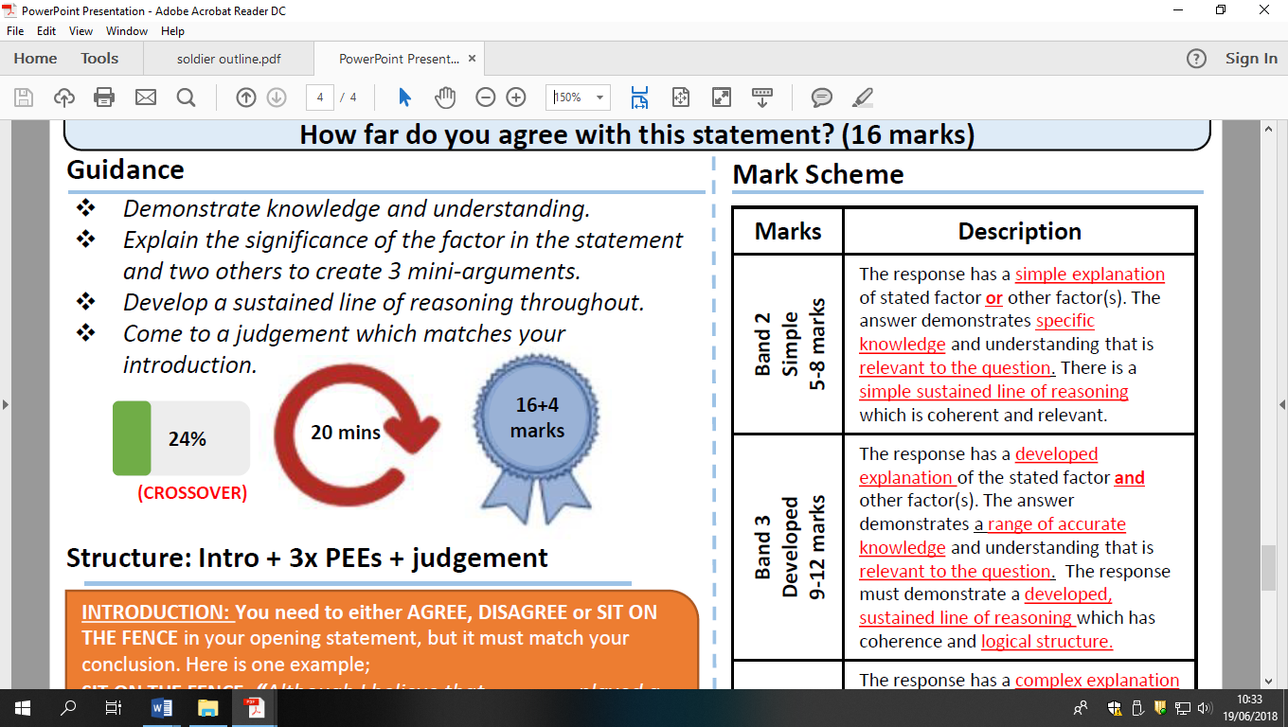

The bombing of Hiroshima destroyed the chance for a good relationship between East and West after the Second World War HFDYA?