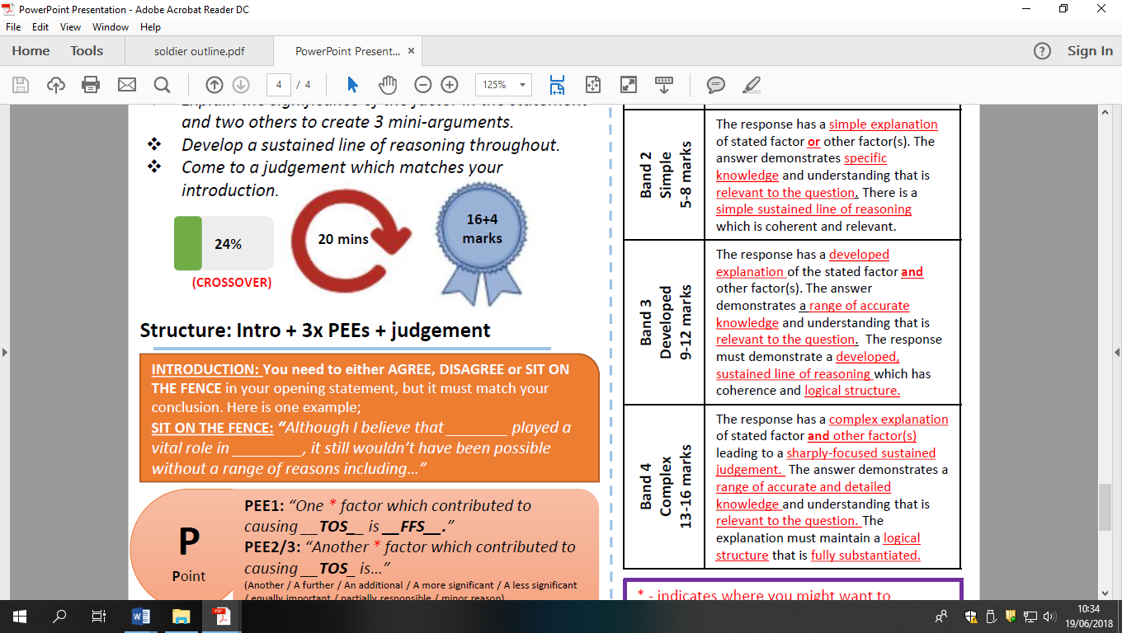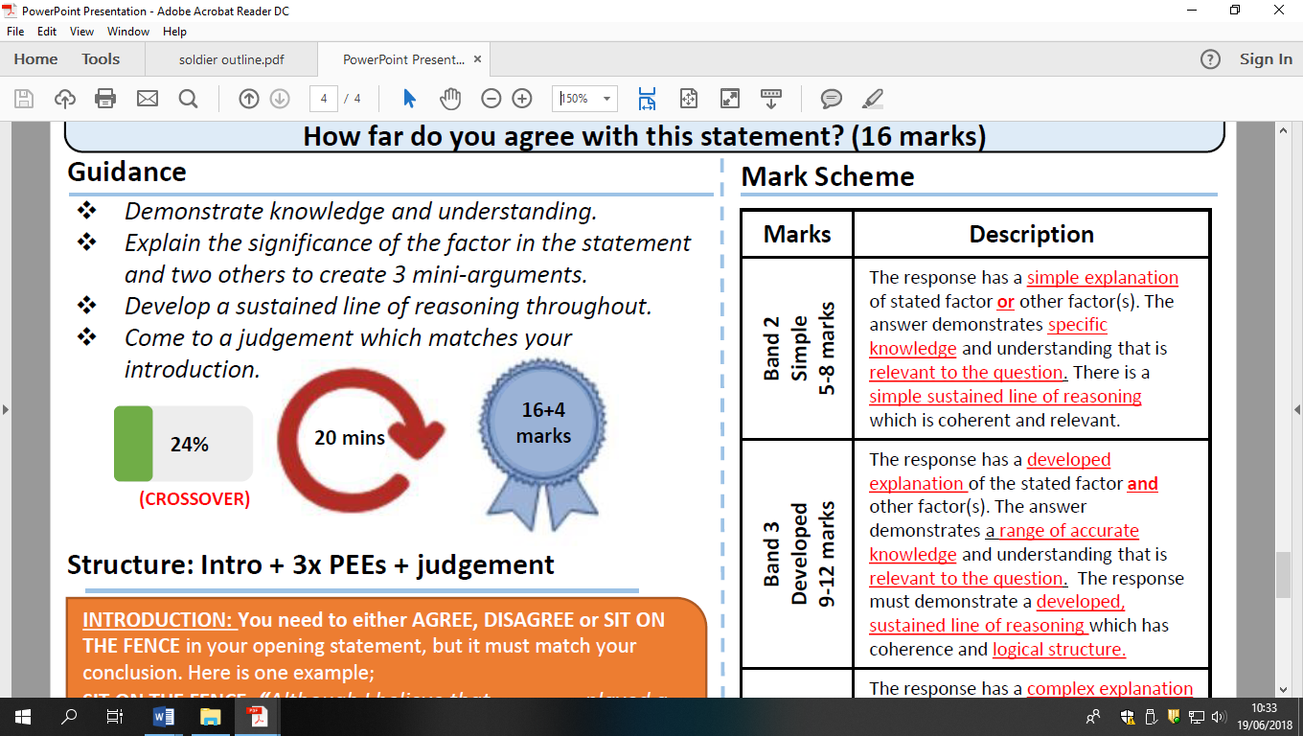

The main reason for tension between the superpowers 1945-9 was the issue of Berlin’ HFDYA?