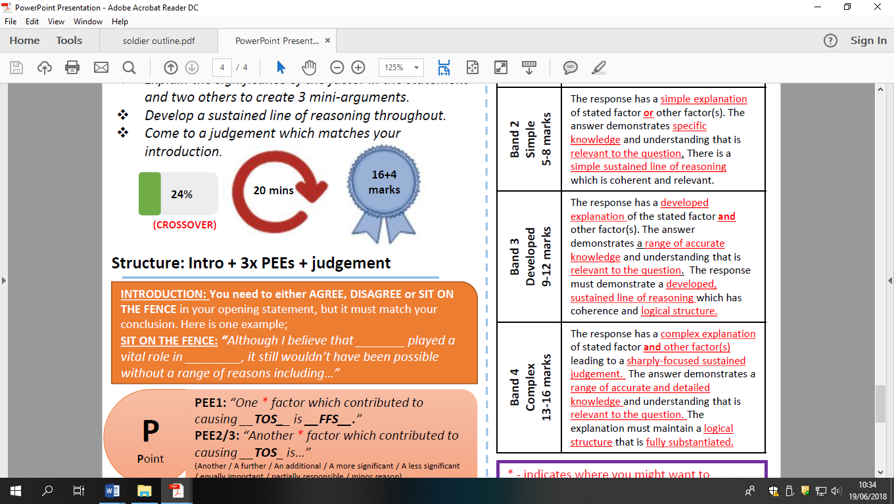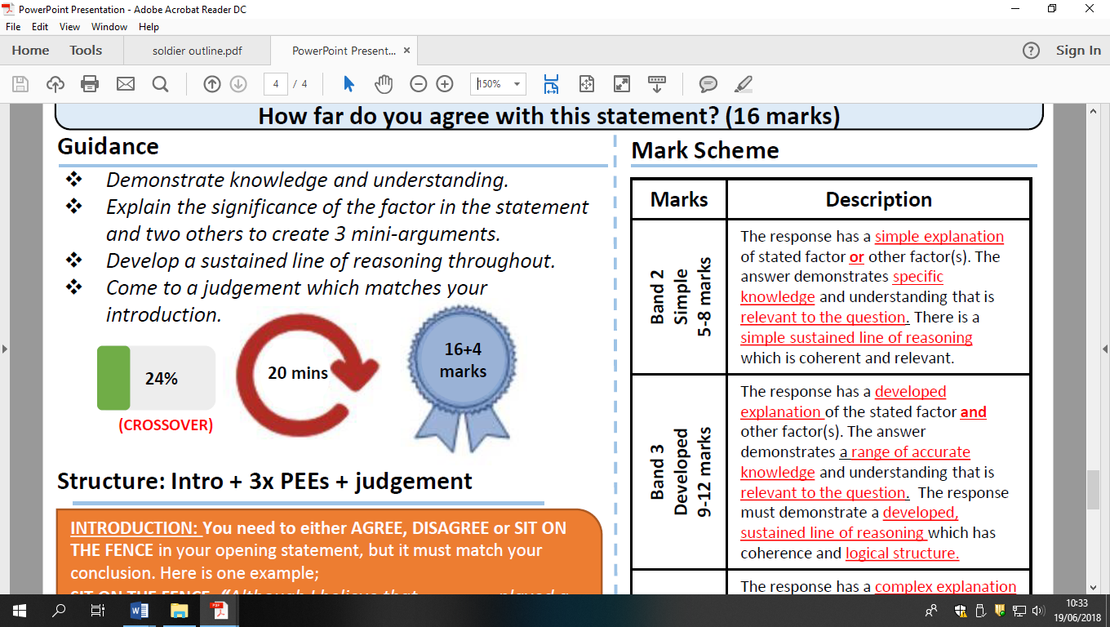

The main area of superpower rivalry 1945-65 was the nuclear arms race’ HFDYA?