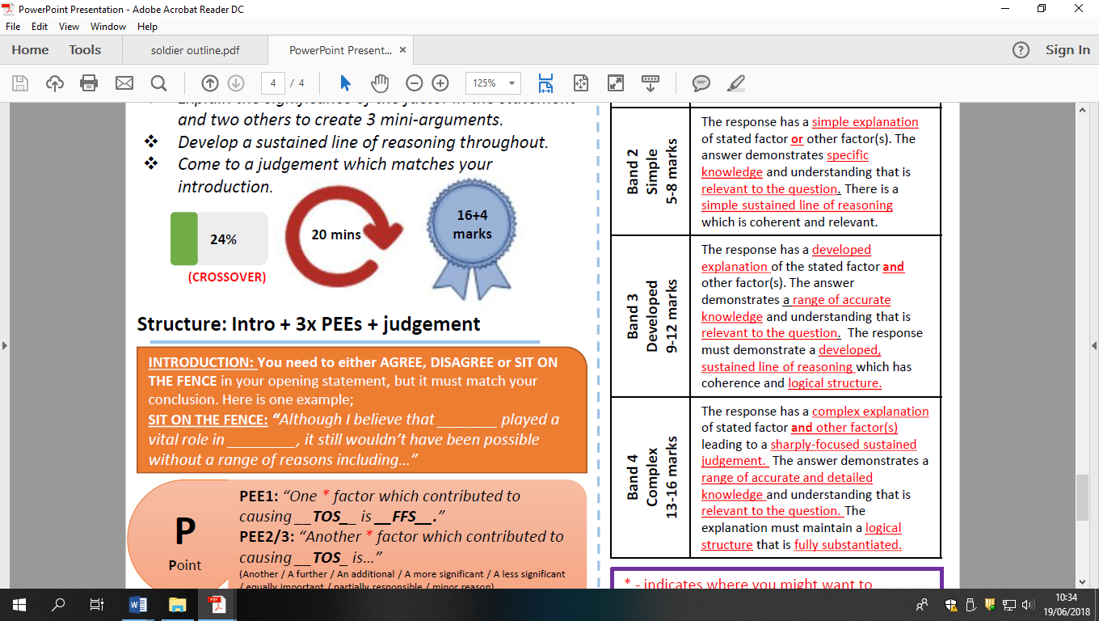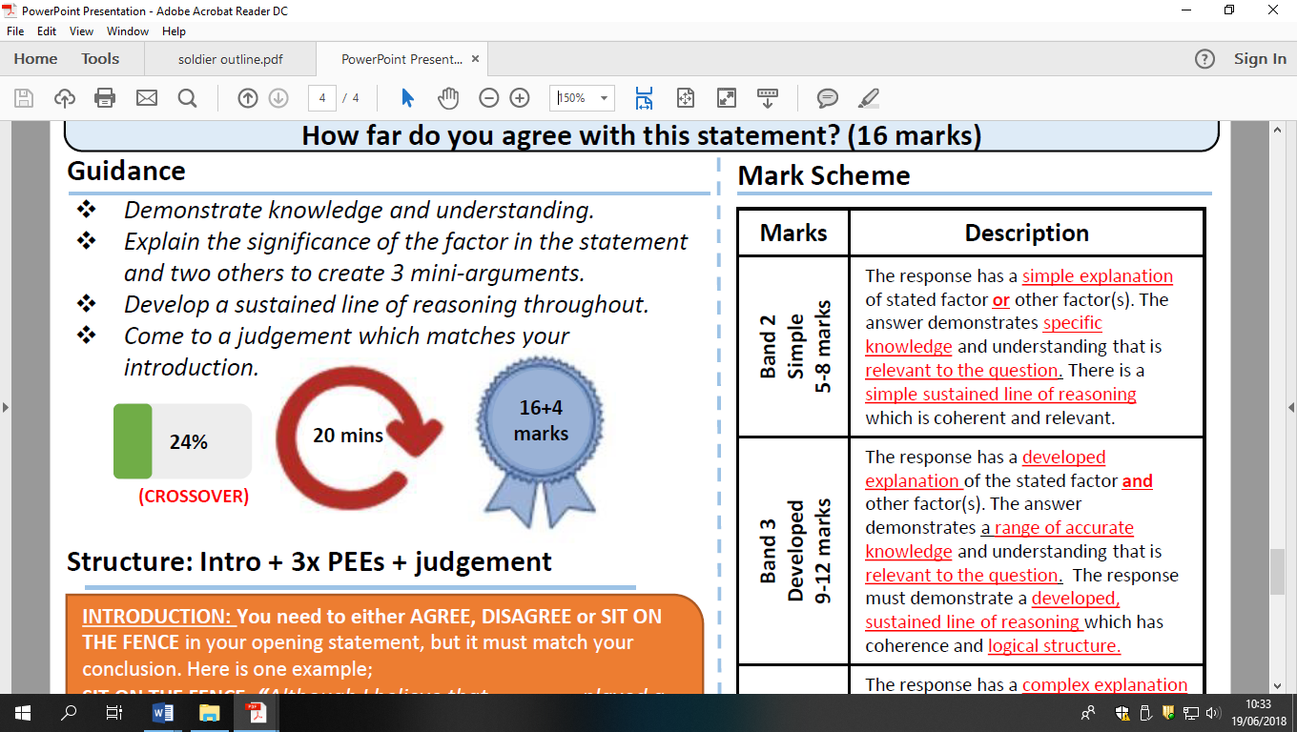

The main reason for détente was the escalating cost of the cold war for USSR’ HFDYA