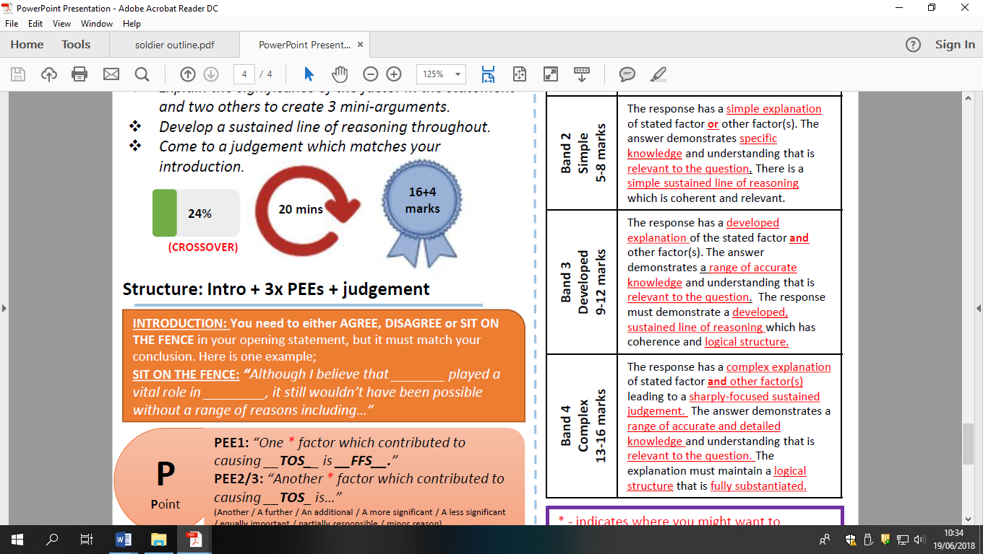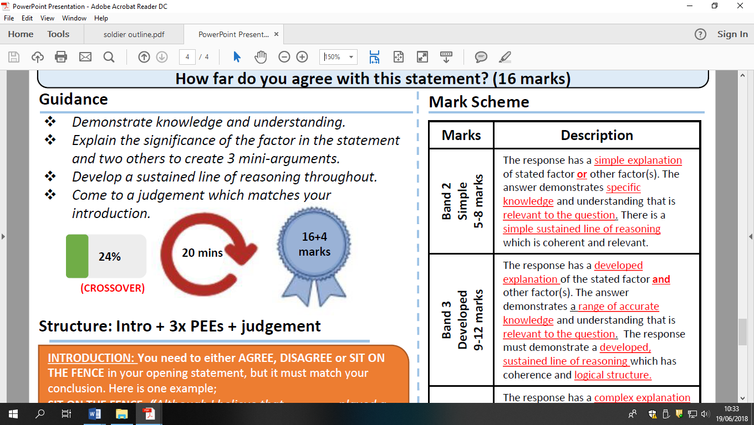

The main consequence of superpower rivalry in 1960s was the Cuban missile crisis of 1962 HFDYA?