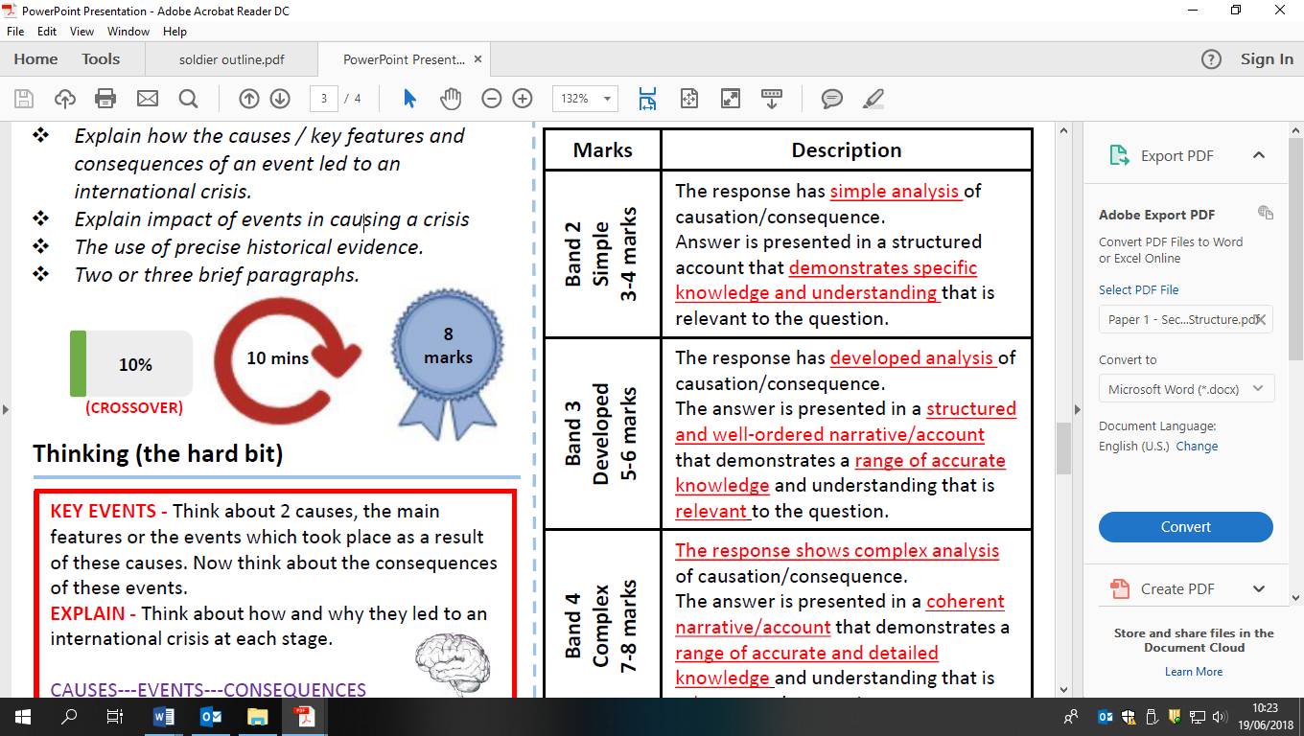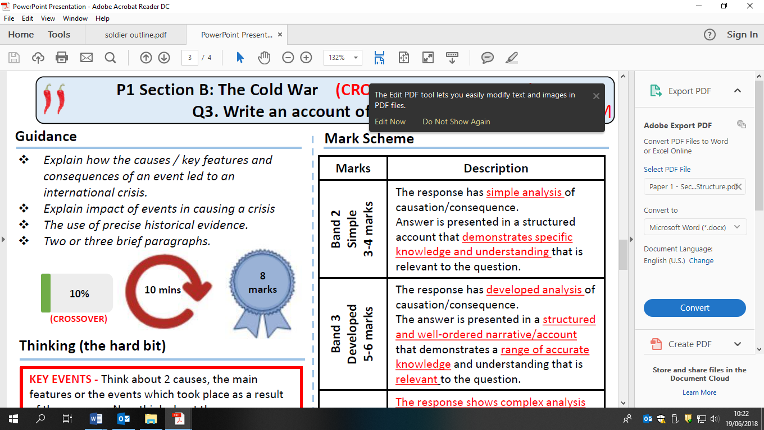

Write an account of how the shooting down of a U2 spy plane in 1960 become an international crisis