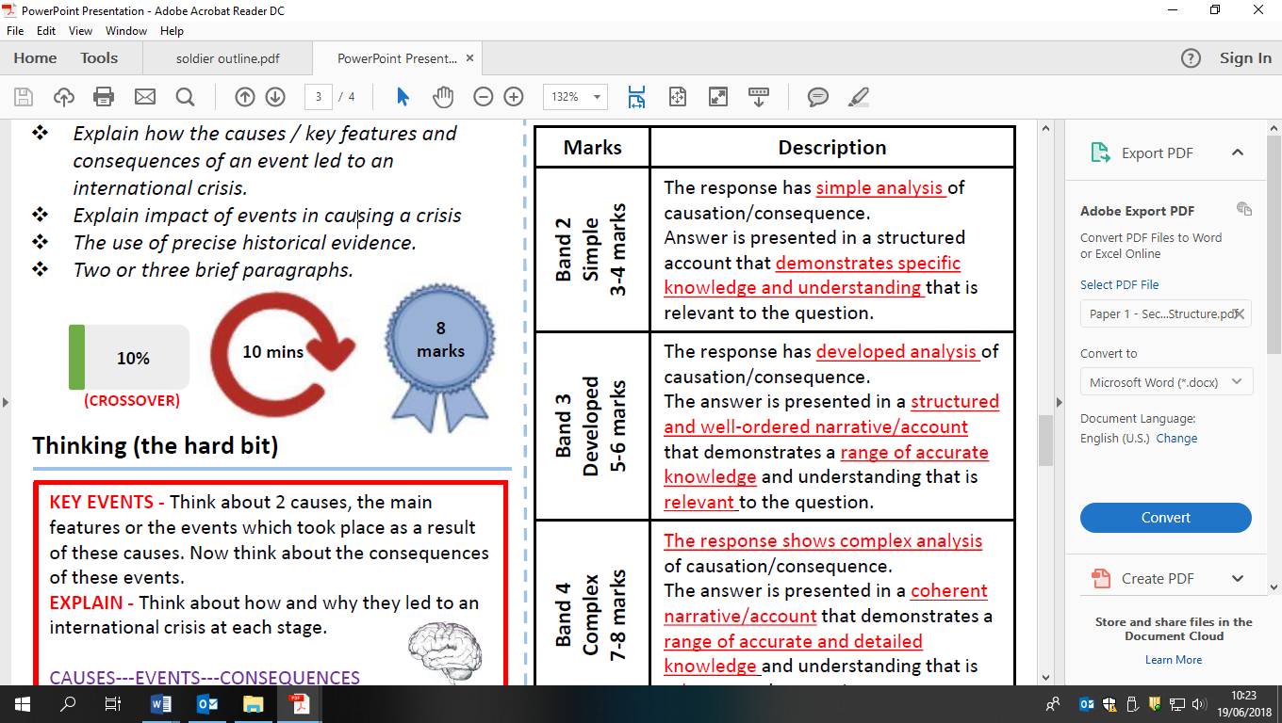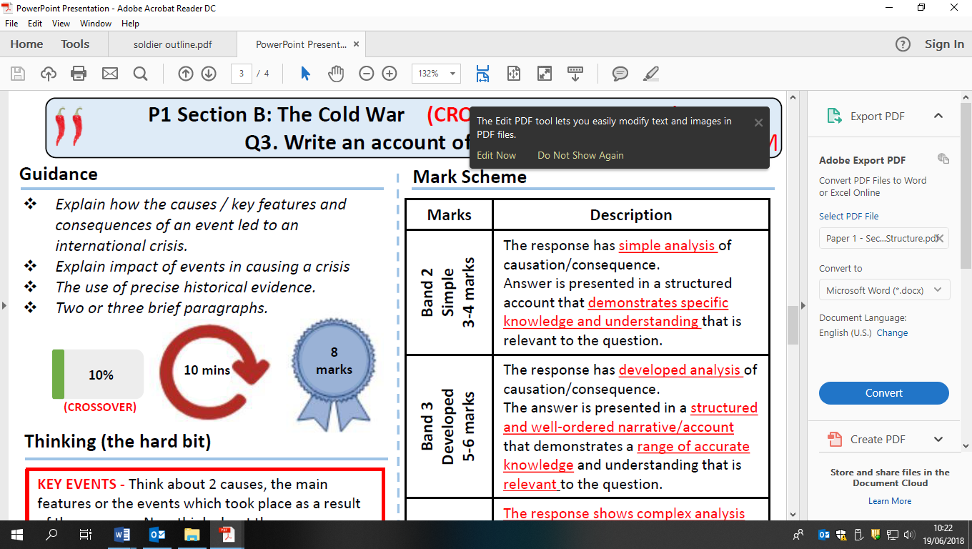

Write an account of how the Marshall Plan and the Soviet response increased tensions between the superpowers between 1947 and 1949