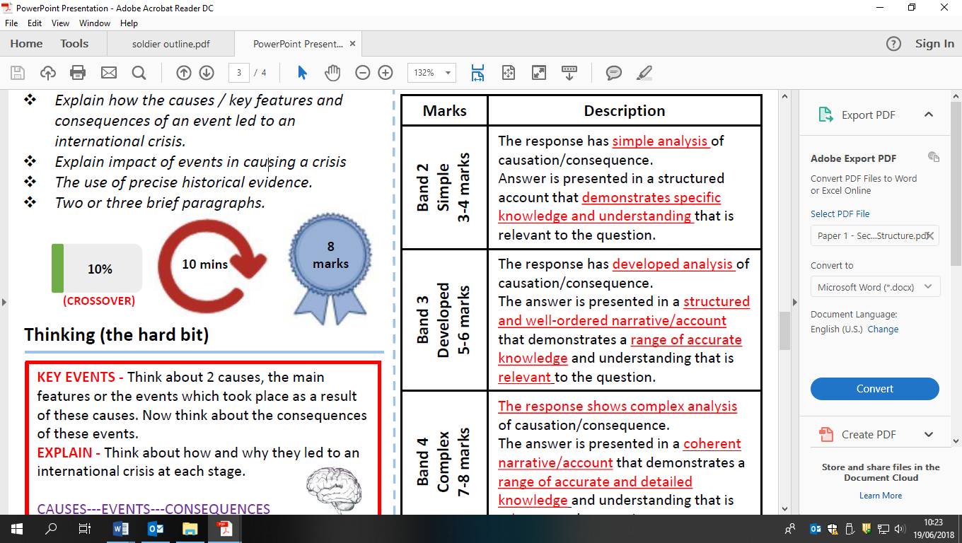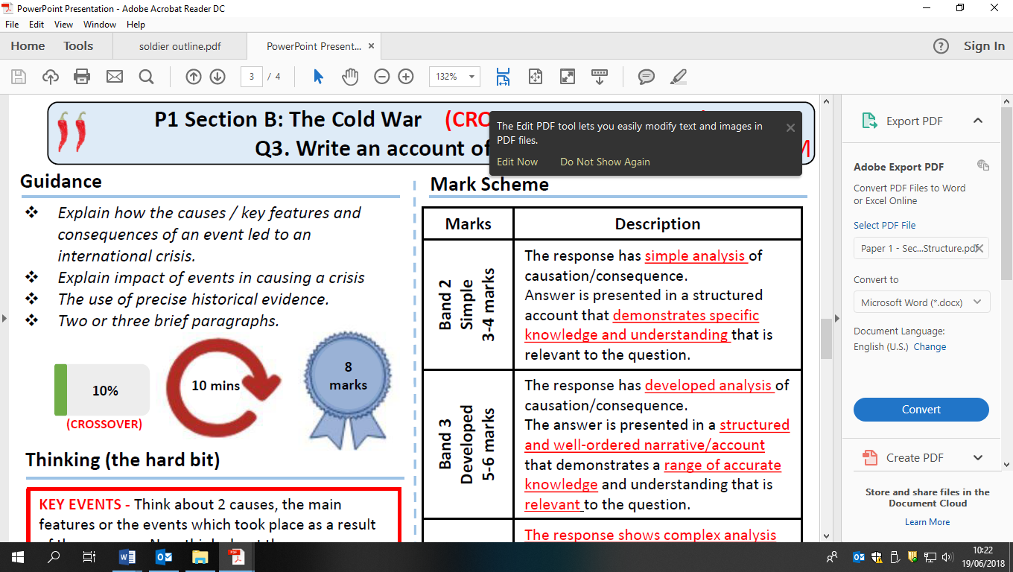

Write an account of how the siting of Soviet missiles in Cuba become an international crisis in 1962