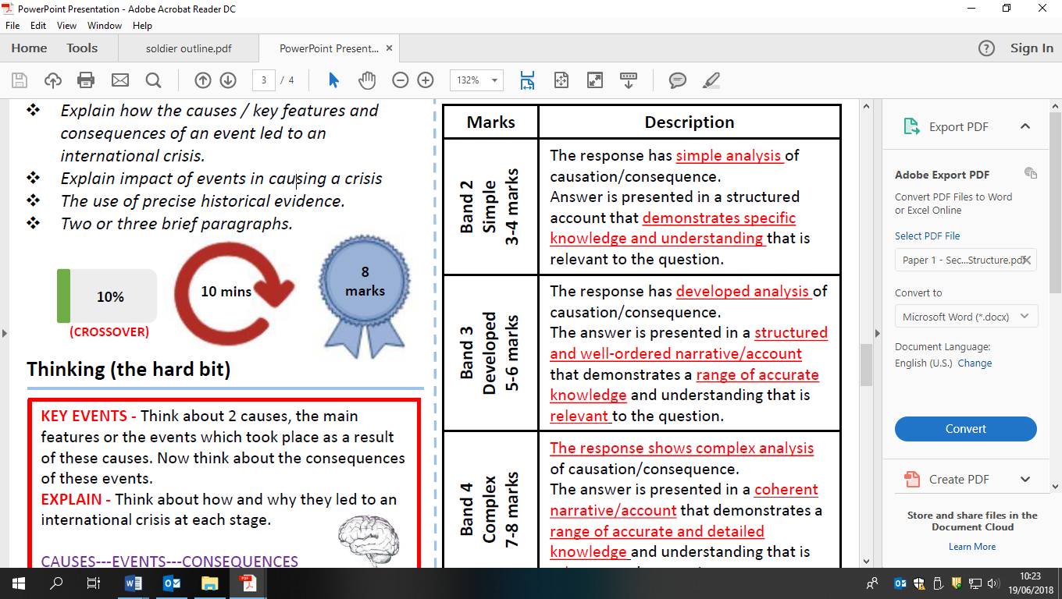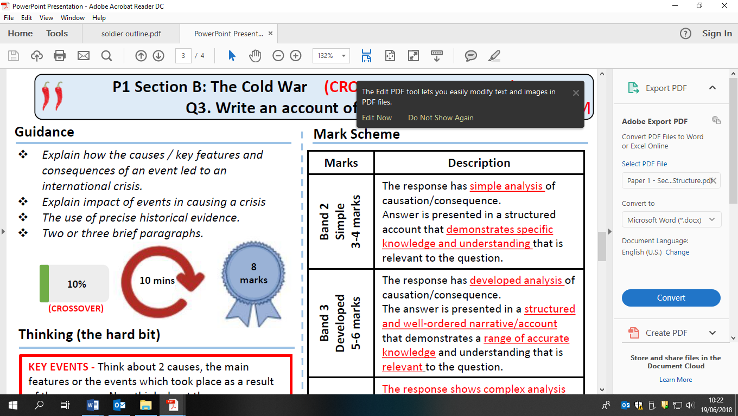

Write an account of how the city of Berlin become a point of tension between the superpowers 1960-63