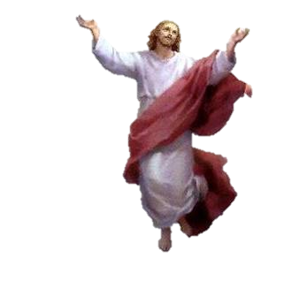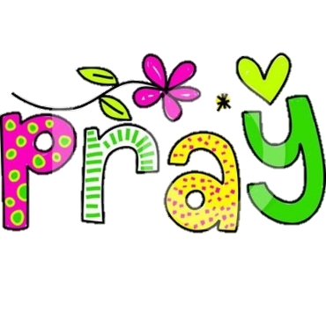

1. Personal relationship with God is possible and important – this is achieved through individual worship
2. Traditionally, worship was seen to be a formal process, happening in ‘**congregations**’ where Christians gathered together. This is called **corporate worship**. On the other hand, private worship can take place by Christians who may never go to church. However, the Bible instructs both corporate and private worship
3. Church attendance has declined to its lowest level ever in 2016, so debate about the role of public worship will become more important as it has implications for the use  
    and sustainability of church buildings

Prayer is how someone **communicates with God**. Jesus taught the early disciples to pray, encouraging them to pray to God as a father – this suggests that prayer is something that has to be learnt.

For Protestants, e.g. CoE, prayer cannot be underestimated. They believe that each Christian is, in their own way, a priest and can have direct access to God through Christ; they don’t have to go through a priest.

Many people pray alone, but many find spiritual support from praying together, believing that they are following the instructions of Jesus, who encouraged his followers to pray together.

Worship is an expression of adoration and praise for God. Acts of worship are frequently referred to in the Bible. For example, the Ten Commandments contain the commandment to, ‘keep the Sabbath day holy,’ which has been interpreted as a command to worship God. There are different ways of worshipping God:

**Liturgical Worship**

Set structure, e.g. Mass or a Eucharist Service

**Informal Worship**

Worship that doesn’t have a set pattern. It is spontaneous in structure. Services in Evangelical denominations are often more informal than traditional worship.

**Individual Worship**

This takes place in addition to worshiping together in a church. Christians believe that it is important to form a personal relationship with God and worshipping alone is a part of this.

Set and informal prayers are an important part of all Christian worship. Worship can also involve:

* Music
* Singing hymns

**Liturgical Worship**

* Follows a set pattern
* Has established rituals
* Public church worship
* Can include the Lord’s prayer (important for Protestant denominations, like Church of England)
* Eucharist, Holy Communion or Mass, is a form of liturgical worship (important for Roman Catholics)

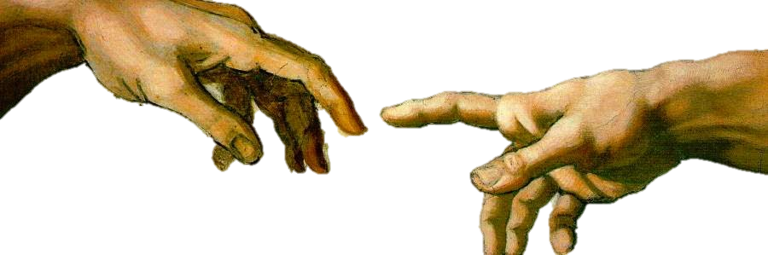



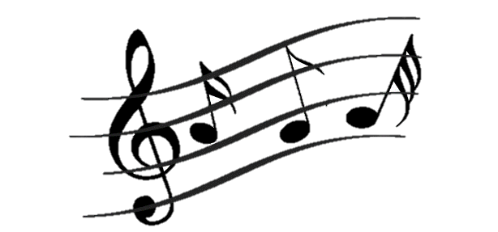





Spontaneous prayer Is non-formulaic (doesn’t follow a pattern). It is considered more spiritually honest because the use of words is influenced by the Holy Spirit. Response to prayer is also influenced by the Holy Spirit. Some denominations who favour spontaneous prayers, (also known as extemporaneous prayers) have rejected set prayers like the Lord’s Prayer as they believe that the real meaning becomes lost and people just end up repeating them without really thinking about the meaning

**Informal Prayers**

Informal prayers use an informal voice and language is used in prayers, e.g. calling God terms like, ‘Dad’ or ‘Big G’, rather than ‘Father’ or ‘the Almighty’. This helps people to connect with God in a more day-to-day language. After all, it is the intention that is important

**Evangelical Worship**

Evangelical worship is informal. Christians are moved by the   
Holy Spirit during worship. This may involve them falling into   
trances or even speaking in unknown languages (speaking in   
tongues). Movement and participation is encouraged and there   
is often music, singing and dancing in the congregation



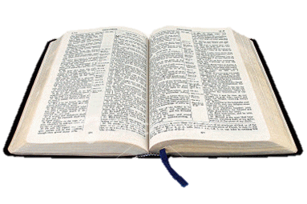



**Church of England**  
Worship is rooted in Thomas Cranmer’s Exhortation and Litany of 1554. It was the first ‘service book’ written in English and outlined how church services should take place.

**Roman Catholic**

Liturgy of the Word: readings from the Bible, a sermon, a public profession of faith (called a creed) and prayers of intercession to ask for help for those in need.

Liturgy of the Eucharist: altar is prepared for the bread and wine. The Eucharist’s Prayer and the Lord’s Prayer are said and people share in the bread and wine. Service ends with prayers and blessings from the priest.

**How do Quakers Worship?**

1. Informal prayers tend to be private and involves more than just communicating with God
2. Can include meditation, contemplation, personal reflection and simply being in the presence of God
3. Quaker ‘services’ do not include set prayers. Instead, they sit in silence and stillness to give people the opportunity to listen and reflect. This helps them to become closer to God
4. There is no official leader of the worship, but occasionally someone might feel moved to speak – this is called ministry
5. Others may listen in silence or speak if they wish to / are influenced by the Holy Spirit



1. Informal approach to worship
2. No set structure
3. Informal worship emphasises the importance of the **Holy Spirit** and spontaneous action
4. Was the original form of worship offered by Christians in the first decades of the Church, before rituals and tradition had been established
5. Emphasises the ability to worship in any place that Christians gather – God is **omnipresent**. This is also similar to Christians in the early Church as before churches – the buildings – were build, Christians used to meet in secret to worship God
6. Learn and repeat prayers that have a significant meaning
7. Prayer can become collective, so single voices can become a communal voice when talking together
8. The Lord’s Prayer, which Jesus taught to the first disciples, taught people how to pray
9. Set prayers are useful because they are part of the tradition and ritual of worship that goes back centuries
10. Set prayers were originally passed on by word of mouth before being written down
11. Many Protestant denominations, e.g. the Church of England, use the set prayers in the Book of Common Prayer

