Emilys Candy RegularEmilys Candy Regular

‘Ecumenical’ means **many Christian Churches** and the Ecumenical   
Movement is an attempt to bring closer together the different Christian   
denominations and **promote Christian unity** throughout the world. The movement aims to,   
ultimately, unite all Christians.   
As a result of the Ecumenical Movement, there is much more cooperation between different   
Christian denominations such as different churched sharing a common building and joint ecumenical   
services. Although denominational differences still exist, today **many Christians believe there should   
only be one Church**. At a local level, many churches actually cooperate and work together.

“*A worldwide fellowship of churches seeking unity, a common witness and Christian service.” The aim   
of these churches is to be a ‘visible sign, deepening communion, sharing the Gospel together   
and making connections*.’

Each year the World Council of Churches (WCC) holds a special week of prayer for   
Christian unity. It brings together churches in more than 110 countries. The Roman   
Catholic Church isn’t a member of the WCC but it does take part in some   
national and local ecumenical organisations.

There has been a decline in church attendance, but some churches are   
thriving in Britain, e.g. Evangelical churches as they are very animated and charismatic.   
Worship has no formal liturgy and focuses on a Bible reading, singing and preaching.   
The services are spontaneous, moved by the Holy Spirit.

Church planting is the process of establishing new non-traditional churches. It happens when   
groups from an existing church split off and go to a new area and establish a church there.   
The Ichthus Fellowship aims to spread Christian values by church planting.

Fresh Expressions attempt to attract people to churches who wouldn’t usually attend church services. People will meet, for example, in a café, on a beach or a gym and talk about their faith.

Christianity is a world religion and it is spreading and growing in other parts of the   
world, e.g. Asia, South America and Africa. It is estimated that by   
2050, four in ten Christians will live in   
Sub-Saharan Africa.

Evangelism is preaching the gospel to others with the intention of   
converting others to the Christian faith. It is the way the gospel is spread   
and means, ‘preaching the good news.’ Evangelism is best shows through the way   
Christians live their lives rather than talking about religion.

Mission is what the church is supposed to do in terms of every Christian being an evangelist as a ‘preacher of the gospel.’ It is the mission of the Church to help Christians live a life of faith and spread the message of Salvation to all. Many Christians see it as a duty or mission to convert other people to Christianity, whether they have no faith at all or belong to another religion.

Missionary work, in the past, had the clear intention of bringing people to the   
Christian faith. Though missionaries also brought education and health support to   
poor and disadvantaged people around the world. Today, missionary work and   
evangelism are more contentious and many people would debate the ethics of  
 trying to convert people to Christianity. In an increasingly plurality (many   
religions) society, many think you should be respectful of different faiths (or   
non-religious beliefs) rather than trying to persuade people to   
change their religion.





Emilys Candy Regular



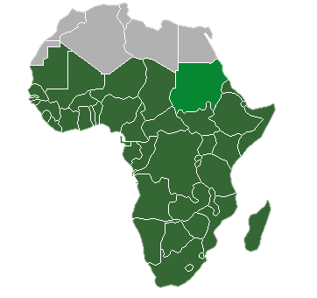Emilys Candy Regular

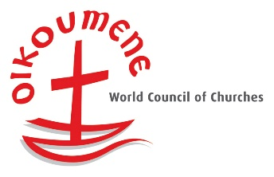

Emilys Candy Regular

Emilys Candy Regular

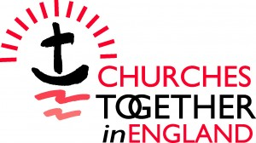

Emilys Candy Regular

Emilys Candy Regular

Persecution has always taken place and the word ‘**martyr**’ is used for   
someone who dies or is killed for their religious beliefs. **Jesus himself   
was a martyr** and he warned the disciples that they would be persecuted for   
their faith; each one of them was eventually martyred. Christians believe they were   
given a divine commission from Jesus to spread the good news of the Gospel and this may   
be in the face of personal danger. Christian persecution continues into 21st Century throughout the world.  
In some parts of the world, Christians are treated unjustly in societies where Christian faith is a minority religion. For example, terrorist organisations like Islamic State in the Middle East have targeted Christians, forcing them from their homes and subjecting them to violent attacks.  
Evangelical Christian organisations such as **Christian Freedom International** and **Open Doors** seek to help persecuted Christians. These organisations provide practical help to persecuted Christians, provide Bibles and world actively for the human rights of Christians suffering persecution.

**Working for Christian Reconciliation**

In the Christian Church there are many denominations, which have caused conflict in the past. Many believe it is important for the different denominations to work   
together as much as possible. Living in a pluralist society, reconciliation  
 is more important now than ever.

Tearfund are a Christian charity who aim **to put Christian beliefs and Jesus’   
command to ‘love your neighbour’ into action**. Christians believe they are   
putting into practice the unconditional or unselfish love (agape) that Jesus talks   
about in the Bible.  
Tearfund help the poor in over 50 countries, providing emergency aid when disasters   
occur and carrying out long-term projects to support local communities. In UK, many people   
support Tearfund by raising money though coffee mornings and buying Tearfund Christmas cards.

**Tearfund are important because:**

1. They have a role in raising public awareness of social issues, such as poverty and discrimination in the world
2. They campaign against the causes of poverty worldwide
3. They give practical help in order to act out the teachings of Jesus to help others
4. They encourage self-help for individuals and communities

**Tearfund in Colombia:**

Tearfund works with children and teenagers. They have set up 30 sports clubs where   
children can come for football training. The clubs provide safe places for young   
people who are at risk of joining gangs and offer mentoring to equip   
them with life skills.

At a local level, ‘Churches Together in England’ grew out of the work of the   
WCC and is a practical attempt to focus locally on the fellowship of those who share the Christian faith. The aim today is to offer practical ways of achieving greater unity. During the week of prayer for Christian unity each January, special Ecumenical services are organised.

Open Doors was established in 1955 when Brother Andrew, a Dutch missionary, smuggled   
Bibles into the Soviet Union – when Christians were persecuted. Today, Open Doors still supports persecuted Christians across the world in different ways:

1. Distributes Bibles to support Christians’ faith
2. Trains Christians and church leaders to deal with the trauma people might be   
   suffering whilst maintain their faith
3. Provides practical support for Christians who have been victims of disasters
4. Speaks on behalf of persecutes Christians to raise awareness of their  
    situation and gather support. For example, they might lobby MPs in the UK government
5. People in UK and Ireland support their work both practically and   
   financially.







Emilys Candy Regular