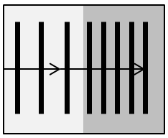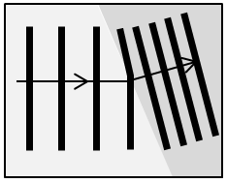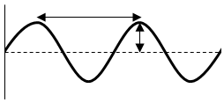

All of the AQA science revision sheets at www.tes.com/teaching-resources/shop/teachsci1

The part of the wavefront that enters the more dense medium first, slows down as the rest of the wavefront continues at the same speed but has to travel further. The difference in distance and speed causes the

wave to refract.

More dense

Less dense

If the wave enters a medium of higher **density** at an **angle** the ray bends towards the normal (diagram to left).  
If it enters a medium **along the normal** then the wave does not change direction but the **wavelength** and **speed** **decrease**.  
(waves closer together on diagram below)

**Wave Front Diagrams**

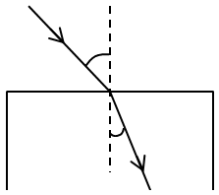

Normal (at 90° to the boundary)

Incoming ray

Angle of incidence

Angle of refraction

Refracted ray

Boundary

**Ray Diagrams**

Required Practical

see practical sheet for detail

**Refraction**  
Waves change speed when they cross a boundary between two materials of different density.

Wavelength (m)

**Wave Experiments**  
To measure the speed of sound two microphones held by a speaker (plugged into to a signal generator) can be connected to an oscilloscope. One microphone is moved away from the speaker until the waves line up on the oscilloscope. The distance between the microphones is the wavelength. Use *V = fλ* to find the speed of sound (*f* = whatever frequency the signal generator is set to).  
The speed of sound in air is 330 m/s.

The speed of water ripples and waves on a string can be investigated and calculated using the waves speed equation.

**Wave Speed**

Frequency (Hz)

Wave speed (m/s)

$$V=fλ$$

**Amplitude** – the maximum displacement from a waves undisturbed position (the horizontal mid-line)

**Wavelength** – the distance between adjacent waves (ie. from peak to peak or trough to trough)

**Trough**

**Peak**

**Frequency** – the number of complete waves that pass a point every second. 1 wave per second has a frequency of 1Hz (hertz).

**Time period** – the time for a complete cycle of a wave:

$$T= \frac{1}{f}$$

Displacement

Oscillation

Transfer of energy

* All EM waves
* Waves on water
* A wave on a string

**Transverse Waves**The **oscillations** (vibrations causing the wave) are **perpendicular** (90°) to the direction of **energy transfer**. Examples are:

**Longitudinal Waves**The **oscillations** are **parallel** to the direction of **energy transfer**. **Sound** waves travel as a longitudinal wave in air.

Oscillation

Transfer of energy

Rarefaction

Compression

**Waves** travel through a medium (substance). The particles oscillate (vibrate) and transfer energy. The particles stay in the same place.

**Waves**