HIVNotRetro Regular

1. Christians believe in special ‘rites’ or rituals called ‘Sacraments’,   
   for example baptism and the Eucharist.
2. During the Sacraments, the Holy Spirit comes down on the believer
3. The Holy Spirit is at work in the world today
4. Evangelical Christians place a large amount of importance on the Holy Spirit:
   1. Worshippers are encouraged to be moved by the Holy Spirit
   2. The Holy Spirit is present and influences their prayers
   3. ‘Faith healing’ can take place within   
      evangelical church services, where the   
      Holy Spirit works in miraculous ways to   
      heal people – spiritual or physical healing

HIVNotRetro RegularHIVNotRetro Regular

Grace and the Spirit

To live a good life, Christians believe that God send the Holy Spirit to bring grace.

Grace is important because: it is a supernatural gift; Christians are able to pray for help from God; Christians are able to turn away from sin.

The gift of grace is recorded in the Book of Acts, when the Holy Spirit appears to the disciples after Jesus’ ascension.

Sacraments

The Sacraments are a way of receiving God’s grace through ritual. Not all Christian churches observe all seven sacraments.

Seven Gifts of the Holy Spirit

1. **Wisdom**
2. **Understanding**
3. **Counsel** (being able to give advice)
4. **Fortitude** (courageous in pain or adversity)
5. **Knowledge**
6. **Piety** (being deeply religious)
7. **Fear of God** (respect and awe for a deity)



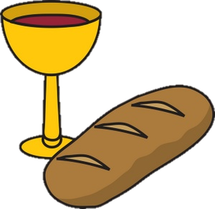

HIVNotRetro Regular

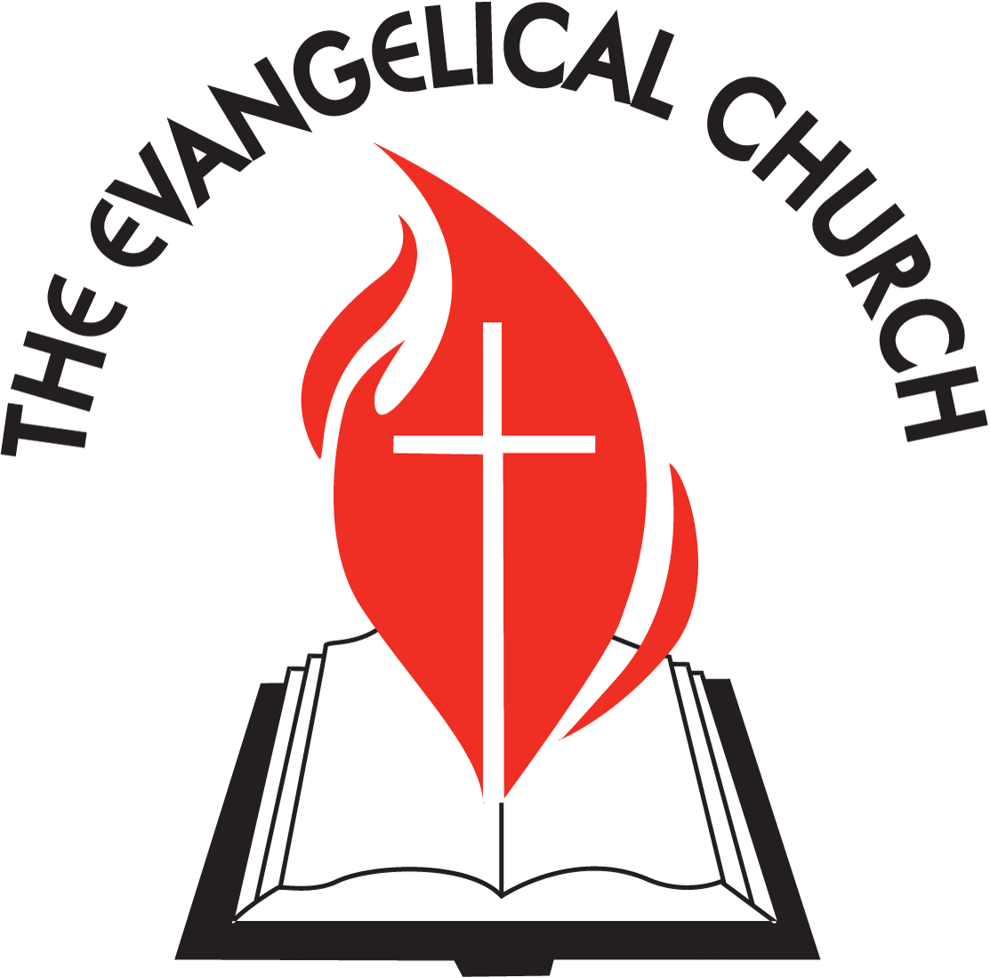



HIVNotRetro Regular

HIVNotRetro Regular

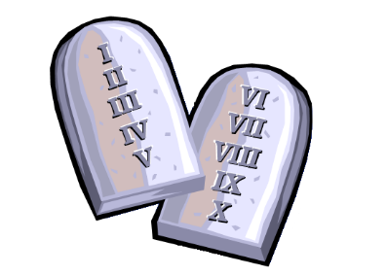

A sin is an immoral act that goes against God’s law. The Bible contains ideas about   
human sinfulness and its link with salvation. Sin separates humans from God, however Jesus’ death atones   
from human sin. Jesus’ sacrifice means we have a chance to live with God for eternity after death. Jesus was a   
sacrifice that paid for human sin. Jesus paid the ransom for human sin, releasing humans from sin and   
allowing them to be saved

Christians believe that they are born with original sin, which came into the world as a result of The Fall. Adam’s sin has been passed down through the generations. It is original sin that causes humans to do things in their lives that go against God’s law and separates humans from God.

Problems with Original Sin:

1. It is unfair of God to punish all of humanity for the sins of another
2. Liberal Christians don’t believe that the events of The Fall actually happened,   
   but it is a symbolic story to show Christians what happens if you go against God’s law
3. It is hard to explain biologically how original sin is actually passes on from one generation to the next
4. For most Christians, original sin’ is a useful way to understand how humans are prone to go against God.

Roman Catholics believe that by taking part in the Sacraments, they will be able to achieve   
salvation and go to heaven. They believe that Baptism washes them clean of sin. Confession   
allows for the Christians to be absolved (freed) of sins committed in life.

Protestants, e.g. Church of England, believe that they must have faith in Jesus and repent   
their sins to achieve Salvation.



* The Bible is the ‘sacred text’ or ‘scripture’ for Christians. It is made up of 66 books and is   
  written by many authors over a long period of time. The authors write in different styles but were all inspired by their experience of God.
* The Bible is split into two sections: the Old Testament (written before Jesus’ birth) and the New   
  Testament (tells the story of Jesus’ life and death).
* For all Christians the Bible is a book of revelation (God revealing his truths to mankind). Through the Bible, God is revealed and Christians can know God.
* The Bible is a record of divinelaw – rules and laws of God given to mankind by which all Christians should live.
* The Bible is a source of authority and advice. It has a major role in worship as readings from the Bible are a feature in Christian church services. However, there is a difference of opinion of how the Bible should be interpreted:

1. The Bible is the ‘Word of God’ and the content is literally true. When science contradicts the stories in the Bible, science is wrong.
2. The Bible requires interpretation as it was written in a specific time and culture, different to ours. Teachings need to be applied to today’s society.
3. A liberal view of the Bible understands that not all of the stories are literally true or happened exactly as they are written. However, the stories are symbolic and show us how God wants us to live our lives.

Christians also use other sources of authority to make decisions:

1. Minister / priest
2. Other Christians (from the community)
3. Pray (ask God)
4. Follow their conscience

HIVNotRetro Regular

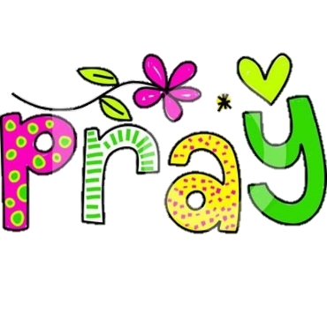

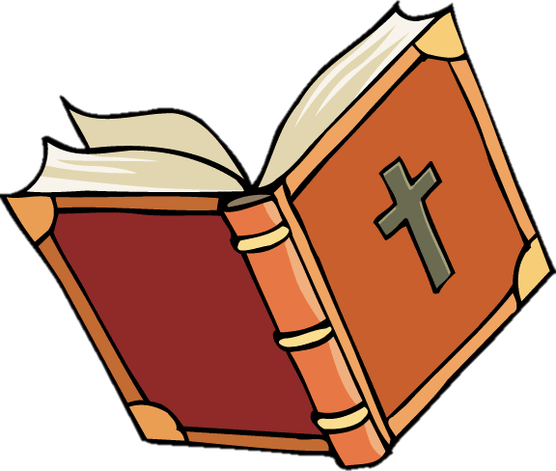HIVNotRetro Regular

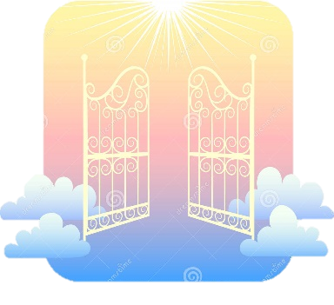

HIVNotRetro Regular

HIVNotRetro Regular