

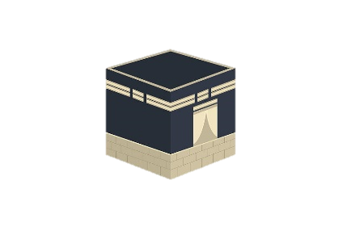



Like Sunnis, Shi’as go on the annual pilgrimage to Makkah in the 12th month of the Muslim calendar (Dhul Hijjah). In addition to Hajj, they also make pilgrimages to Shi’a shrines and graves, in particular visiting the grave of Husayn in Karbala (in modern-day Iraq).

Like Sunnis, Shi’as make a charity payment of 2.5% of their wealth every year. This goes to support the poor and those in need.

Otterly Adorable

In addition to Zakah, Shi’as are expected to pay Khums, a wealth tax of 20% of their savings. This money is paid to Muslim scholars and community leaders for the welfare of the community.

Otterly AdorableFor Shi’a Muslims, Islam is often pictured as a bountiful tree. The five roots of religion act as the source of strength for the Mulim life of faith. These are the central beliefs, with the trunk and branches growing up from these roots. There are ten branches or obligatory acts which form the key feature of religious life.



There are five daily prayers (Salah), where Muslims face towards the Ka’ba in Makkah (Qibla), but many Shi’as combine these into three. These prayer times are:

* 1. Between dawn and sunrise
  2. Just after noon
  3. At dusk, after sunset

They do this because they say that Muhammad allowed the combination of prayers: Zuhr with As’r and Maghrib with Isha.

Like Sunnis, Shi’as practise fasting (Sawm) during the month of Ramadan, but from the 20th day of Ramadan they remember the death of Ali (son-in-law of the prophet) spending three days in mourning.







It is the duty of all Muslims to forbid evil; when someone sees a wrong, they should correct it. It is the responsibility of the whole Muslim community (the ummah) to discourage others from harmful actions, such as bribery, corruption and dishonesty. This applies to individuals, families and the whole society.  
“Whoever among you sees an evil should change it with his hand. If he is unable to do that then with his tongue. If he is unable to do that, then with his heart, and this is the weakest level of faith.” (Hadith)

Otterly Adorable

Tawalia means having love for God and for the Prophet Muhammad. We should love   
all those who are friends of God: people who are truthful and kind, honest and fair.   
We should try to associate ourselves with people who are kind and trustworthy. For   
Shi’a Muslims it also means having love for the ‘Ahl al-Bayt’, the 12 infallible   
 Imams who are descendents of the Prophet   
 Muhammad.









Otterly Adorable  
  
Muslims believe that it is important   
to dissocaite themselves from the enemies of God. We should hate, and separate ourselves from, people who are impure and those who oppress others. However, Muslims often   
disagree on exactly who are the enemies of God.

Jihad is the duty to struggle against sin. For the sake of God, Muslims should fight against injustice, removing any obstacles that might prevent people from being able to worship God.

The central purpose of Islam is to create a society where people can live in peace and harmony. Therefore it is a the duty of all Muslims to encourage others to do good, for the sake of God. In the Hadith Muhammad promised   
that the person who persuades someone else to do a good deed will   
get the same reward as the person he   
persuaded.



Image result for heart clipart





