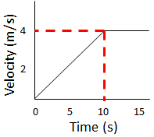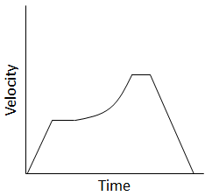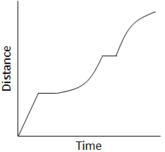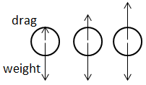

**Velocity-Time Graphs**

All of the AQA science revision sheets at www.tes.com/teaching-resources/shop/teachsci1

2. Put in numbers and calculate v2:

3. Find the square rout to give v:

1. Rearrange the equation:

$$v^{2}=u^{2}+2as$$

$$v= \sqrt{96 } =9.8m/s$$

Distance (m)

Acceleration (m/s2)

Initial velocity (m/s)

Final velocity (m/s)

$$v^{2}-u^{2}=2as$$

**Uniform Acceleration**This can happen due to gravity acting on an object in free fall.

eg. If a car travelling at 24m/s decelerates uniformly at 2m/s2 as it enters a housing estate 120m away, what will its speed be as it reaches the housing estate?

Distance (m)

Time (s)

$$s=vt$$

Speed (m/s)

**Acceleration**How **quickly** something is **speeding** **up**. Deceleration is negative acceleration.

**Velocity-Time Graphs**

Time (s)

Change in velocity (m/s)

Acceleration (m/s2)

The area under the line is a triangle, so ½ the area of a rectangle.

½ x 10 x 4 = 20m

Eg. the distance over the first 10s is:

The **acceleration** is the **gradient** of the line (Δ v ÷ t).  
To work out the **distance** travelled, find the **area** under the line.

Increasing acceleration

Constant acceleration

Constant deceleration

Steady speed

Steady speed  
Steeper line = faster speed

Accelerating

Decelerating

Stopped

**Terminal Velocity**The maximum speed an object will fall at through a fluid (liquid or gas).

Speed increases so frictional force (drag) increases.  
Acceleration is reduced until the drag is equal to the weight. Terminal velocity is reached.

The **shape**, and **surface area** will affect terminal velocity. A larger surface area will increase air resistance so decrease terminal velocity.

**Speed** is how fast something is going without reference to a direction. It is a scalar quantity.

**Velocity** is a speed in a given direction. It is a vector.

**Typical Speeds** - Walking = 1.5 m/s  
 - Running = 3 m/s  
 - Cycling = 6 m/s  
 - Car = 25 m/s  
 - Train = 55 m/s  
 - Plane = 250 m/s

**Speed, Velocity and Acceleration**