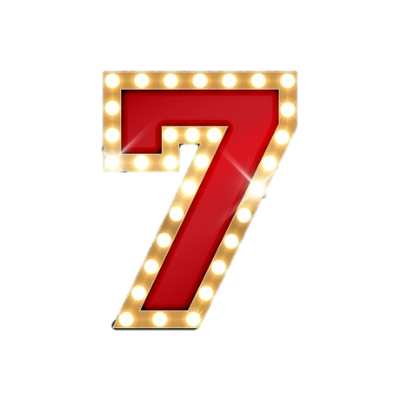

**Sacraments are an outward sign of an invisible and inward blessing by God,   
for example Baptism and the Eucharist.**

**Sacraments are the Christian rites – a ‘visible sign of an invisible grace’. So the actions, words and objects   
involved in each sacrament are a sign that Christians are receiving God’s grace or blessing.**

**There are 7 specific rites that are seen as central to Christian life. All 7 are still acknowledged by Roman Catholics.   
Church of England observe 2 of the sacraments (Baptism and Eucharist), because these were the only two practiced by   
Jesus during his life.**

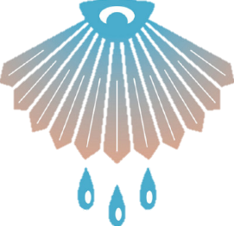



**Baptism**

Initiates people into the Christian Church

**Confirmation**

Committ-ing to the Church for yourself

**Eucharist**

Bread and wine to remember Jesus’ death

**Penance** or Confession

Frees a Christian of sins

**Marriage**

Spiritual union of the couple and God

**Holy Orders**

Joining the priesthood of the Church

**Anointing of the Sick**

Priests anoints the ill

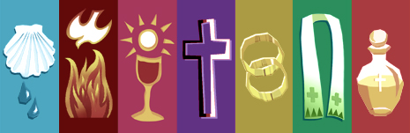

1. It is a rite of entry, allowing people to become members of the Christian Church
2. Original sin is removed through the action of baptism
3. It follows the example Jesus set, who was baptised as an adult by John the Baptist in the River Jordan
4. Believers’ baptism gives a person the opportunity to publicly declare their personal faith
5. It is seen as the first sacraments – a ‘covenant’ between humans and God
6. Baptism links believers directly with the belief in the death and resurrection: “We were buried with him through baptism into death in order than, just as Christ was raised from the dead through the glory of the Father, we too may live a new life.”
7. Jesus gave very clear instructions to his disciples to baptise people: “Go and make disciples of all nations, baptising them in the name of the Father, Son and Holy Spirit.”
8. Baptism is a sign of the gift of the Holy Spirit. The baptised Christian becomes untied with Christ, including in his death and resurrection. Through being baptised, they are able to enter heaven and live eternally with God after death.
9. Jesus said: “No one can see the kingdom of God unless they are born of water and the Spirit.”
10. **Baptism**: Initiates people into the Christian church. Catholics believe that it washes away sin. Many churches practice infant baptism, though some only allow adults to be baptised. The belief is that as an adult they can understand the commitment they are making.
11. **Confirmation**: When a baptised person becomes old enough, they commit to the church themselves. They remake the promises make by their parents and godparents on their behalf.
12. **Eucharist**: Worshippers share bread and wine in remembrance of Jesus’ death.
13. **Penance**: (Also known as Reconciliation or Confession). Catholics confess their sins to a priest, who will then ‘absolve’ (or free) them from their sins and ask them to carry out a penitent act to show they are sorry for what they have done. This might include praying or fasting.
14. **Anointing of the sick**: This is performed when a Catholic is seriously ill or dying. It is carried out by a   
    priest who will apply oil to the sick person.
15. **Holy Orders**: Joining the priesthood of the church. This is known as being ‘ordained’.
16. **Marriage**: Spiritual union of the couple and God.

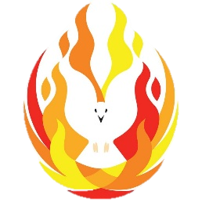

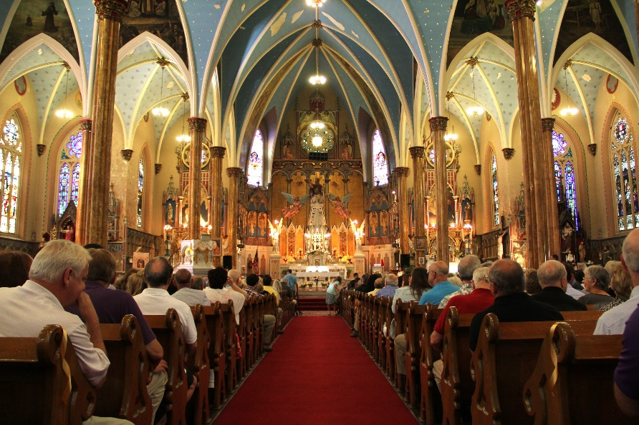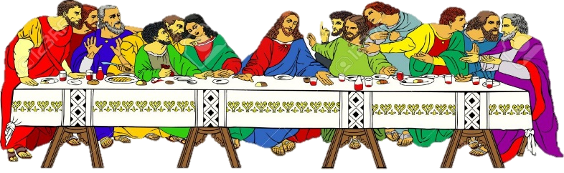

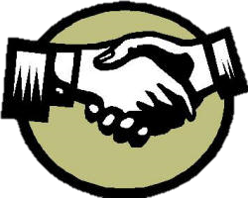

1. It must be performed by an ordained minister or an authorised **lay person**
2. **RC/CoE:** Infants are baptised, marking the entry into God’s community. Parents and godparents make promises to   
   bring the child up in the Christian faith
3. **Baptists**: don’t believe in infant baptism but instead have   
   a believer’s baptism, where the person is able to declare   
   their own faith
4. **Evangelical Christians**: fully immerse the person being   
   baptised in water, as Jesus was in the River Jordan

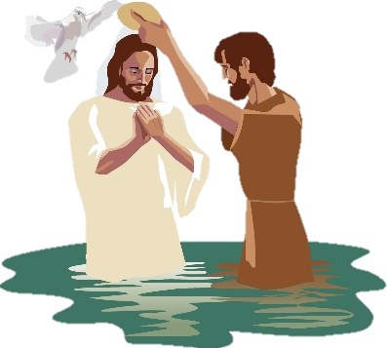

**What happens during the Eucharist / in a Mass?**

1. Also known as Mass or Holy Communion
2. Started by Jesus at the Last Supper. Jesus shared bread and wine with his disciples, telling them they represent his body and blood. He said that they should do this in his memory after his death
3. Taking the Eucharist brings Christians closer to God
4. ‘Eucharist’ means ‘thanksgiving’. It is an act of thanksgiving for the life and death of Jesus and for the Christian faith
5. Eucharist services are an example of liturgical worship – they have a set structure and the same rituals happen each time.

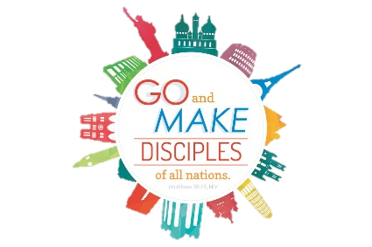

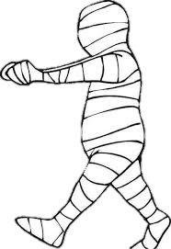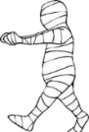



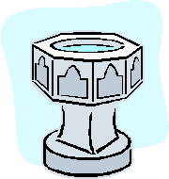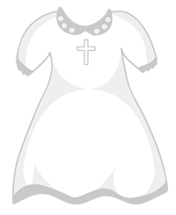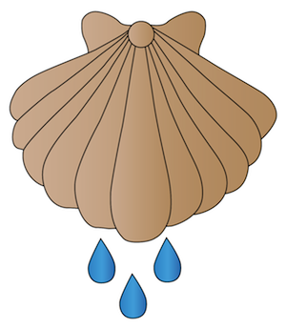

**Different views about the Eucharist**

1. **Roman Catholics** believe that the bread and wine actually become the body and blood of Christ. This is called transubstantiation, where the body and blood of Christ are somehow present in the bread and wine.
2. **Protestants**, e.g. **Church of England**, do not believe in transubstantiation. They believe that Christ is present spiritually, rather than physically.
3. **Protestants**, e.g. **Baptists**, believe that the ritual of the Eucharist is simply an act of remembrance. This is known as memorialism.

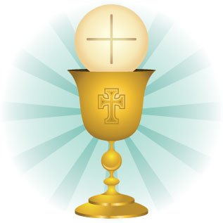

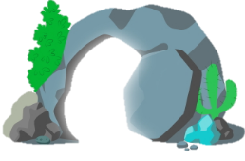

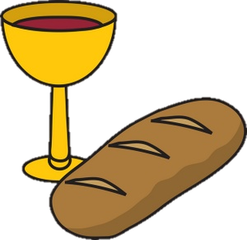

Baptised children and adults wear **white** – the colour of a ‘clean soul’ after sins have been washed away and of **heaven** and the **resurrection**.

**The shell** is a symbol of baptism. It is found near **water**, which is a symbol of spiritual cleansing/ Water washes away the sins of the person baptised.

**The font** is usually at the front/entrance of the church. It is a symbol of entering into God’s family.

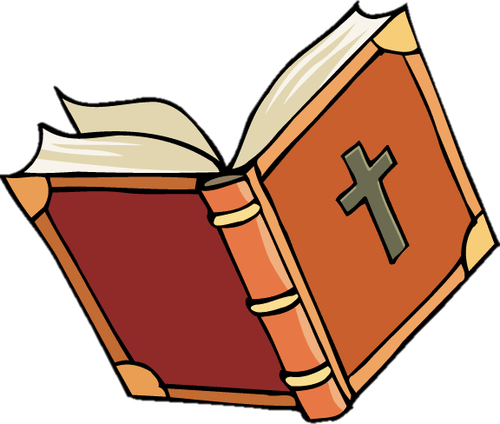

Whatever the Christian view, the fact that the ritual revolves around bread and wine is important. Food and drink are intrinsic to human physical health and survival, in the same way that Christians believe this sacrament is important to spiritual health and survival.