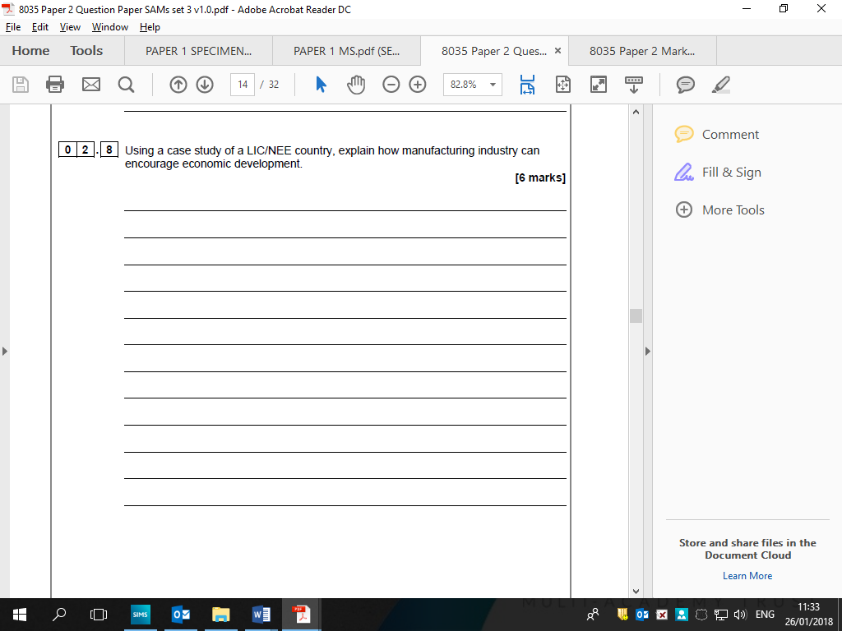

Technique for 6 mark questions are the following:

**P= Point D = Development**

**P+D+D AND P+D+D – 3 points that are developed**

**P+D AND P+D – 3 points that are developed**

**Level 1 (Basic) (1-2 marks)**

Simple, listed points.

Shows limited generic knowledge with some understanding.

**Level 2 (Clear) (3-4 marks)**

Provides range of accurate knowledge and shows a reasonable understanding.

**Level 3 (Detailed) (5-6 marks)**

|  |  |  |  |  |
| --- | --- | --- | --- | --- |
| |  |  | | --- | --- | | Demonstrates thorough understanding and provides a balanced discussion with well-developed ideas through a detailed understanding of the issue. |  | |  | | **IMPORTANT – Some 6 markers require case studies to achieve L2+ (TIP always try to apply them)** | |

**Max top L1 if no named country or name country not LIC/NEE.**

Manufacturing industry creates jobs so that the employees pay taxes which the government can… (Investment / education?)

Paid employment also means a greater number of people with money to

Spend on…

Industries themselves will also pay taxes…

There is also a multiplier effect as industries stimulate growth…

As industries grow they will attract foreign companies, often TNCs, who will…

**6 mark practice questions**

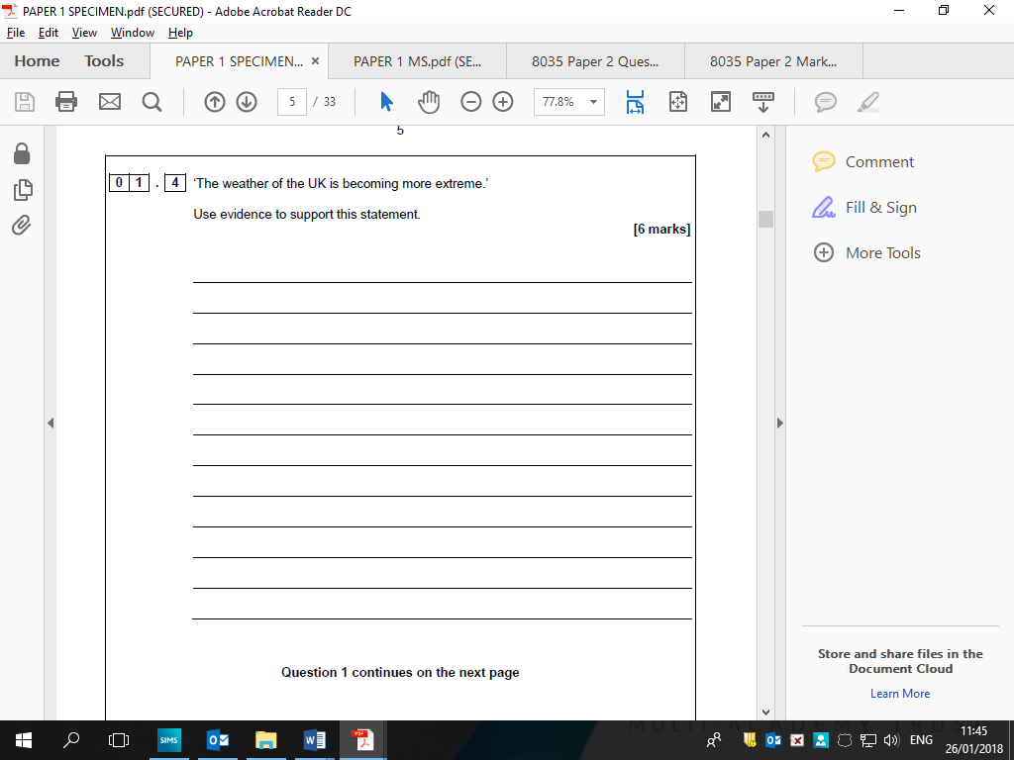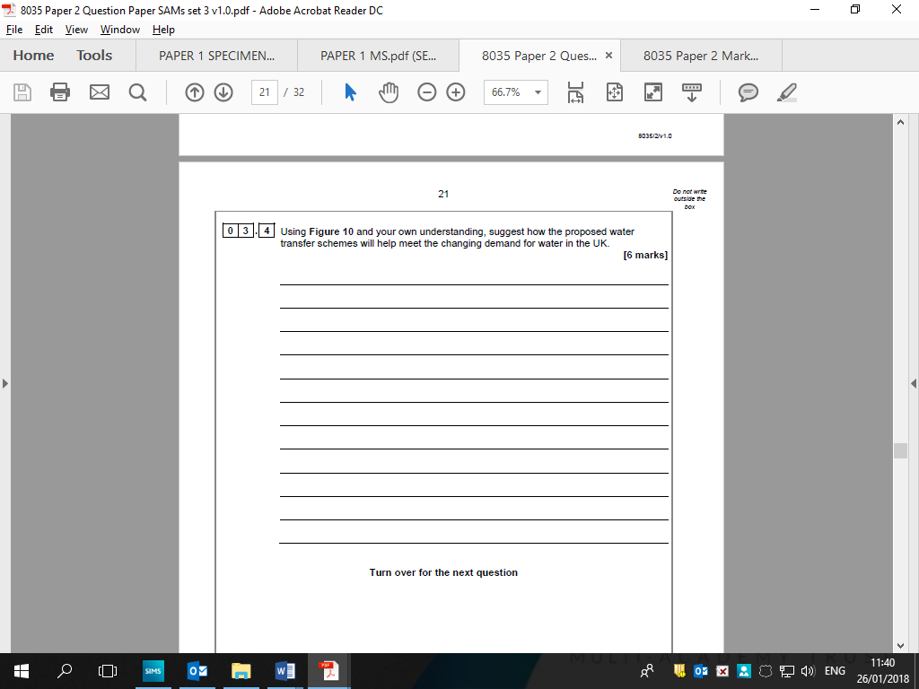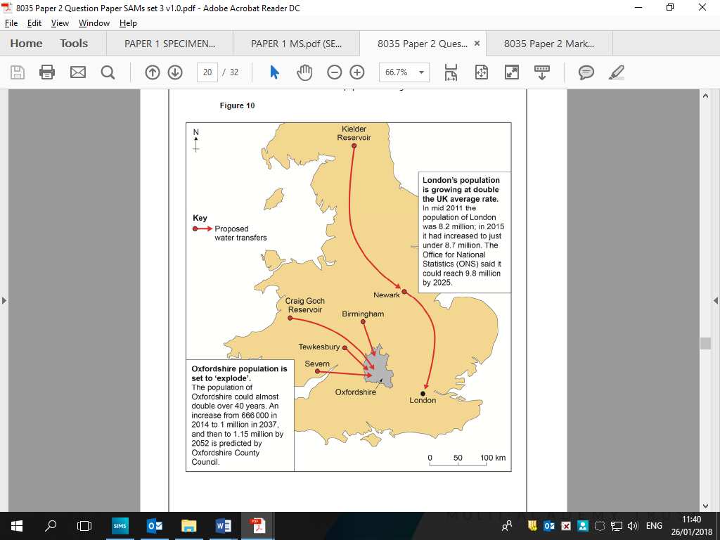

Allow reference to a wide range of extreme weather types.

There should be description of specific weather conditions and an indication of how the weather has become more extreme.

Answers may refer to the increasing frequency of these extreme events, the high levels of rainfall, intensity of wind, high temperatures.

Credit reference to specific extremes of temperatures and rainfall in recent years in the UK.

EXAMPLE - The Somerset Levels were severely flooded due to heavy persistent rainfall in 2014,

Students should be making some assessment of how proposed transfers will meet the increased future need in the UK.

Figure 10 should be used by reference to areas on the map and/or transfer schemes shown and/or figures for population.

Population forecast in Oxfordshire and London?

Transfers are from areas with…

Increased use are in areas where they use a lot of…

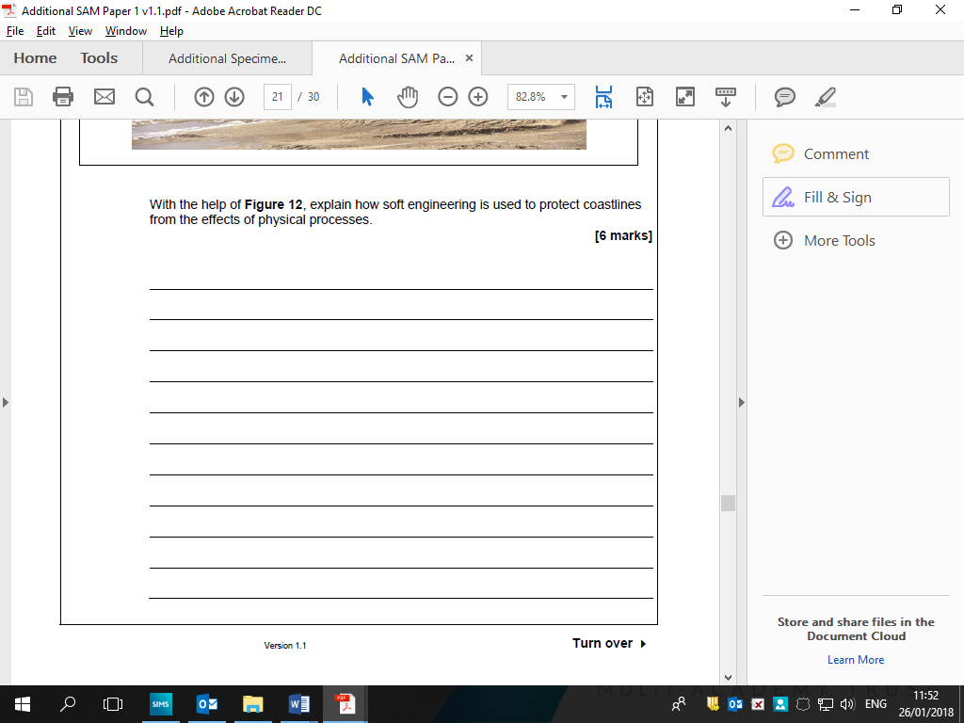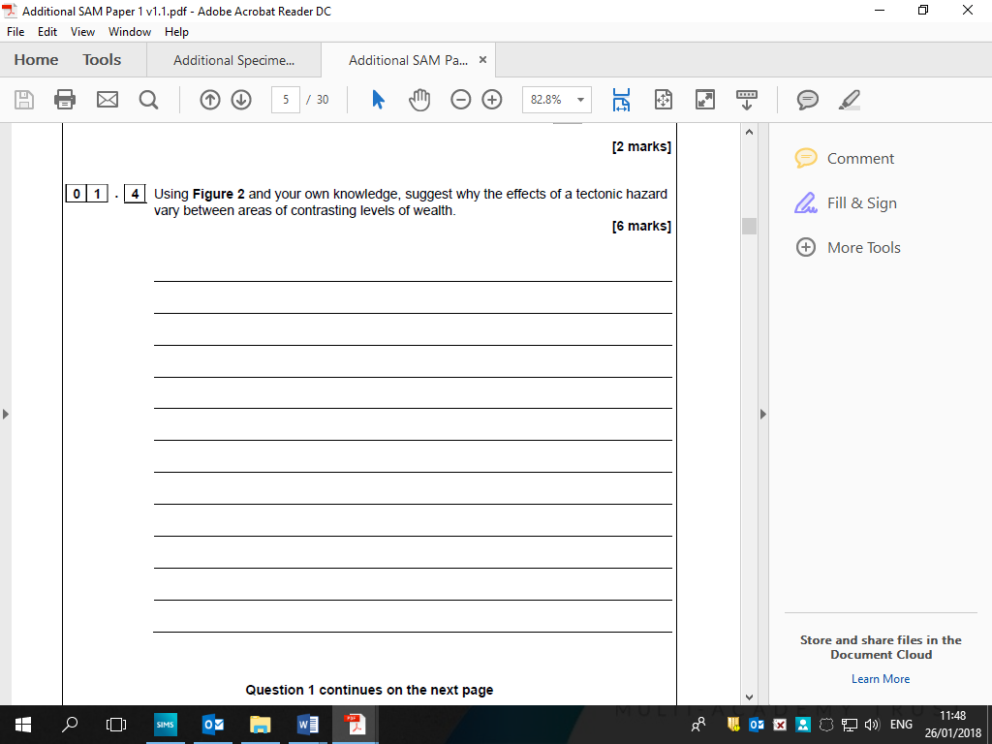

Students might use an example (place) or discussion of soft engineering

techniques.

Soft engineering: beach replenishment; beach recycling; beach re-profiling.

Students who simply describe methods of soft engineering will be

restricted to lower levels.

For higher level marks the emphasis needs to move towards considering how soft engineering methods work in order to protect coastal areas from physical processes.

Effects can relate to any type of tectonic activity and can be considered in socio-economic and environmental terms.

Effects can be primary and secondary.

May simply agree with the premise that wealth gives better opportunities for prediction, preparation and planning or

may look at individual aspects within these categories.

Students may reflect on ‘recovery times’ linked to levels of wealth.

A broader discussion may consider that while wealth is an

important factor there may be other considerations.