**4 mark practice questions**

Technique for 4 mark questions are the following:

**P= Point D = Development**

**P+D AND P+D – 2 points that are developed**

**P + P + P + P – 4 points listed**

**P + P + (P+D) – 3 points and one of the is developed**

**(P + D + D) + P – 2 points and one is developed and expanded on.**

**OR Sequence formation**

Using the mark schemes I would like you to have a go at writing an answer. You will need to consider which techniques are appropriate (it is usually more than one).

**Level 1 (Basic) (1-2 marks)**

Simple, listed points.

Points are separate and generalised and the links are unclear.

**Level 2 (Clear) (3-4 marks)**

Points are developed and linked with detailed evidence.

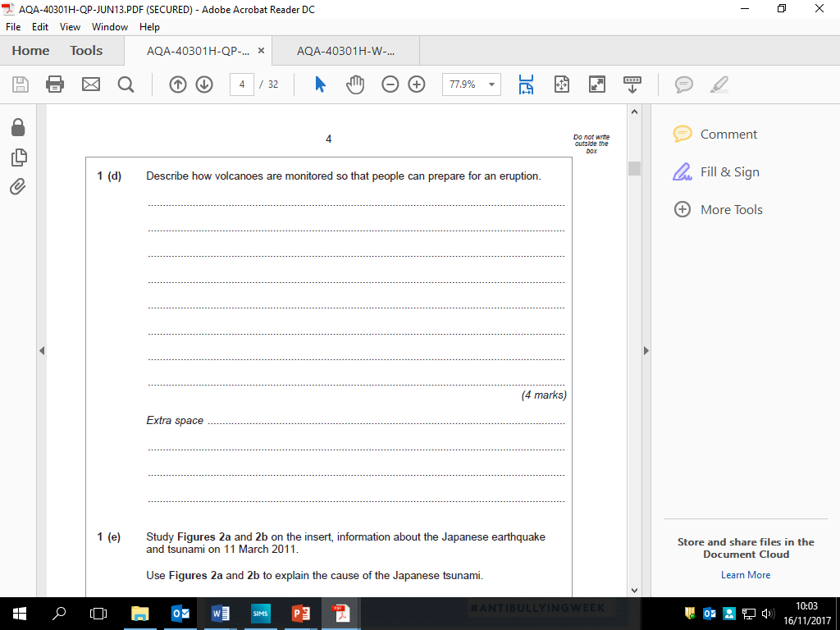

**Use to write a 4 mark answer (Don’t just copy)**

Earthquake activity is monitored, as this can be a sign or a trigger of a volcanic eruption.

Observation of changes in the shape of the land and more accurately the use of tiltmeters to identify and record such changes.

GPS use satellites to detect the smallest movement – of a mm and robots known as spiders are introduced into craters to monitor changes in gases – especially sulphur dioxide

– which can signify an eruption.

All of these allow people to prepare and to

evacuate if necessary.

Techniques?



Techniques?

**Use to write a 4 mark answer (Don’t just copy)**

Likely to explain the presence of the canopy and emergents as the trees fight to get to the sunlight to allow photosynthesis to take place.

There may be reference to specific features such as:

* Lianas that climb the trees to reach the light.
* Epiphytes that live on the trees to access the light.
* Buttress roots which seek to stabilise the trees as their roots are shallow and they grow so tall.
* Drip tip leaves that are designed to shed the large amount of rain as is the smooth bark.



**Use to write a 4 mark answer (Don’t just copy)**

There is likely to be reference to horizontal layers of hard and soft rock, with the hard rock forming the cap rock.

Erosion of the underlying softer rock at a faster rate causes an overhang to develop; abrasion and hydraulic action are particularly important erosion processes; material from overhang collapses causing waterfall to retreat.

The process begins again and repeats, subsequent collapses lead to the formation of a gorge – the narrow steep-sided valley in

front of the waterfall.

Techniques?

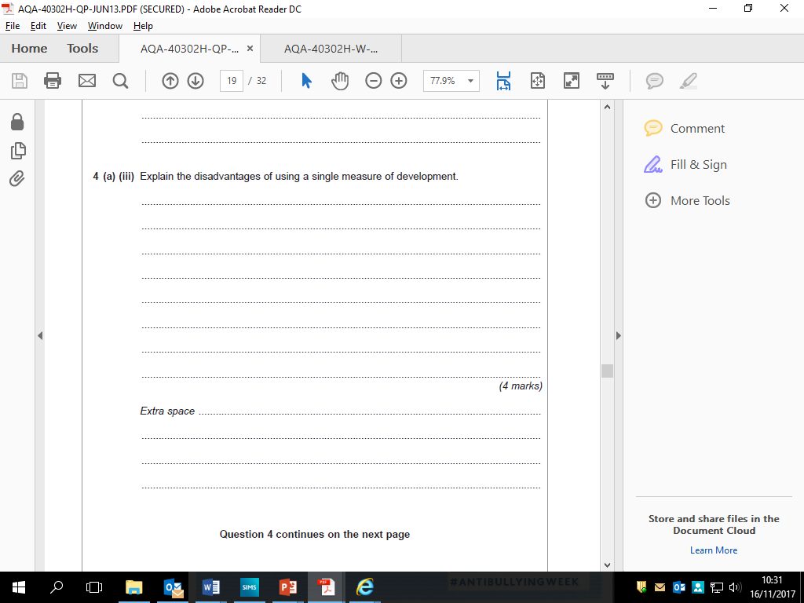

**Use to write a 4 mark answer (Don’t just copy)**

Candidates should show an awareness of how using a single measure can be misleading for any number of reasons. These might include the fact that they are averages and so don’t reflect elites or spatial variations, that different aspects develop at different

rates, a country might score well on one measure but not another.

Credit use of examples to illustrate.

Techniques?

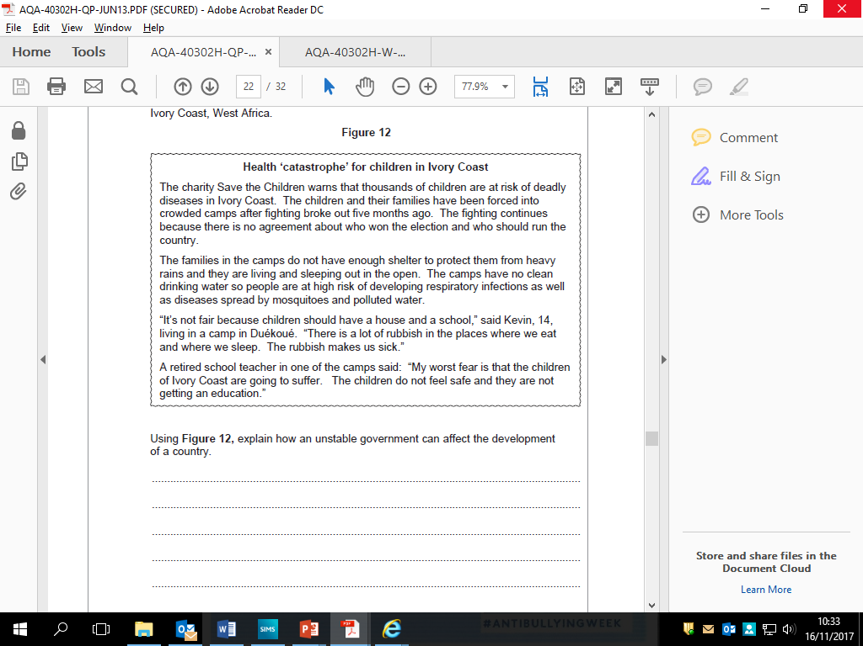

**Use to write a 4 mark answer (Don’t just copy)**

There should be evidence of the use of the newspaper article.

The candidate should show that they understand the link between future

development and political instability such as the reversing of development progress and the hindering of education.

They may also mention the lack of willingness of foreign countries to engage or invest in unstable areas.

The command is to “explain” not “describe”. Level 1 only for description / direct lifts.



Techniques?

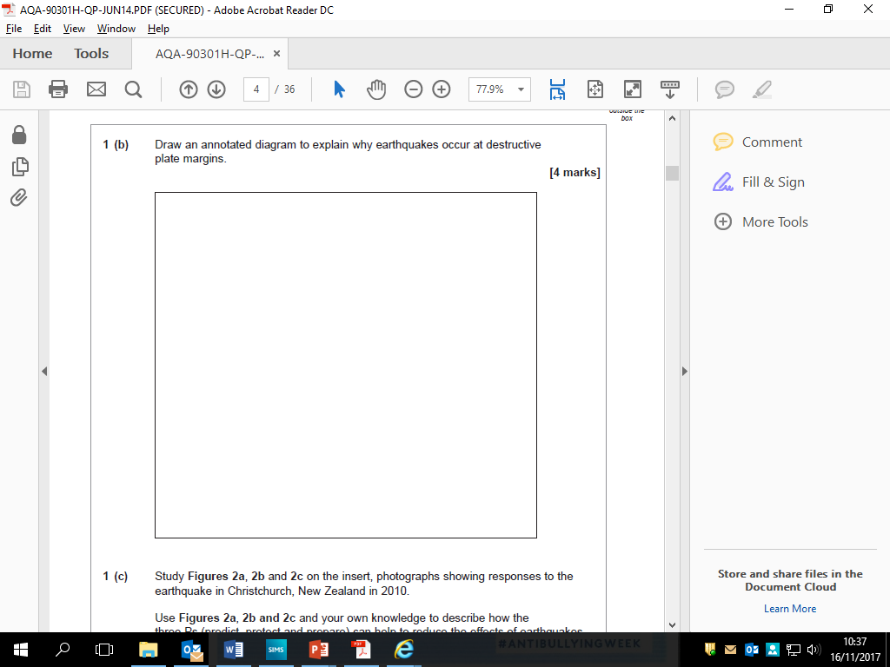

**Use to write a 4 mark answer (Don’t just copy)**

Two plates move towards each other.

One is made from oceanic crust and one of continental crust.

The oceanic plate is denser than the continental. So it sinks beneath the continental plate – which is subduction.

This exerts great pressure on the crust and the release of the pressure that has built up over time causes the plates to shift and results in an earthquake.

Diagram should show oceanic and continental crust, direction of plate movement and consequences.

Diagrams may cross section or three dimensional.

Techniques?



Techniques?

**Use to write a 4 mark answer (Don’t just copy)**

There is likely to be reference to cacti as succulents that store water in their stems so they can survive when there is no rain.

The saguaro cactus has a pleated ‘skin’ to allow for expansion as water is stored.

Many plants have small leaves to reduce transpiration.

Some plants have dormant seeds that grow when it rains, seed and die in a few weeks to avoid drought.

Certain plants can survive in salty conditions as salts tend to rise to the surface.

The emphasis should be on the above surface features. However, if there is reference to roots, there must be a link to climatic features e.g. plants that have shallow roots that catch any moisture before it evaporates.



Techniques?

**Use to write a 4 mark answer (Don’t just copy)**

Must be ICT only.

Candidates are asked to link the ICT to development so they should do more than just describe features.

There is no requirement for a case study or examples but these are likely to add clarity. Likely examples are Expect comment on the ease / speed with which companies can communicate with other parts of the world through internet and cable systems; satellite communications; video conferencing can replace face to face; reduced costs of all these negate the need for proximity.