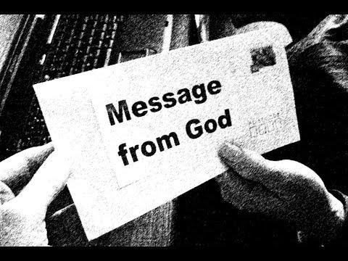

**Muhammad is the last and greatest prophet**

Muslims believe that through history, God has communicated to   
humans through revelations and the last and greatest of these revelations was   
given to the Prophet Muhammad. Muhammad did not come from a rich family   
and it is likely that he could not read or write. He was no a learned man or a scholar,   
but he was very **devout**. He would take himself off for days to meditate in a   
cave in the desert, seeking God. Muslims believe that God chose Muhammad   
as a prophet because he was a humble, honest man; a man he could   
trust with such a special message.

“***God chooses for Himself whom He wills and guides to   
Himself whoever turns back [to Him]***.”   
(Qur’an 42:13)

Copasetic NF Regular

Islam teaches that God sent many prophets throughout history; 25 of   
them are mentioned by name in the Qur’an, going right back to the creation of the world. Many of these prophets are characters from the Jewish and Christian scriptures (what Christians refer to as the Bible). However, Islam teaches that, over the centuries, the messages from these prophets have either been lost or corrupted, so there was a need for a final revelation. Muhammad is known as the Seal of the Prophets because his revelation of the Qur’an was God’s final and absolute word.

Muslim tradition says that, in total, there have been around 124,000   
prophets and that, once a prophet has been called by God, he lived   
a sinless life. Muslim authors put PBUH (peace and blessings be   
upon him) after a prophet’s name to show them a   
deep level of respect.

A ‘rasal’ is a prophet. ‘Risalah’ means bringing prophecy from God.

The channel of communication between God and humanity is called risalah;   
the prophets are our guides. They are human beings chosen to carry guidance   
from God to people, but their wisdom does not come from within   
themselves; it comes from God.

The Qur’an teaches that every community has been given its own prophet,   
bringing God’s message in a book. The message brought by the Prophet   
Muhammad is essentially the same message as had been preached by  
 all the prophets back to Adam: the need to worship the one,   
true God, who will be the   
judge of all

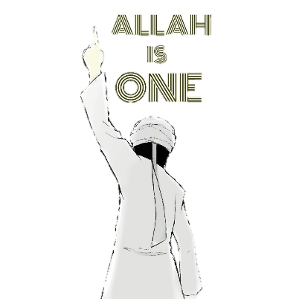

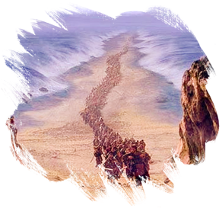Steagisler Regular

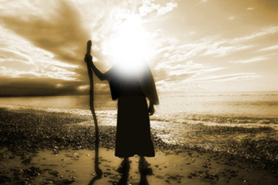Steagisler Regular

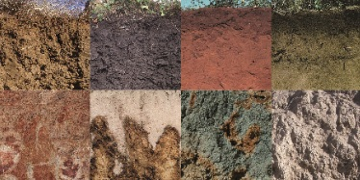



Adam is said to be the **father of the human race**.   
According to the Qur’an, God formed Adam from a   
handful of **soil of many colours**. This represents the diversity   
of people on earth. Eve was created from Adam’s rib and they lived together in paradise. They were commanded not to eat from a particular tree, but the devil was able to convince them to taste its fruit. As a result, they were banished to earth. However, **Adam confessed his sin and was forgiven**, becoming the first prophet.

Muslims believe that Adam was created as God’s “**khalifah**” (his representative on earth). It was his job to rule in the place of God. Tradition says that he built the first **Ka’ba** (House of God –   
the black covered, cube-shaped building at the   
centre of Islam’s holiest mosque)   
in **Makkah**.

***“And they did not kill him,   
nor did they crucify him;   
but [another] was made to resemble him to them.”***(Qur’an 4:157)

Steagisler Regular

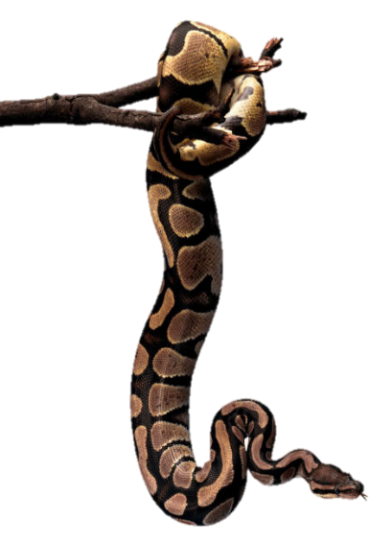

**Musa** (Moses) is remembered by Muslims as one of the   
most significant prophets. The teachings of Ibrahim had been   
forgotten and his book lost, so a new prophet had to be sent. Musa led the Israelites out of slavery in Egypt and into the Promised Land. Islam teaches that he was given the word of God, known as the Tawrat (Torah), but the people were disobedient and the message became distorted.

**Dawud** (David) was Israel’s greatest king, who made Jerusalem a   
holy place for Muslims. He received the word of God in   
the Zabur (Psalms), beautiful hymns of   
praise to God.

Steagisler Regular

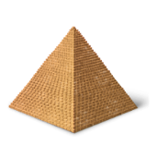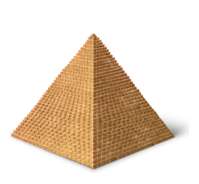

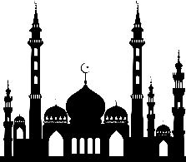

Steagisler Regular



**Isa** (Jesus) and his mother **Maryam** (Mary) are the most   
prominent figures in the Qur’an, after Muhammad. It recognises Isa as a prophet and as a successor to Moses. He was given the Injil (**Gospels**) and   
he performed miracles. However, Muslims deny the Christian teaching of   
the Trinity and reject the belief that Isa is God. They say **God is ‘one’**not ‘three’.

The Qur’an teaches that, although it appeared as if Isa had   
been crucified, in fact **he did not die**. God could not allow evil   
men to triumph over his prophet in such a way. Instead,   
**Isa was taken up to heaven and will reappear in the   
second coming when God judges the world**.

* Ibrahim (Abraham) regarded himself as a hanif. This means that he   
  had an inner knowledge that there is only one true God. For this reason, he is seen as the greatest of the prophets before Isa (Jesus). He was born into a family of polytheists (people who believe in many Gods), but he rejected these beliefs in favour or monotheism and became a Muslim (one who bows down to God).
* “*Abraham was neither a Jew nor a Christian, but he was   
  one inclining toward truth, a Muslim [submitting to God].   
  And he was not of the polytheists*.” (Qur’an 3:67)
* Ibrahim had two sons who were both prophets: Ishma’il (the   
  prophet to the Arabs) and Ishaq (the prophet to the Jews). For   
  Muslims, Ishma’il is the more important because he is an   
  ancestor to Muhammad.

When Muslims go on Hajj they remember the distress   
of Hajar (Ishma’il’s mother) as she ran between the hills  
 of Al-Safa and Al-Marwah in search of water.

They also remember how God instructed Ibrahim to sacrifice Ishma’il. When Satan tried to tempt Ibrahim to disobey God,   
telling him to refuse to sacrifice his son, Ibrahim drove the  
 evil one away by throwing stones at him.

There is a tradition that God revealed a holy book to Ibrahim,   
known as the ‘scrolls of Ibrahim’ or she ‘Sahifah’.   
The Qur’an mentions this book, but no   
record remains of it   
today.

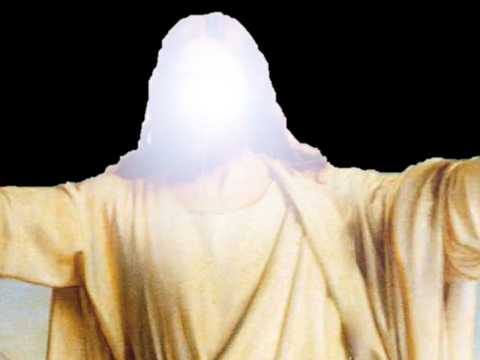

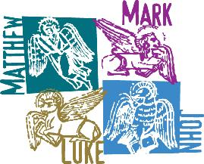

Steagisler Regular