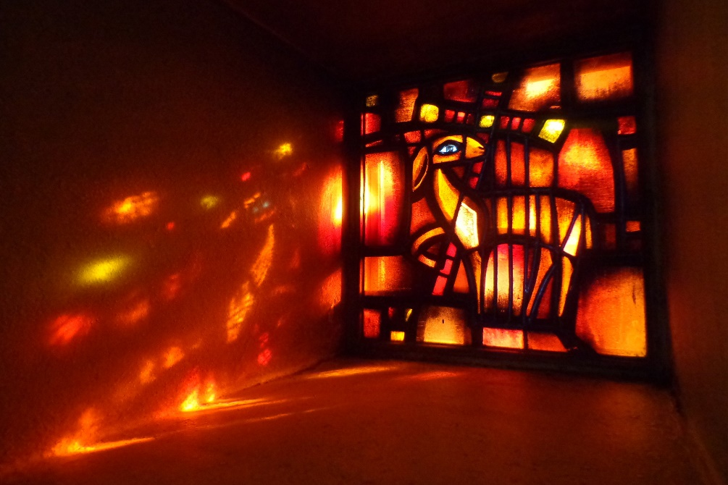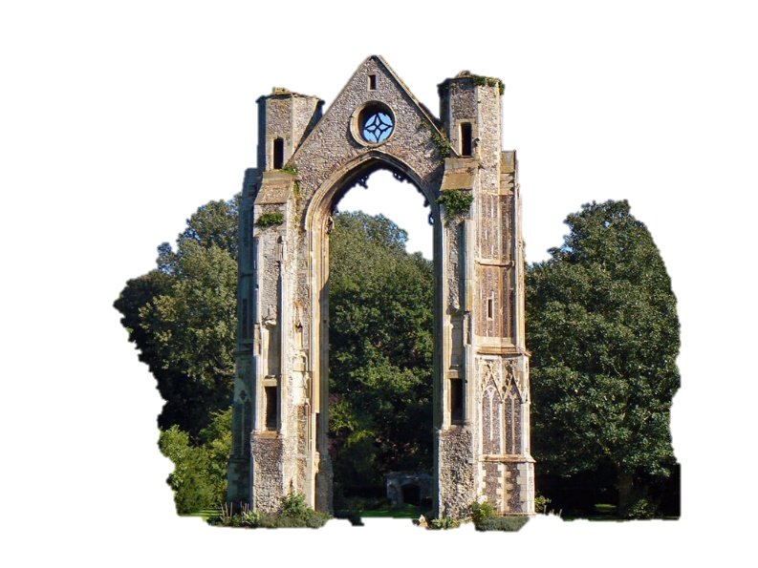



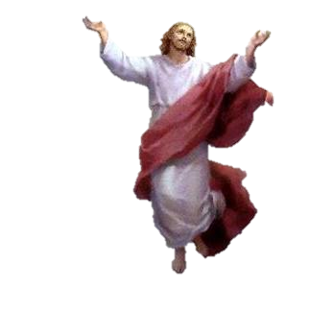

A pilgrimage is a journey to a sacred place, usually as an act of religious   
devotion. In Christianity, pilgrims might travel to the Holy Land to ‘*walk in the   
footsteps of Jesus*’. Pilgrims believe that life itself is a journey towards God. A   
pilgrimage is faith in action, the journey representing the journey that all Christians   
undertake from earth to heaven.

When Christians go on pilgrimage they travel somewhere that is special to their faith. It   
might be to places written about in the Bible, such as where Jesus and the early Christians   
lived. It may be a place where a miracle once happened or a saint is buried. Often the journey   
itself matters as much as being at the special place, because it gives the ‘pilgrim’ – the person   
on the journey – time to pray and think.

Pilgrimage is an important part of spiritual life for many Christians. By taking the time to go on pilgrimage, people can leave behind everyday concerns from back home and spend time in the   
presence of God as they travel to a place with special meaning. People have always   
gone on pilgrimage for many reasons, e.g. saying sorry (penance) or because of an   
 illness. They might be looking for an answer to a problem or difficulty, or they might   
 be looking for peace or healing. Over the years, places have become   
 special for different reasons, and Christians decide to visit them   
 to become closer to God in these special places.

Monks – from all Christian denominations - travel to Taizé to live a life  
of communal prayer. It is unusual because it is Ecumenical, meaning it represents unity within the different Christian churches. Today there are more than 100   
brothers, from both Catholic and Protestant traditions. Reconciliation, the   
resolution of conflict, is at the heart of the Taizé community. By bringing together different Christian denominations the Taizé community promotes understanding and cooperation between them.  
When pilgrims arrive in Taizé they join the life of the monistic community (the monks) by taking part in the set times of prayer in the ‘*Church of Reconciliation*.’ They also spend time in private prayer, attend Bible-study discussion groups led by monks and share in the communal work.  
 The services are world-famous for the use of chants and music, and Taizé chants  
 have become popular in many churches. During the services the monks wear  
 white robes and all of the pilgrims who visit Taizé are required to attend the  
 monastic church services three times each day.

Walsingham is in Norfolk. It has been a holy place since 1061 when the  
 widow of the Lord of the Manor of Walsingham Pava had a dream where the   
**Virgin Mary asked her to build a replica of the house of Nazareth** where the announcement of the birth of Jesus took place – where Mary was told by the Angel Gabriel that she would have God’s child. Walsingham is important because our human journeys begin with birth and Walsingham is a **shrine to the place where Jesus’ birth was foretold**.

Many visit the places where Jesus lived, especially during the Christian festivals (for example, Bethlehem, where he was born, at Christmas; Jerusalem, the place where he died, at Easter).

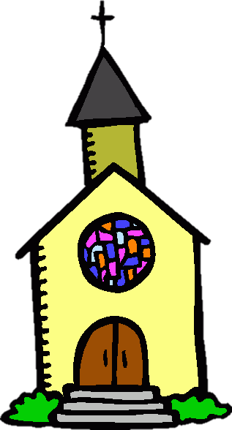



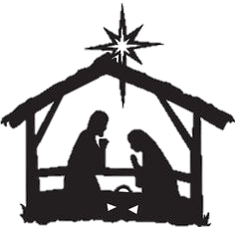

Glotona Black 0



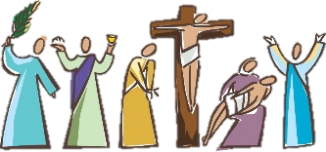

Jerusalem is an important place of pilgrimage for Christians. Christians   
believe that Jesus visited Jerusalem at Passover time and spent the week   
leading up to his death there. Christian pilgrims visit Jerusalem, therefore, to   
remember key events in Jesus' final week, known as Holy Week. Places that  
 Christian pilgrims might visit include:

* The **Garden of Gethsemane** - where Jesus prayed before he was arrested by the Romans and put to death. Christians visit here for contemplation and prayer.
* **Church of the Holy Sepulchre** - this church is built on the site where Jesus was crucified, as well as his place of burial
  + **Via Dolorosa** – walking the path that Jesus took carrying his cross on the way to his crucifixion.
  + **Church of the Ascension** - marks the site of the Ascension, when Jesus rose into Heaven forty days after his resurrection. There is a stone inside the Church, believed to be imprinted with his footstep.



Glotona Black 0

# 

* In 1858, a young girl called Bernadette Soubivous had a vision of Jesus' mother, Mary. The spring waters that flow from the fountains are believed to bring miraculous healing from God.
* It is mainly Roman Catholic Christians who pilgrimage to Lourdes
* Christian pilgrims now visit and pray in the **Sanctuary of Our Lady of Lourdes** and worship at the grotto where the vision is said to have taken place.
* Pilgrims also take part in a **Torchlight Marian Procession** which takes place every evening before a service of mass takes place in the grotto. Pilgrims also confess their sins at the **Reconciliation Chapel**.
* It is one of the world’s most important pilgrimage sites for young people
* Over 100,000 people make pilgrimages to Taizé each year
* Young people pilgrimage to Taizé because:
  + Curiosity
  + Adventure
  + Holiday
  + Act of remembrance
  + An attempt to walk in the footsteps of people of faith
  + Historical reasons
  + Act of atonement
  + Act of supplication (asking God for something)



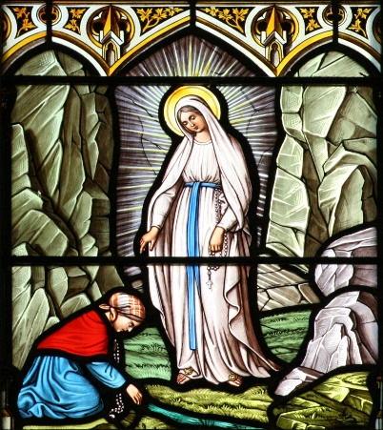

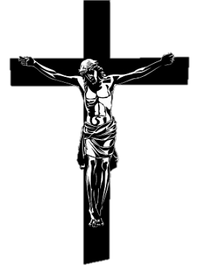

Glotona Black 0

# Jerusalem

Jerusalem is an important place of pilgrimage for Christians. Christians believe that Jesus visited Jerusalem at Passover time and spent the week leading up to his death there. Christian pilgrims visit Jerusalem, therefore, to remember key events in Jesus' final week, known as Holy Week. Places that Christian pilgrims might visit include:

→ The **Garden of Gethsemane** - this is believed to be where Jesus prayed before he was arrested by the Romans and put to death. Christians visit here for contemplation and prayer.

→ **Church of the Holy Sepulchre** - this church is said to be built on the site where Jesus was crucified, as well as his place of burial. Others believe the **Garden Tomb**, situated just outside Jerusalem's city walls, is the place which marks the site of the death and resurrection of Jesus.

→ **Via Dolorosa** – this is a special route that Christian pilgrims walk from the outskirts of Jerusalem to the Church of the Holy Sepulchre, especially on Good Friday. It is believed to be the very path that Jesus took carrying his cross on the way to his crucifixion.

→ **Church of the Ascension** - this is said to mark the site of the Ascension, when Jesus rose into Heaven forty days after his resurrection. There is a stone inside the Church, believed to be imprinted with his footstep.

Many Christians believe that undertaking a pilgrimage to Jerusalem can bring them closer to the experience of Jesus as he approached his death. Christians believe that this will help them to develop spiritually and become closer to God.