Distillation – a particle’s perspective
Write a short story (around 1 page in your exercise books) of distillation through the view point of a water particle in a mixture with another liquid.
Use the level ladder to help your story. You have two weeks to complete this homework.
Level Ladder- Step to Success | Tick
Level 4
- Describe what a mixture is
- State what a distillation is used to separate
Level 5
- Include a diagram of the water particle in a mixture with another liquid
- Describe what happens to the water particles- include keywords such as evaporation and condensation
Level 6
- Explain how the two liquids are separated by boiling points
- Describe how the particle feels when being boiled and when being condensed.
Level 7
- Explain and describe how the mixture of liquids is different to the pure collection in the conical flask.
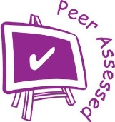
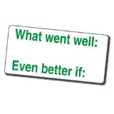
Peer assessment:

Distillation – a particle’s perspective
Write a short story (around 1 page in your exercise books) of distillation through the view point of a water particle in a mixture with another liquid.
Use the level ladder to help your story. You have two weeks to complete this homework.
Level Ladder- Step to Success | Tick
Level 4
- Describe what a mixture is
- State what a distillation is used to separate
Level 5
- Include a diagram of the water particle in a mixture with another liquid
- Describe what happens to the water particles- include keywords such as evaporation and condensation
Level 6
- Explain how the two liquids are separated by boiling points
- Describe how the particle feels when being boiled and when being condensed.
Level 7
- Explain and describe how the mixture of liquids is different to the pure collection in the conical flask.
Peer assessment:

