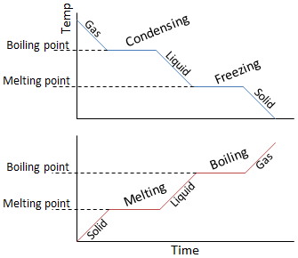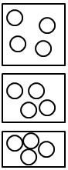

All of the AQA science revision sheets at www.tes.com/teaching-resources/shop/teachsci1

**Specific latent heat of fusion** = melting or freezing.  
**Specific latent heat of vaporisation** = evaporating, boiling or condensing.

Specific latent  
heat (J/kg)

Mass (kg)

Energy (J)

$$E=mL$$

Bonds are broken, taking in energy. Internal energy increases but the temp. doesn’t until all the substance has changed state.

Bonds are formed, giving out energy. Internal energy decreases but the temp. doesn’t until all the substance has changed state.

**Specific Latent Heat** – the energy needed to change the state of 1kg of a substance

**Internal Energy** – the energy stored by the particles in a systemHeating a system increases the energy particles have in their **kinetic** and **potential energy stores**.  
A **temperature change** depends on the mass of substance, what it is made from and the energy input (see specific heat capacity). If the substance is heated enough particles can have enough energy in their kinetic stores to break bonds holding them together and so a **change in state** occurs.

* Higher temp. = higher average energy of particles
* Higher energy = higher average speed (Ek = ½mv2)

**Gases**  
Have almost **no forces** between particles. Have **more energy** and are **free to move** in random directions and speeds.

**Liquids**  
Have **weaker forces** between particles so although the particles are close together they can **move** over each other at low speeds in random directions.

**Solids**  
Have **strong forces** between particles, holding them close together in a **fixed**, **regular** arrangement. The particles can only vibrate around fixed positions.

**Density**Measures how compact a substance is. Depends on the material and how the particles are arranged.

**Measuring Density**For a **regular shaped solid** object you can measure the length, height and width and use the correct formula to calculate volume.  
For an **irregular solid** you can use a **eureka can** filled with water. The volume of water that is displaced is the volume of the object. Use a balance to find the mass.

For a liquid you record the mass of 10ml of the liquid (using a measuring cylinder on a balance). You can then use these values to calculate density.

Required Practical

see practical sheet for detail

Volume (m3)

Mass (kg)

Density  
(kg/m3)

Compressing a less dense material pushes the particles closer together. The mass would not change (same number of particles) but the volume would.

**Particle Model**

**Gas Pressure**When the particles in a gas **collide** with the side of the container they **exert a force** on it.  
The **pressure** is the **force exerted per unit of area**. In a sealed container the gas pressure is the total force of all the particles on the area of the container walls.

**Increasing the temperature** increases pressure because particles have a larger kinetic energy store. This means they move faster so collide with the sides more often and with more momentum = a larger total force exerted so increased pressure.

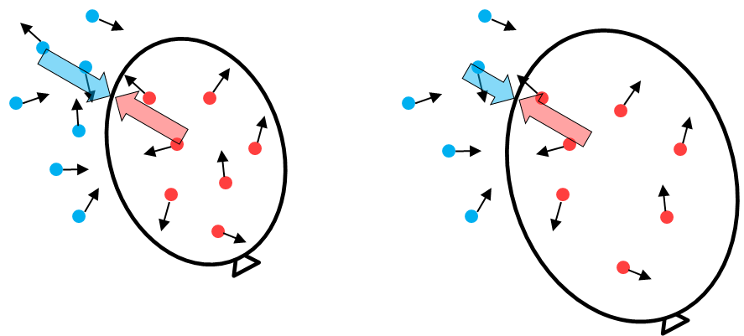

**Pressure**For a sealed container the gas pressure is the total force of all the particles per unit of area.  
Increasing the temperature of the gas means particles have more energy so collide with the sides of the container with more force. Therefore the gas pressure is higher.  
Decreasing the volume means particles are closer together so hit the sides more often. Therefore the gas pressure is higher.

Pressure (*p*) and volume (*V*) are inversely proportional (if one increases the other decreases):

$$pV=constant$$

**Work Done**Work is done when energy is transferred by applying a force.  
Work done on a gas increases its internal energy. This can increase the temperature of the gas.

Pumping up a bike tire does work **mechanically**. The gas exerts a force on the plunger (due to pressure). To push the plunger down against this force work has to be done. Energy is transferred to the kinetic stores of the gas particles, increasing the temperature.

Balloon rising. Air pressure decreases. Internal pressure is greater so balloon expands

Balloon at ground  
level. Internal and  
external pressures are equal.

**Volume**Gas pressure causes an outwards force at right angles to the wall of the container.  
The pressure of the air pushes on the outside of the container.  
A change in pressure can cause a container to change shape. Eg. if a helium balloon is released it rises. As it gets higher the atmospheric pressure decreases, causing the balloon to expand until the pressure inside the balloon equals the air pressure again.

**Temperature**Energy is transferred to the kinetic stores of particles when the temperature is increased.  
The higher the temperature the higher the average energy of the particles. This means the higher the energy the faster the particles move.

**Physics Only**

**Particles In Gases**